Micro services

Provides set of related functions to the specific part of the application.

SOA:

A service can be served to multiple systems like mobile, website, pc etc.,

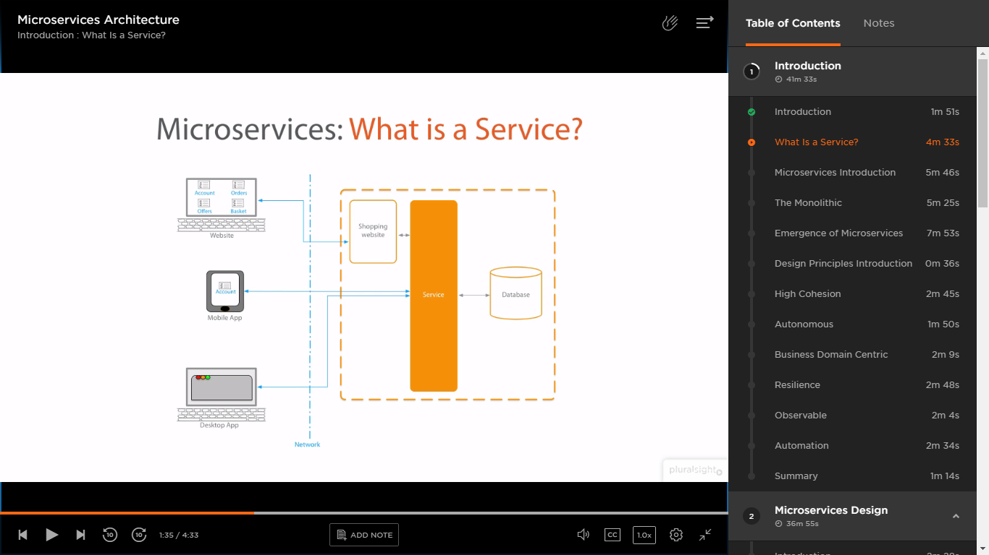

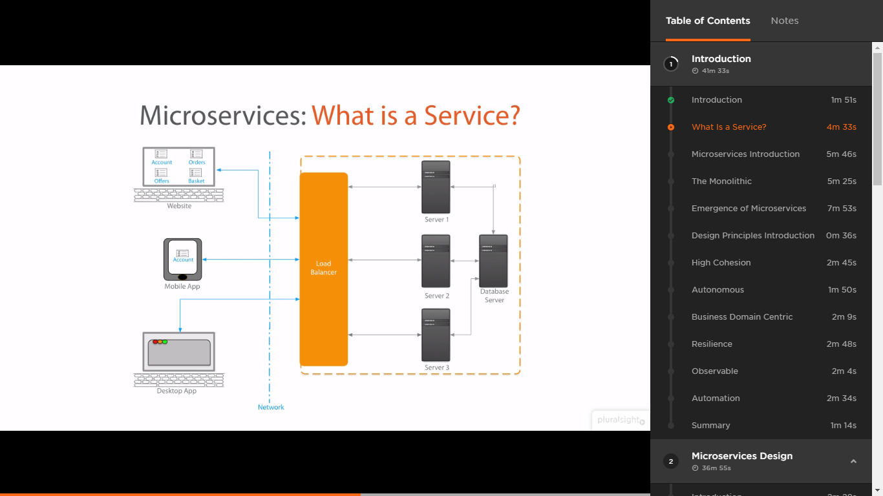

Multiple servers having the copies of the same services which will be redirected by load balancer on demand.

Scalability, reusability

Services are stateless.

Monolithic services: Large services contains the bigger functionality. Maintenance is tough. Not scalable.

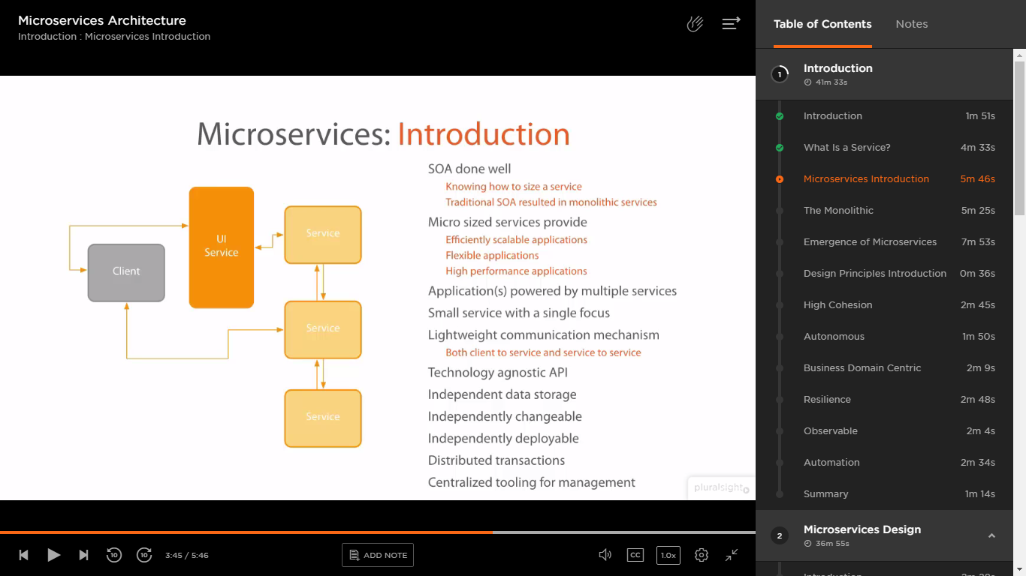

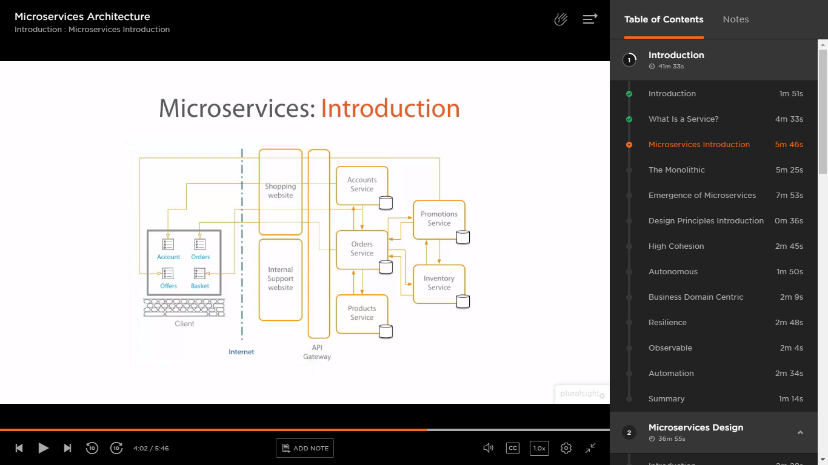

Each service can be separately deployable and upgradable. If I would like to upgrade only Orders service I can do that. Also I can make multiple instances of any service I need for eg., Orders service.

Monolithic:

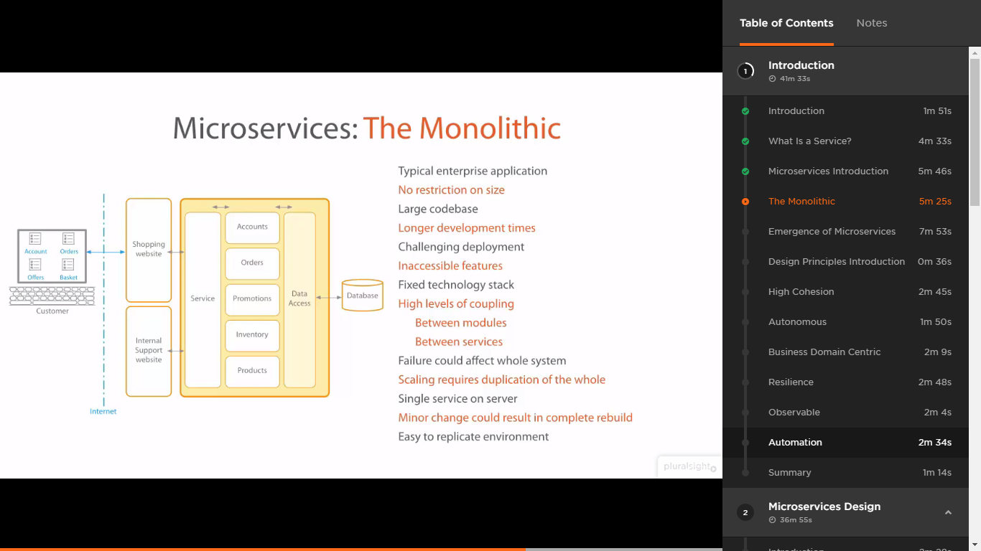

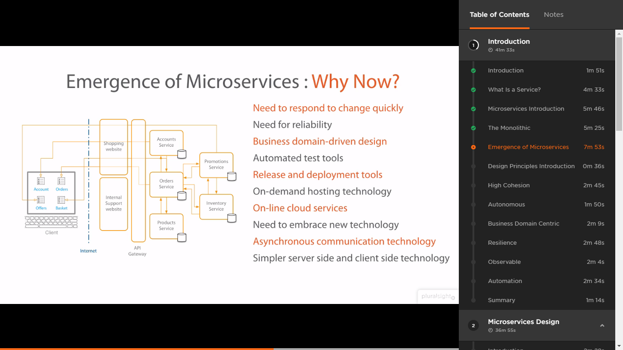

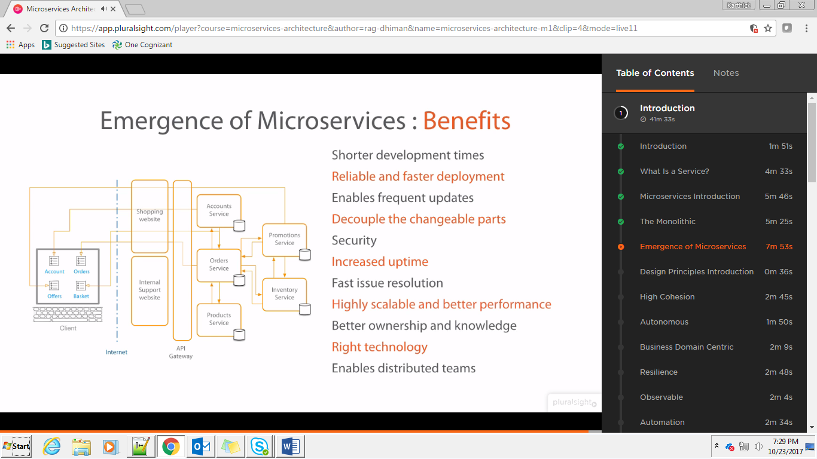

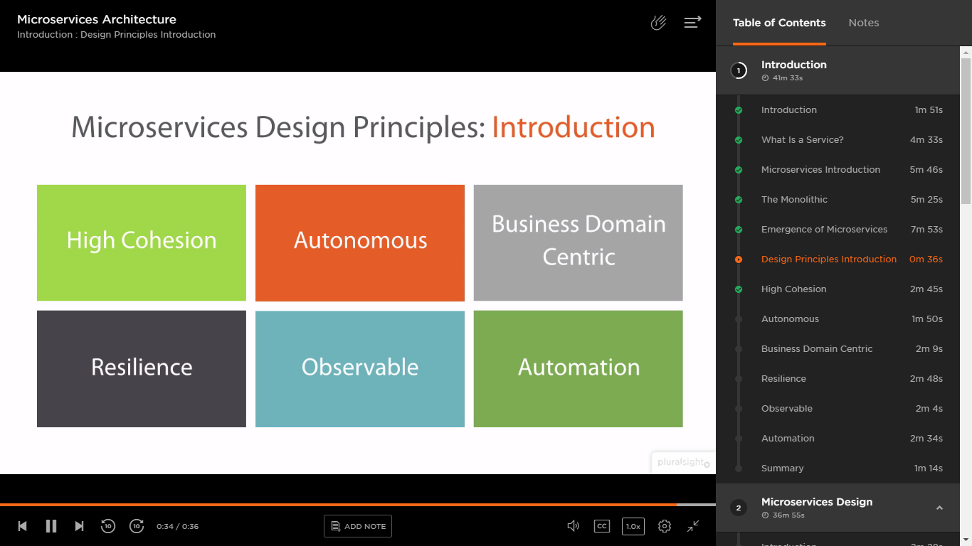

Cohesion: the action or fact of forming a united whole. The input and output of a micro service must be coherent.

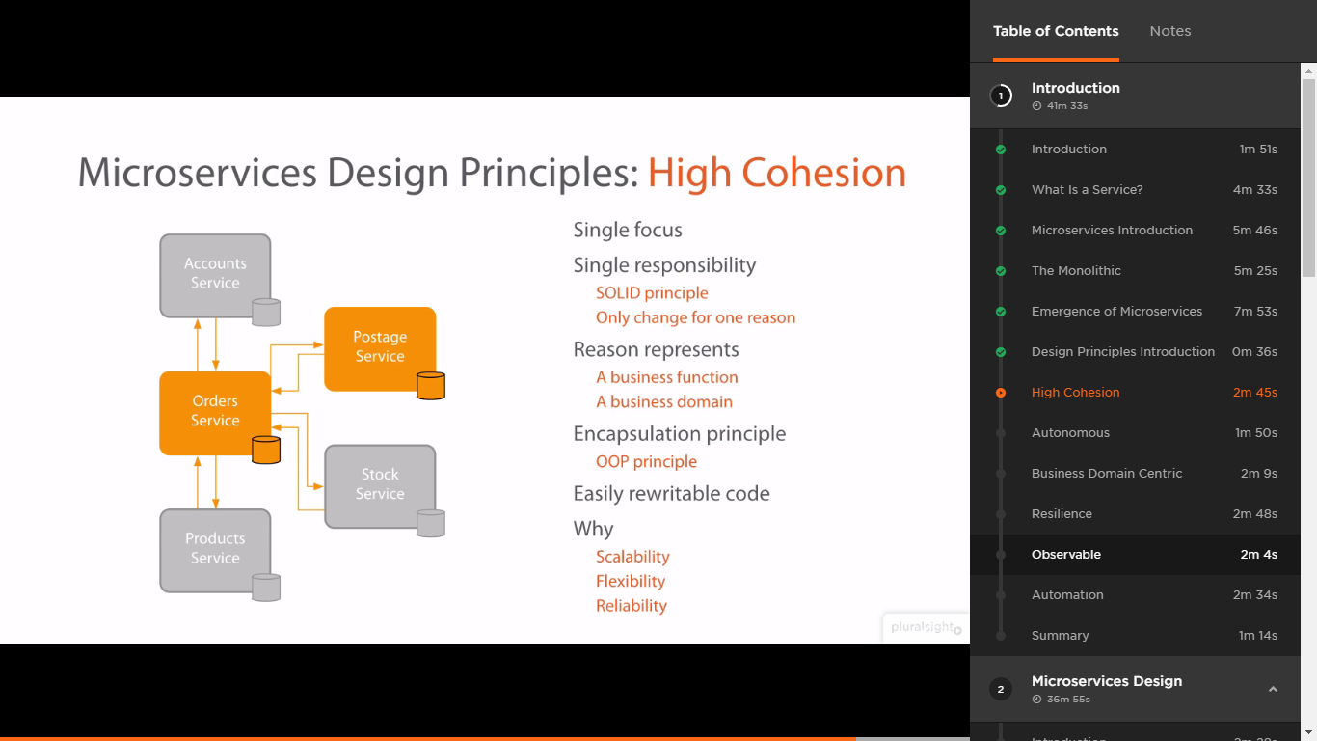

Autonomous: Micro services should not be changed based on the other systems that interacts with it. The input and output shouldn’t be changed.

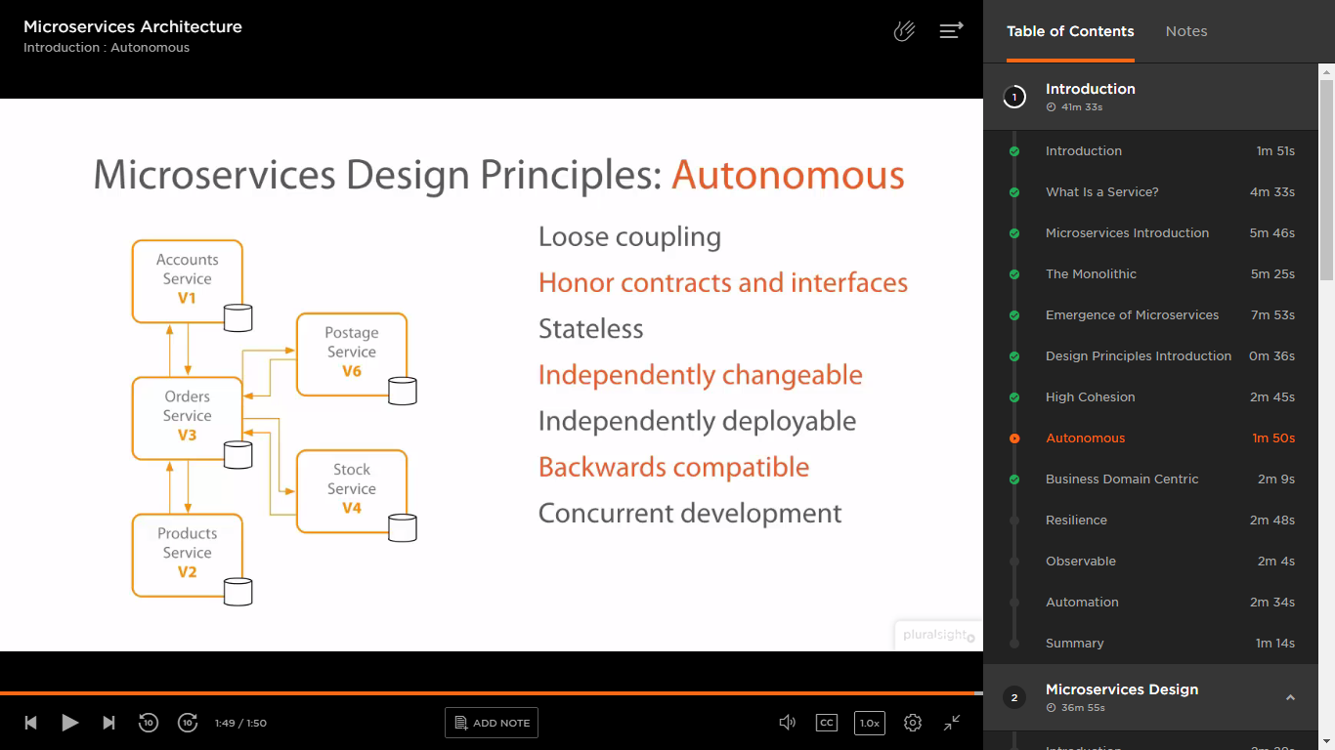

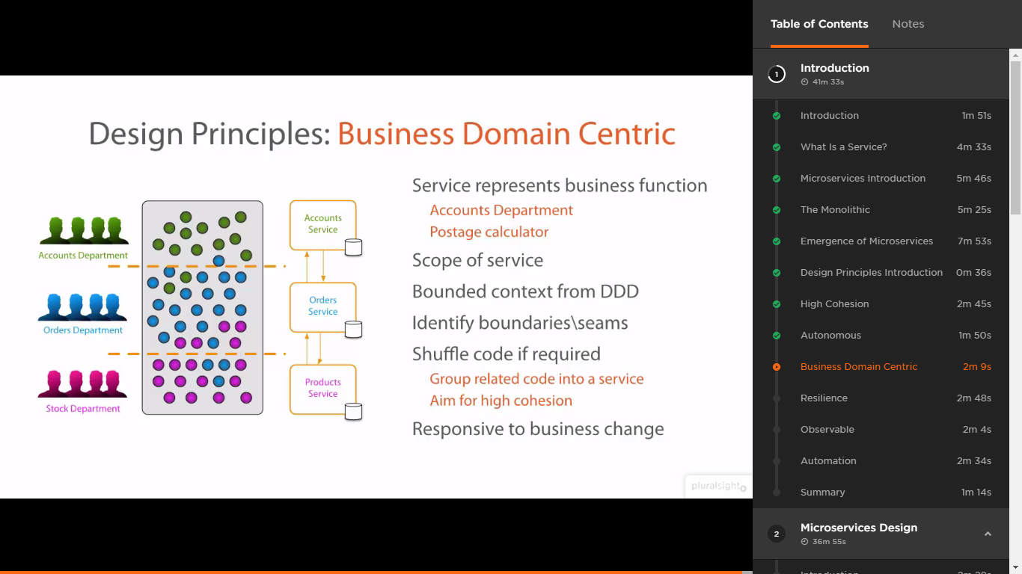

Resilience: the capacity to recover quickly from difficulties; toughness.

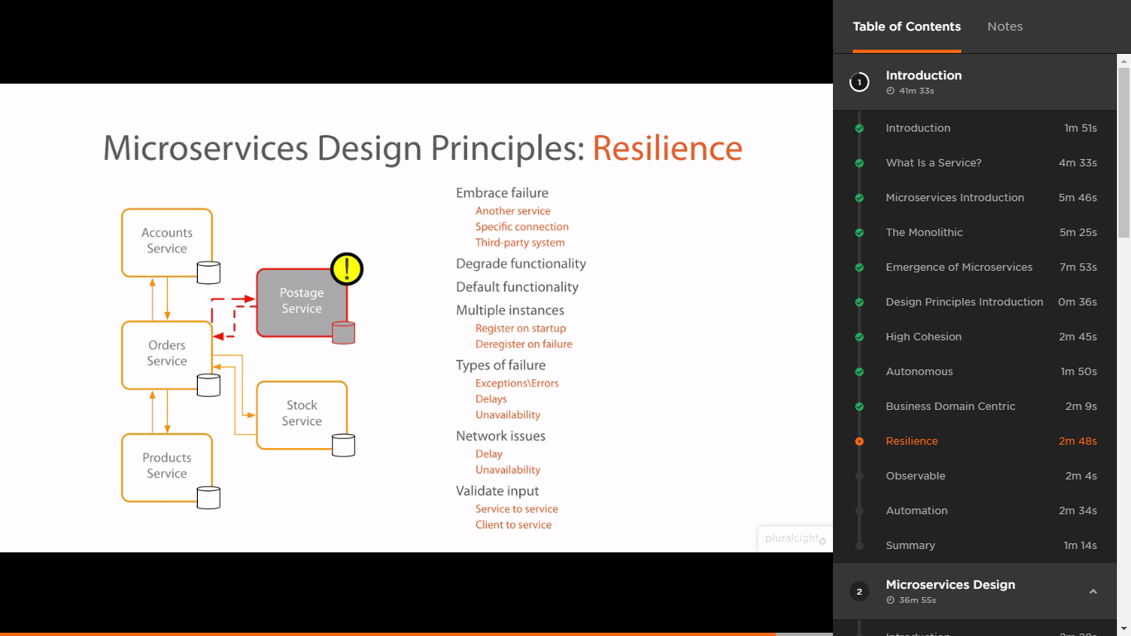

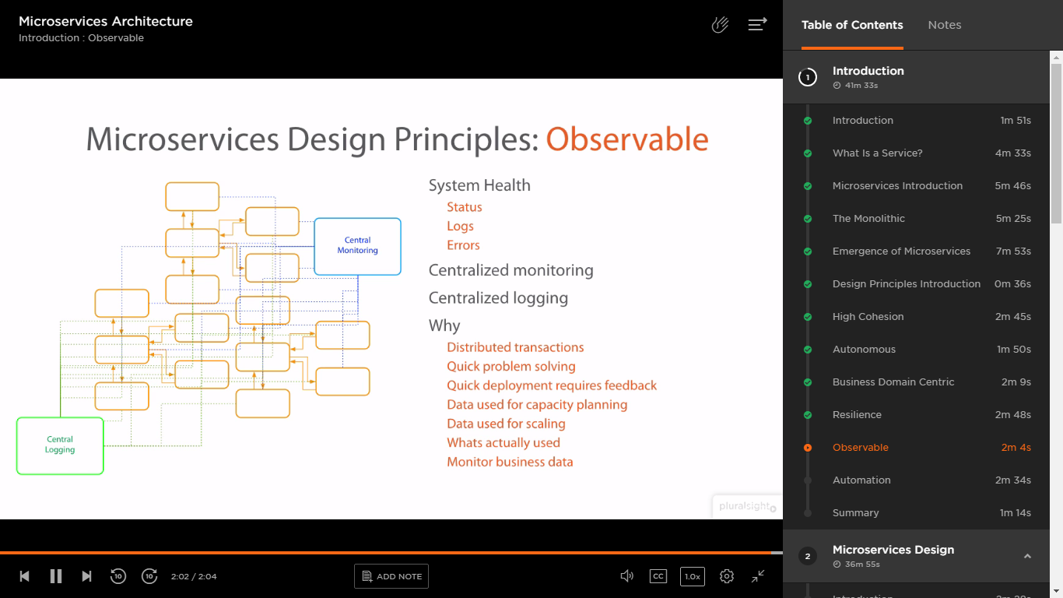

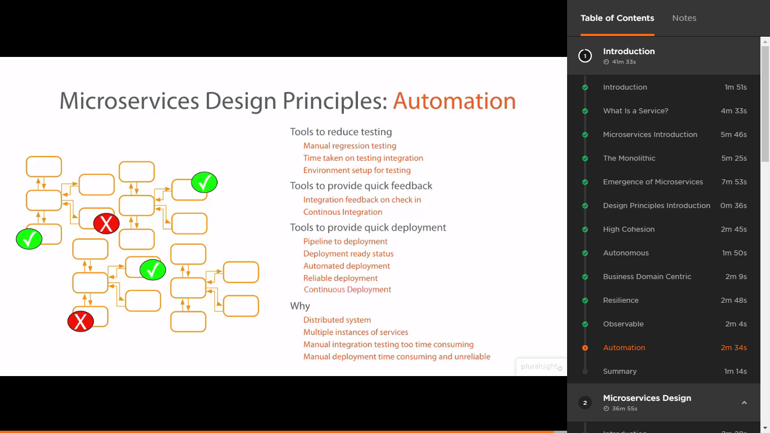

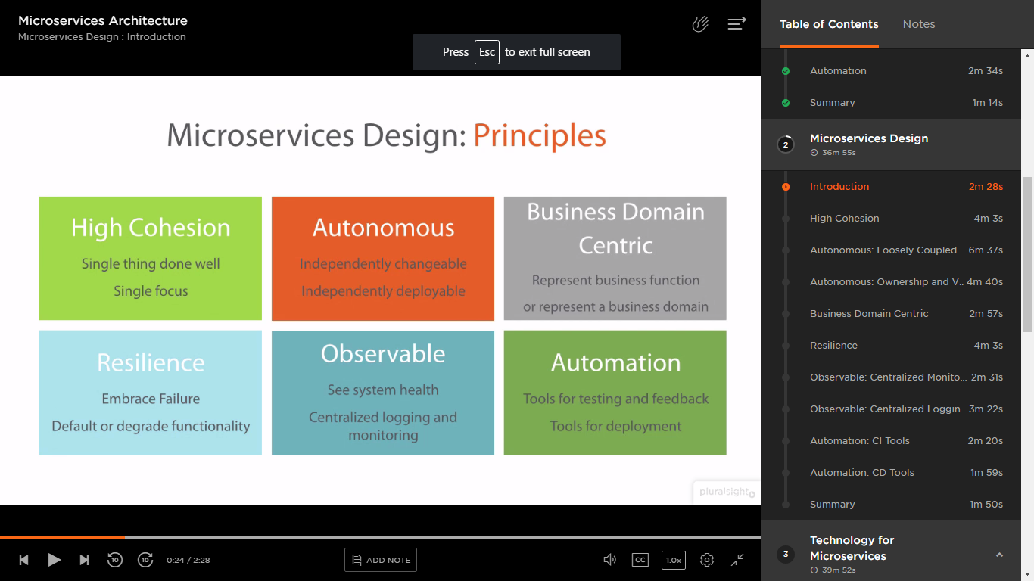

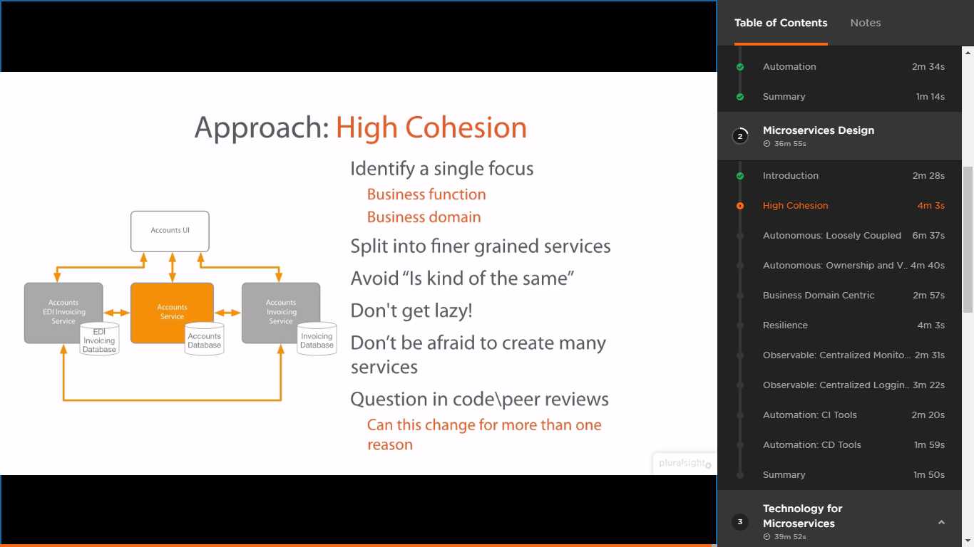

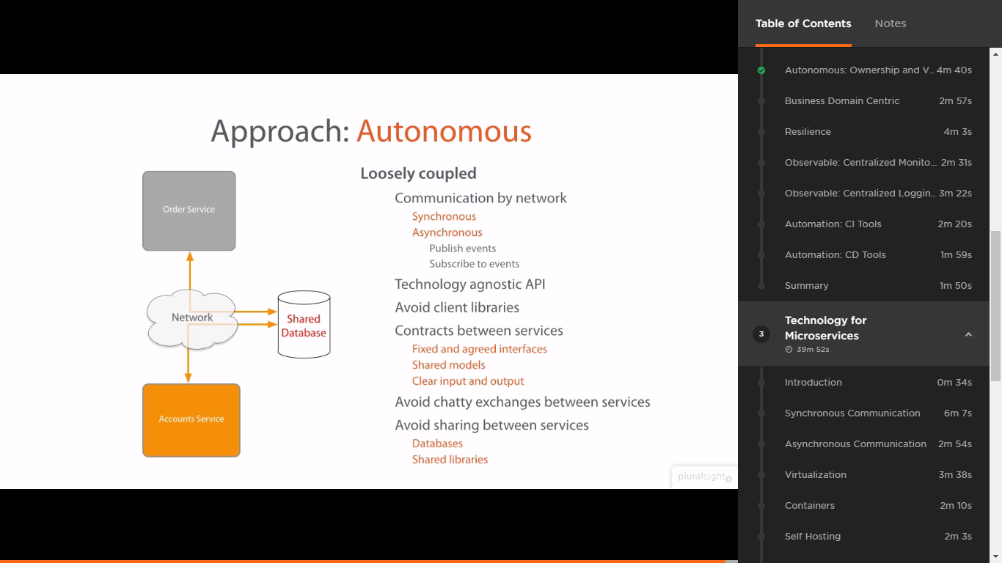

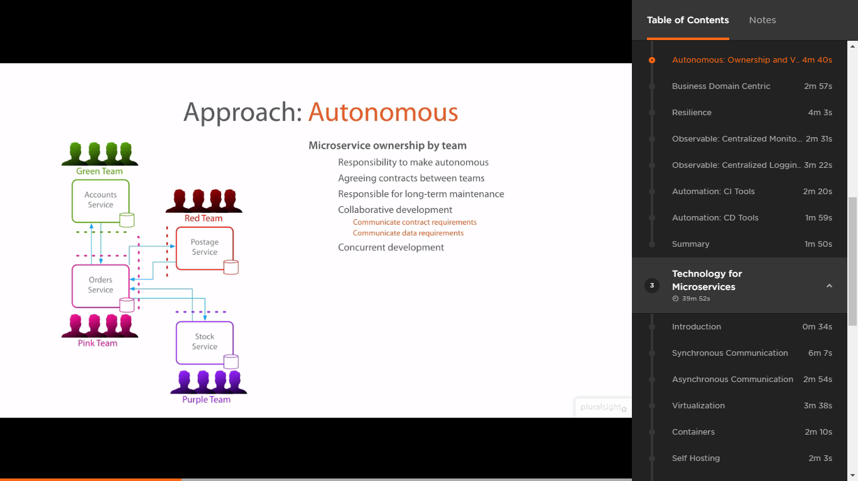

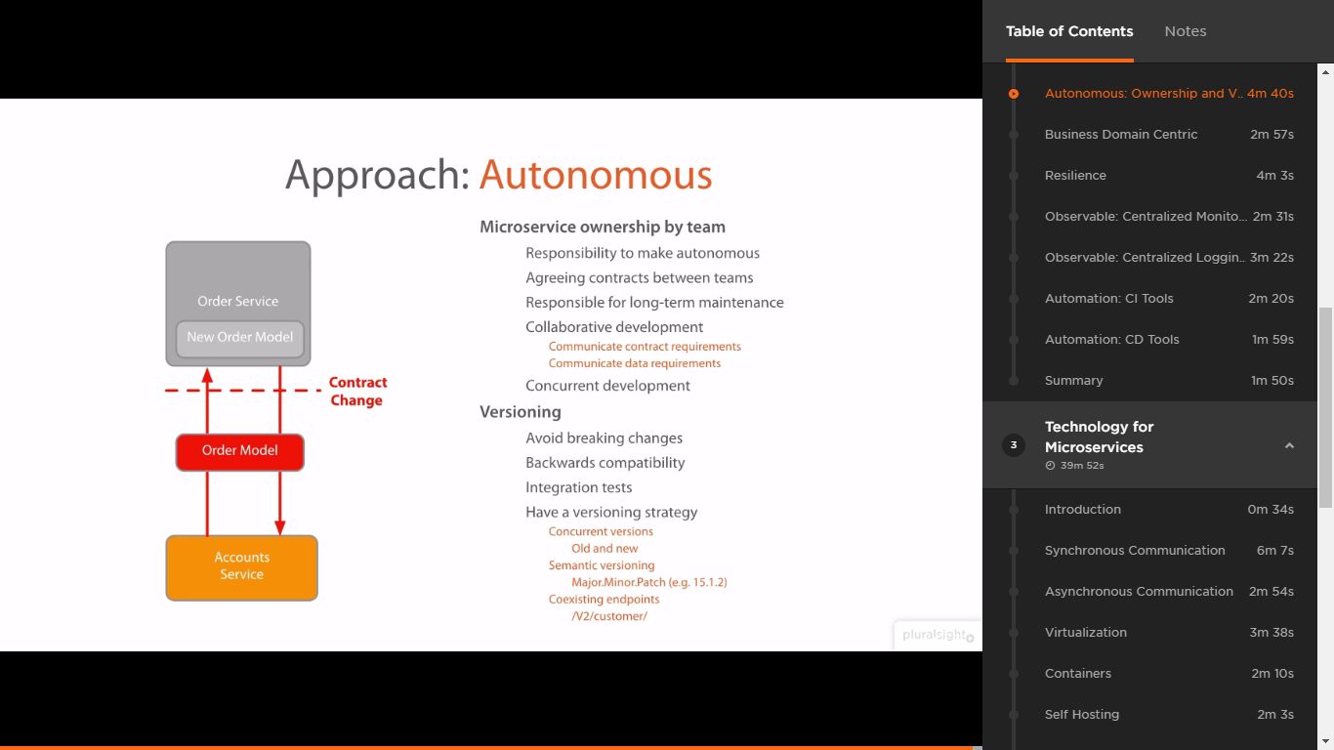

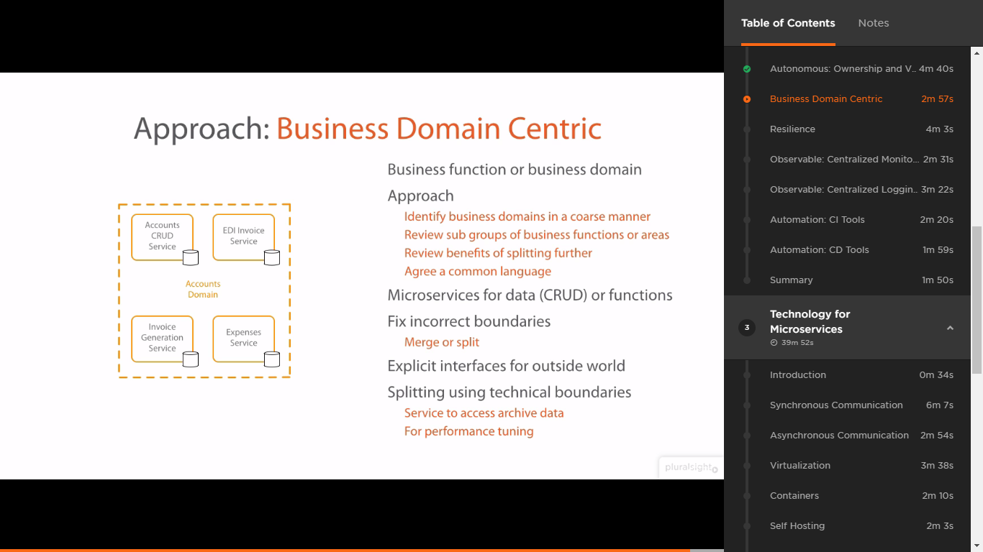

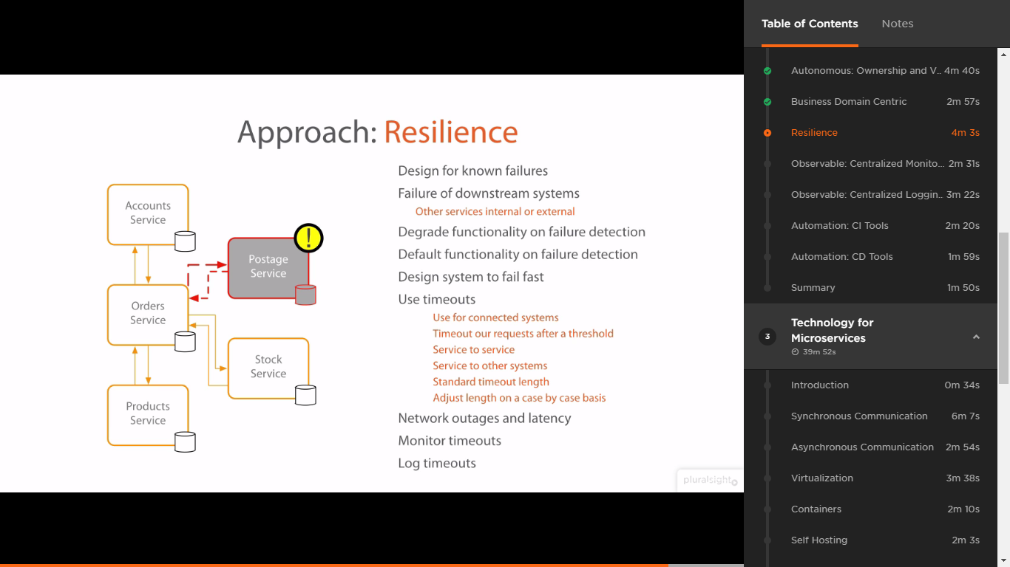

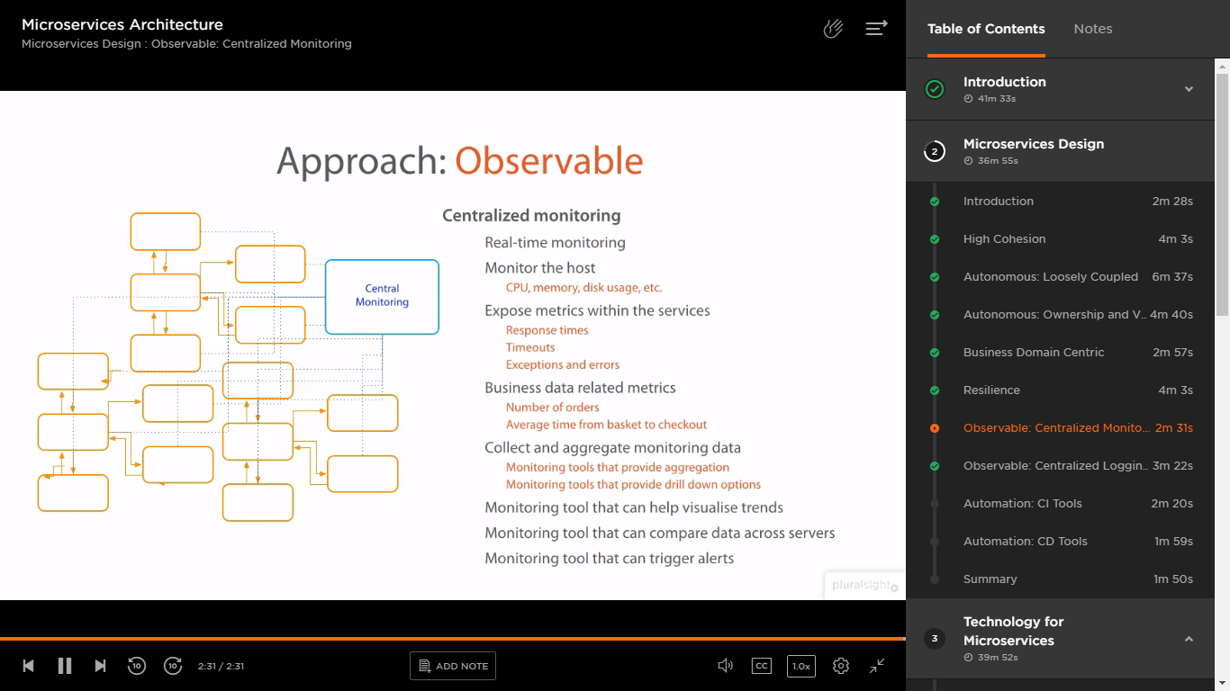

Monitoring – checking the numbers for performance etc.,

Logging – checking the reason for all the process. What? Why? When? Etc.,

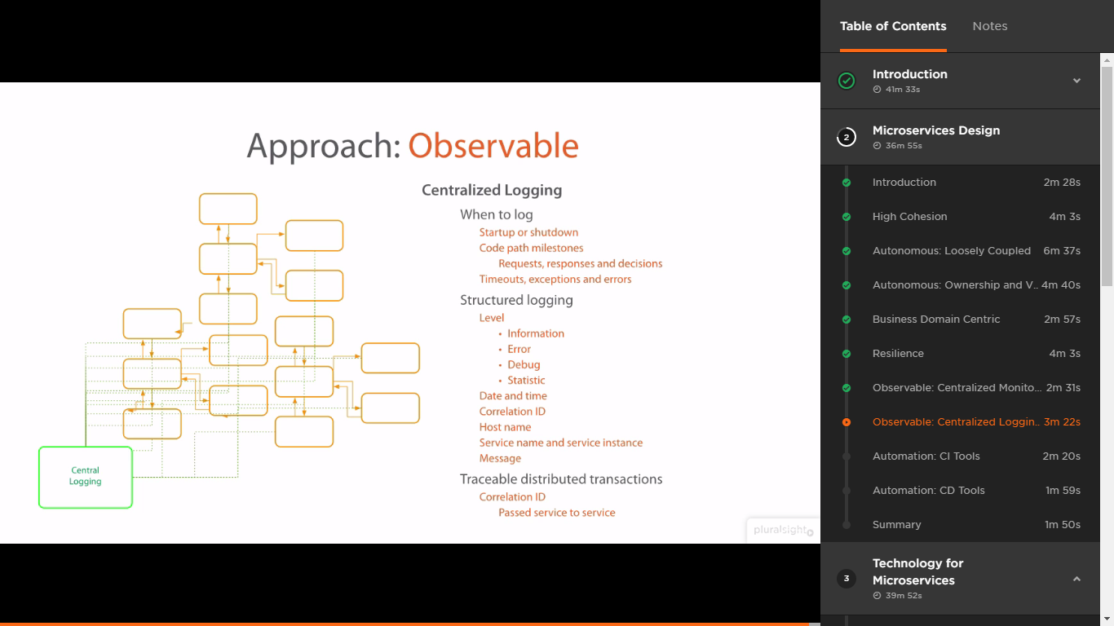

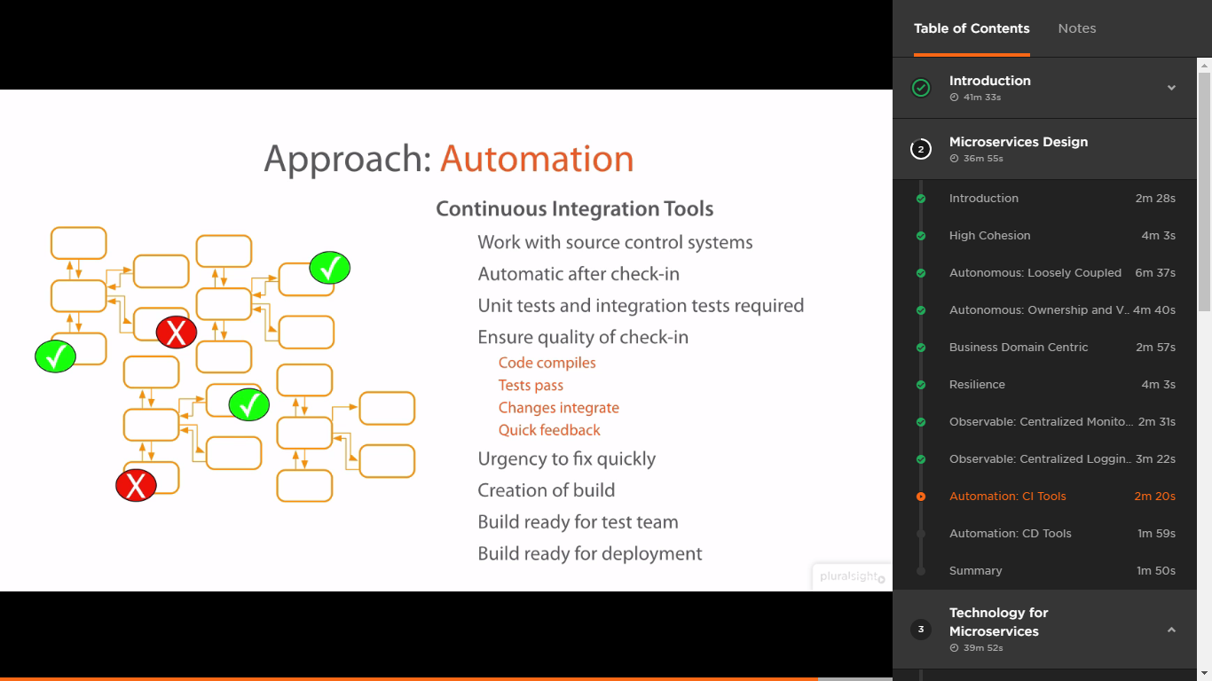

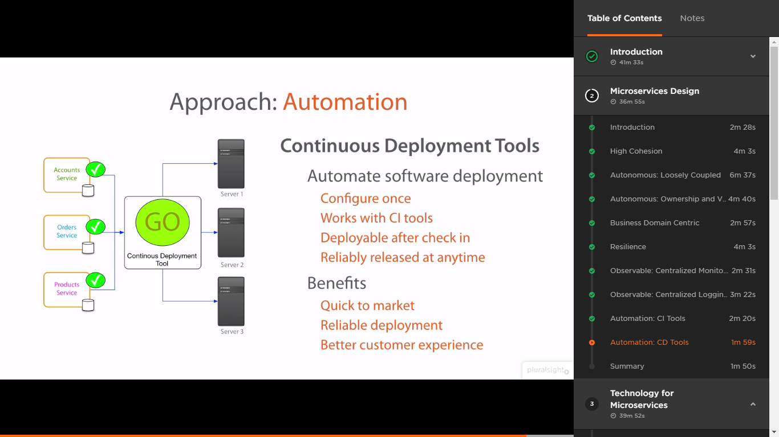

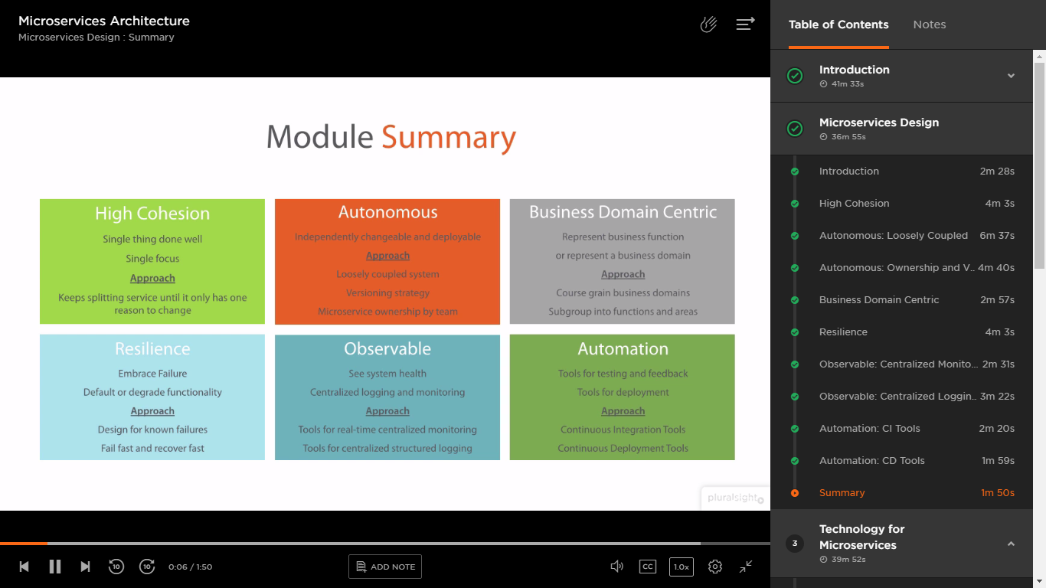

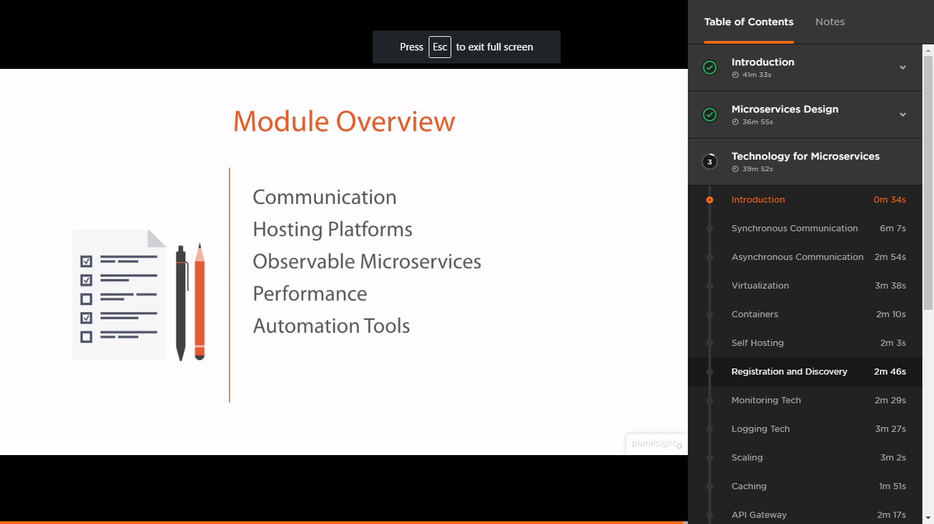

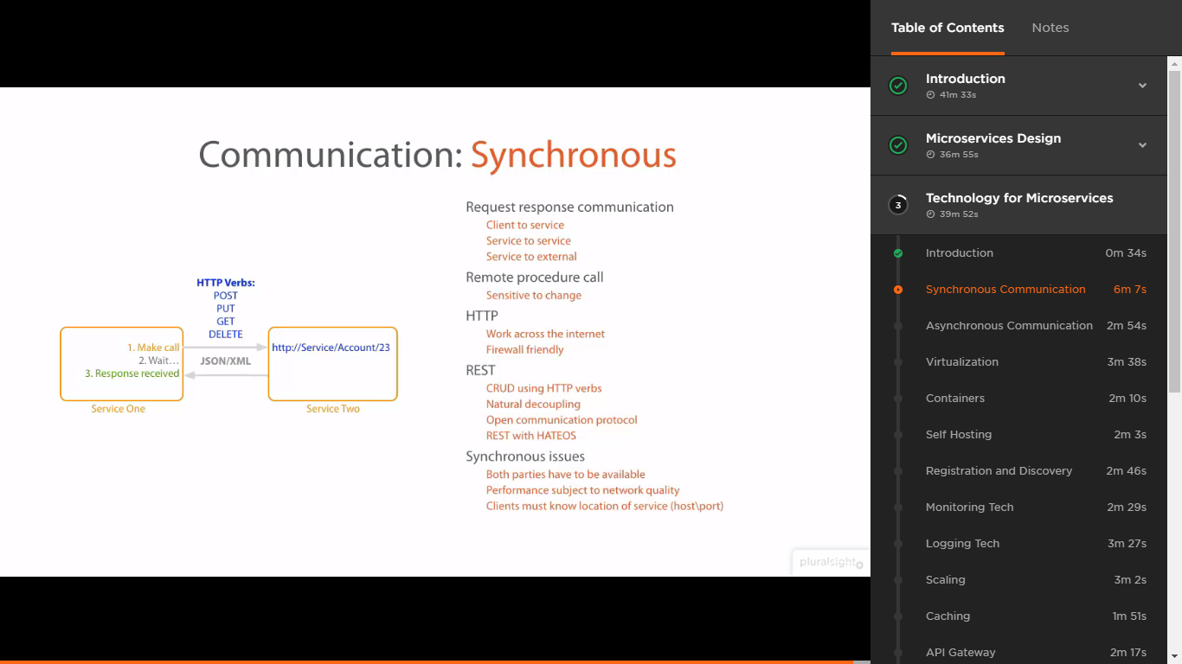

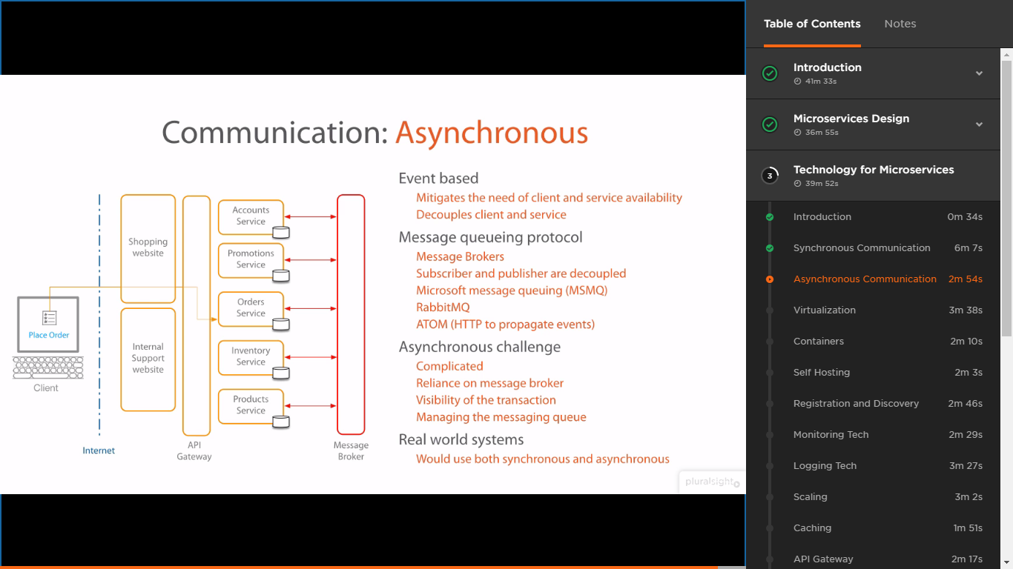

Virtual machines: A physical machine (or server) can have the multiple VMs. Advantage of VM is we can clone as multiple copies of the instance of one VM to other VM. So, we can create multiple instance of micro services easily while using VMs. Virtual machines are the foundation of multiple cloud platforms.

If we set up the cloud based infrastructure in one VM, which can be cloned to other VMs. I guess from VMs, OS also be copied.

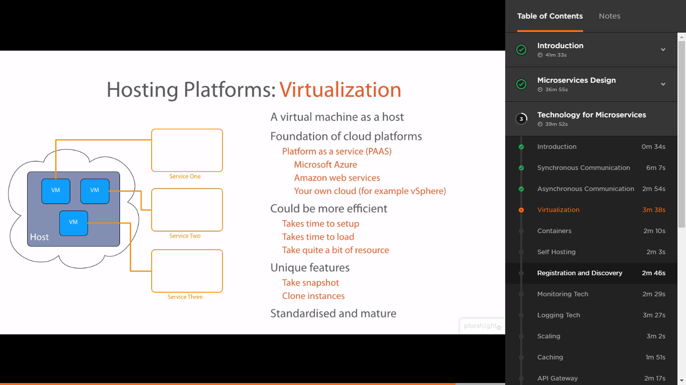

One more advantage is, we can take snapshot of a VM. Later we can set up other VM using this snapshot.

Containers don’t have the OS.

Action item: diff between VM and Containers.

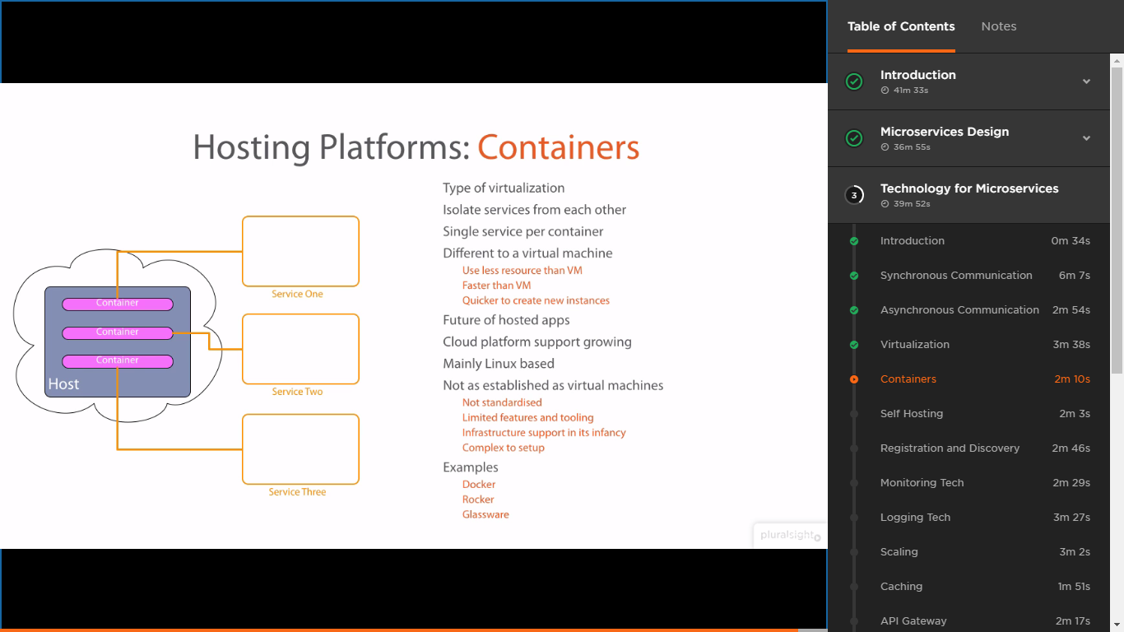

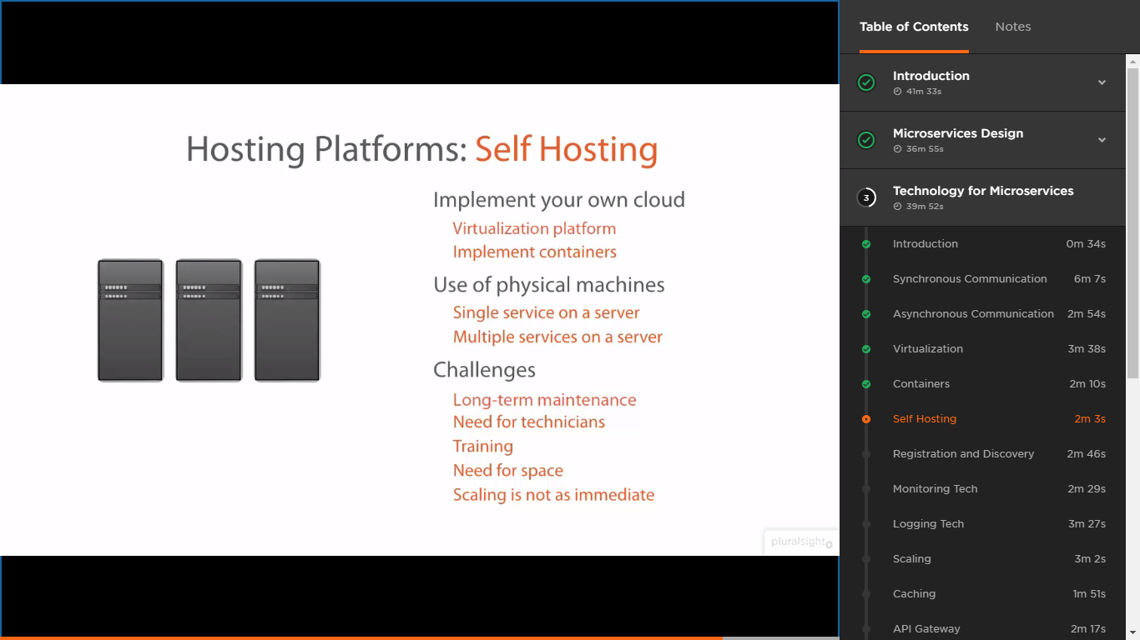

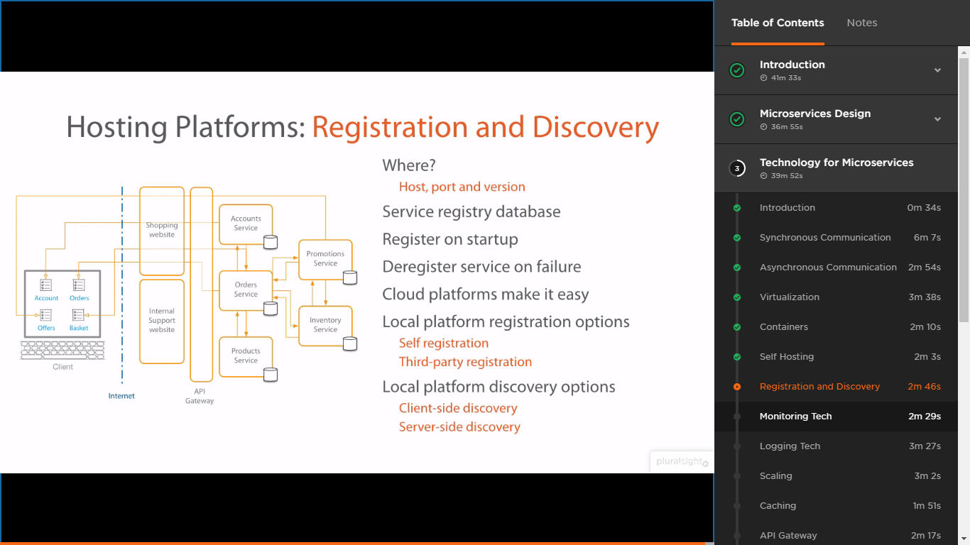

Client-side discovery – Client is directly connecting to service registry database in order to find the location of the service.

Server-side discovery – Gateway or Load balancer is connecting to service registry database in order to find the location of the service.

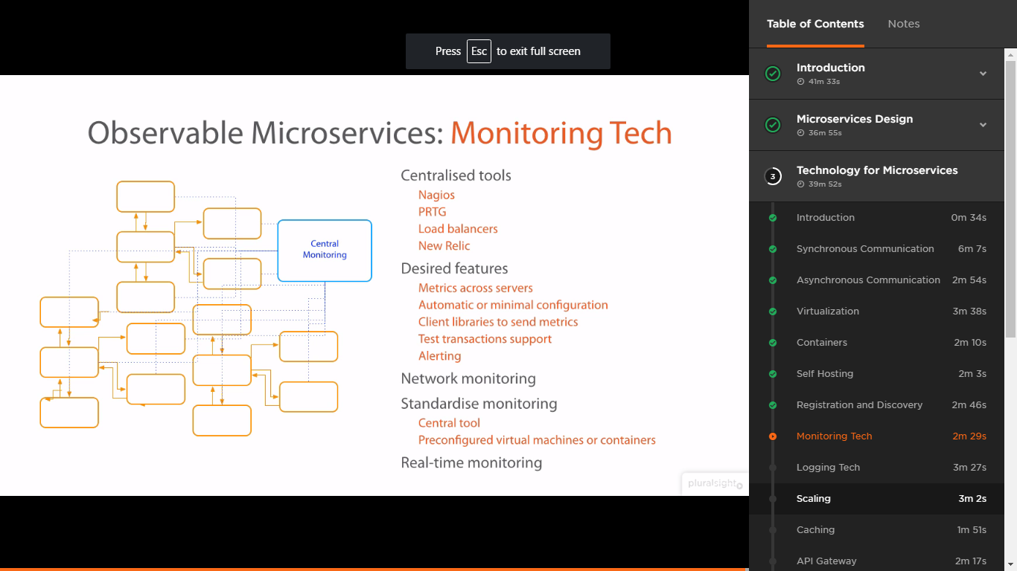

Lot of centralized tools available to store the log information of micro services. Transaction, Context or correlation ID we can use to get the log information from the centralized tools.

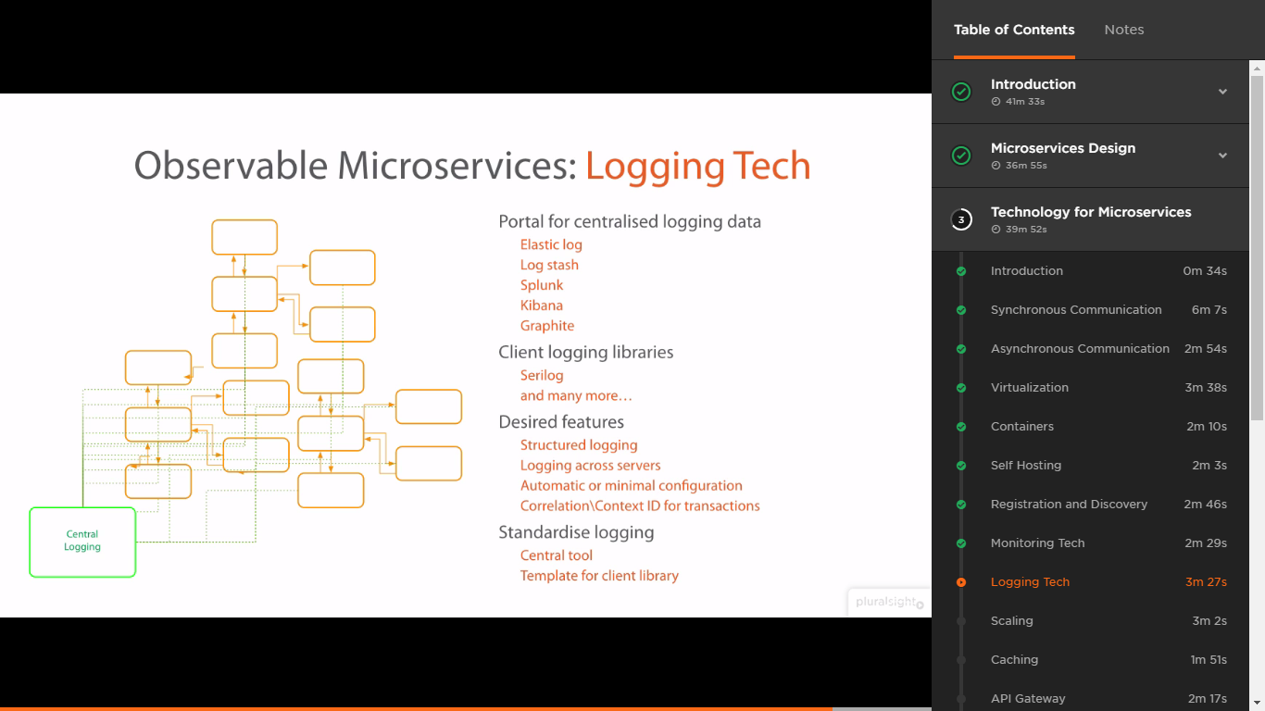

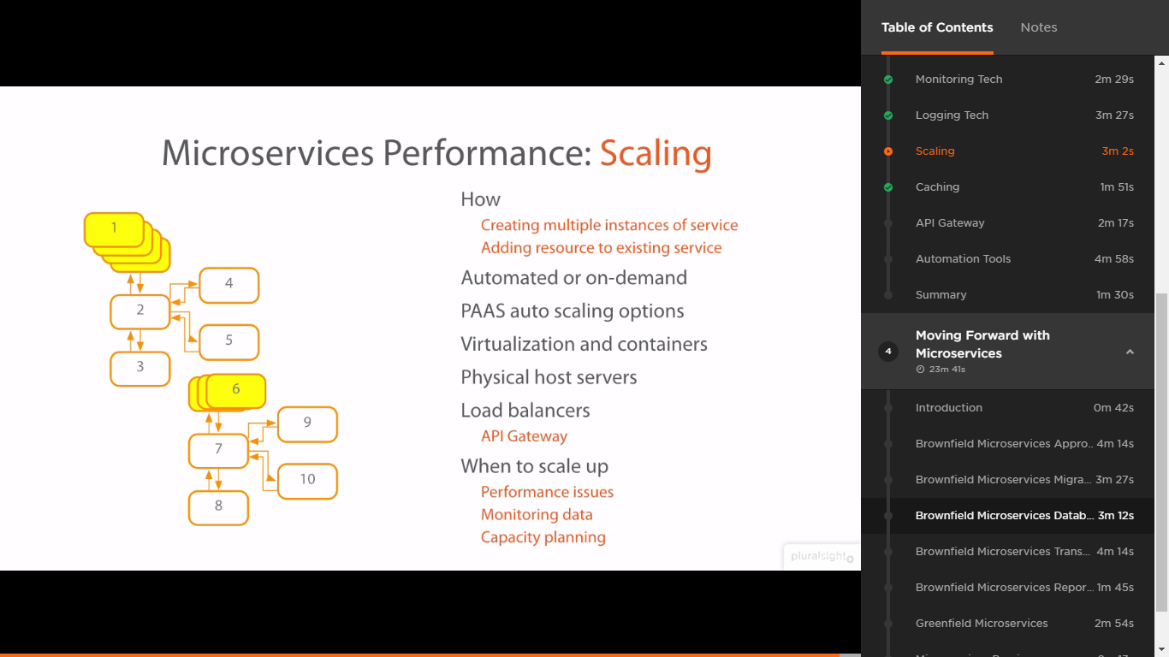

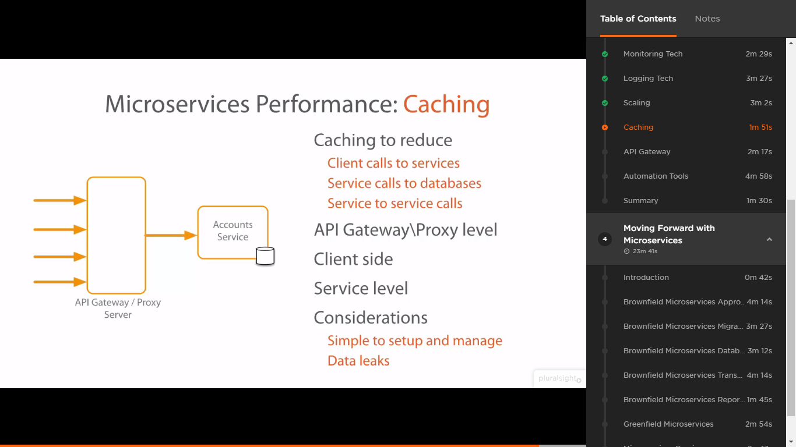

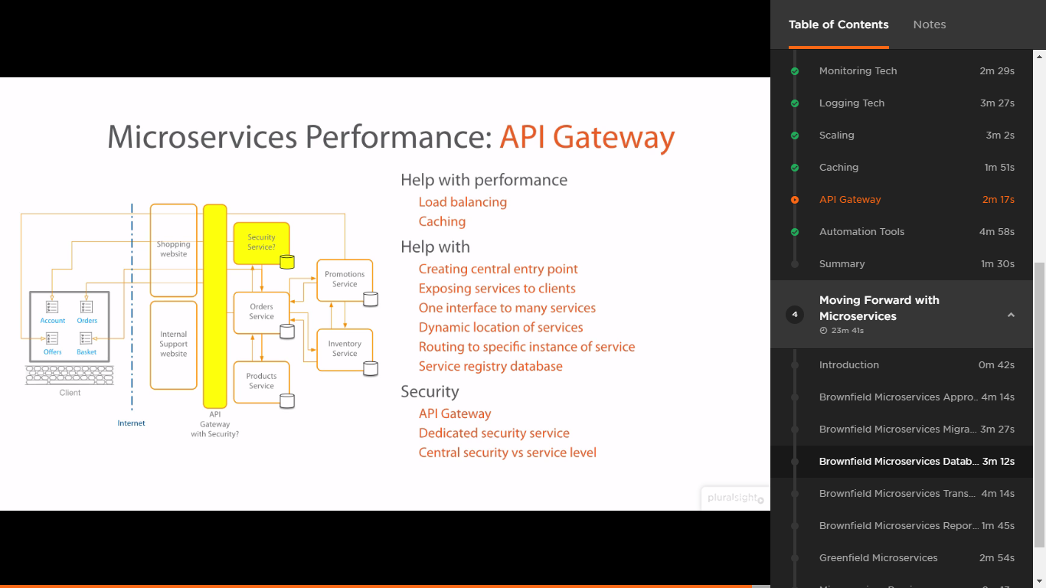

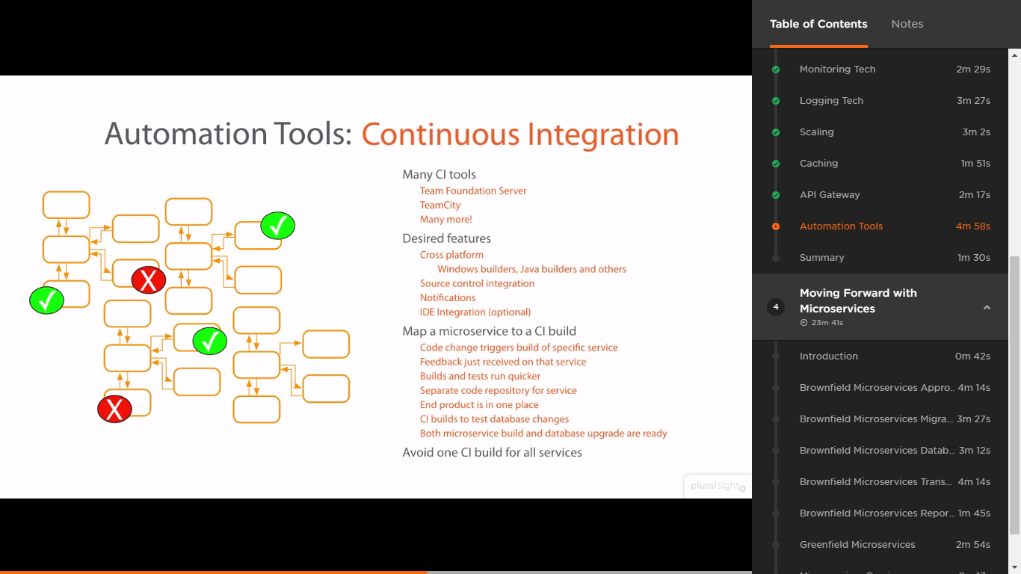

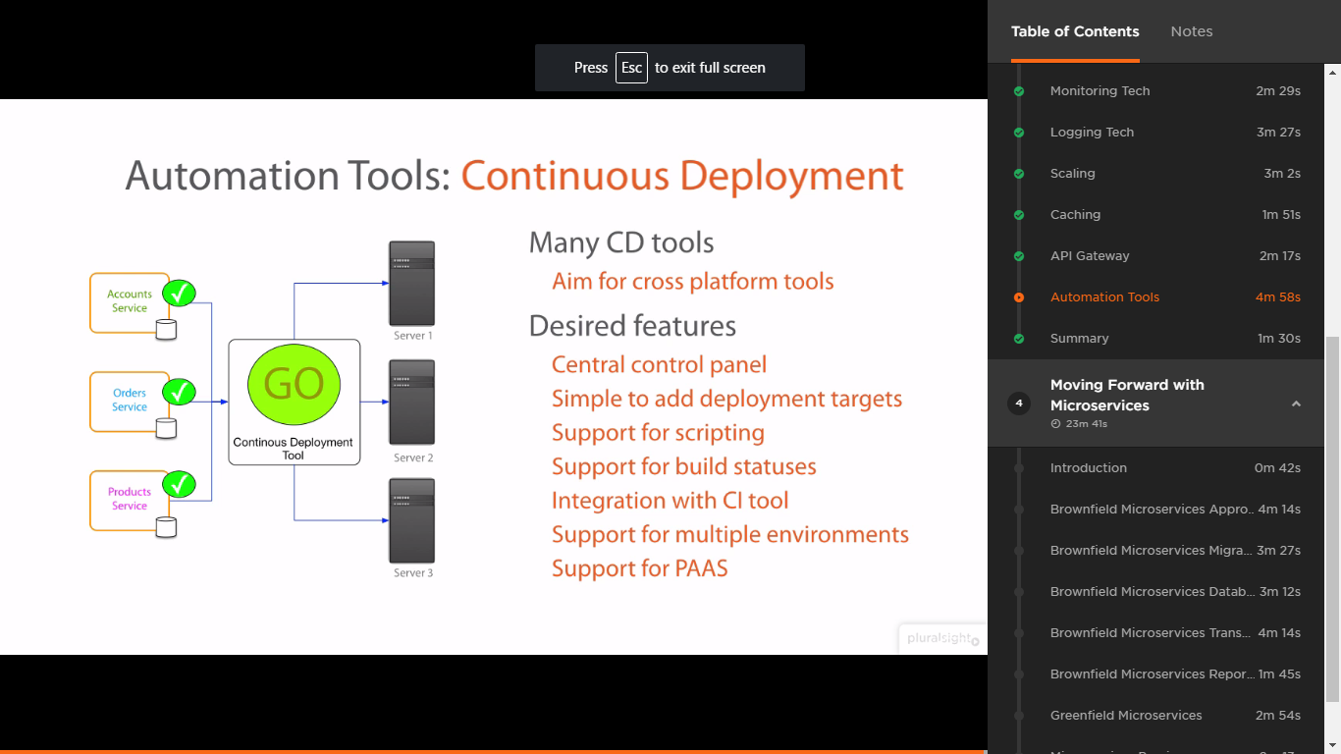

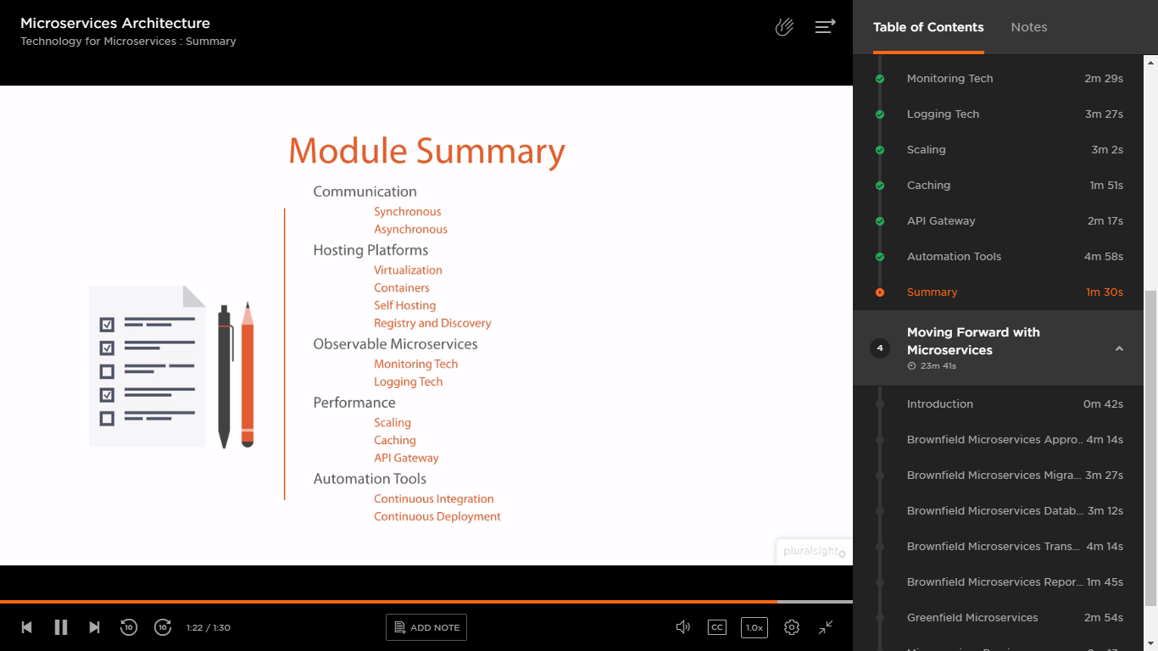

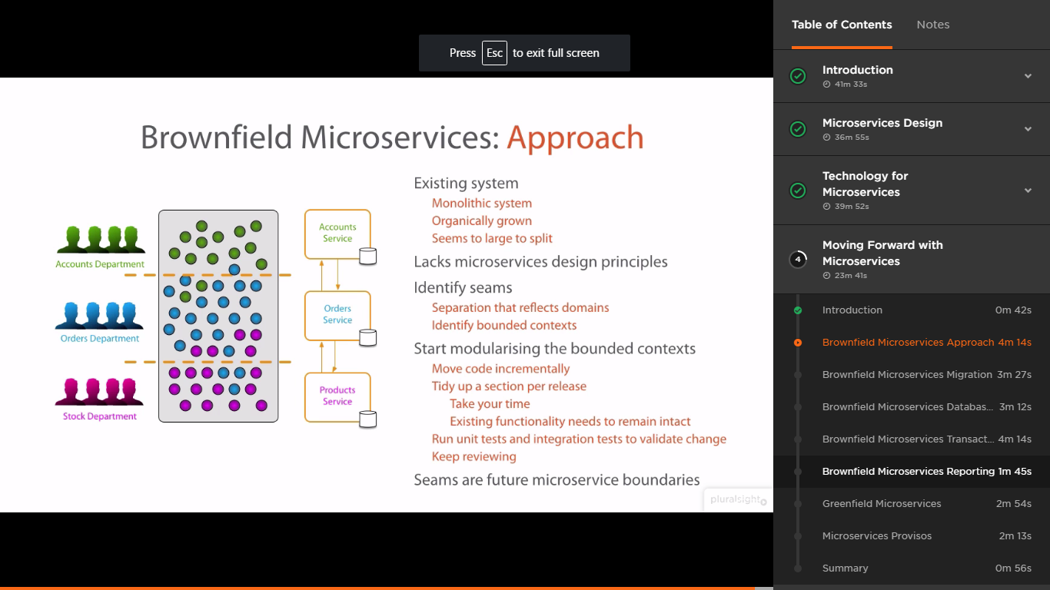

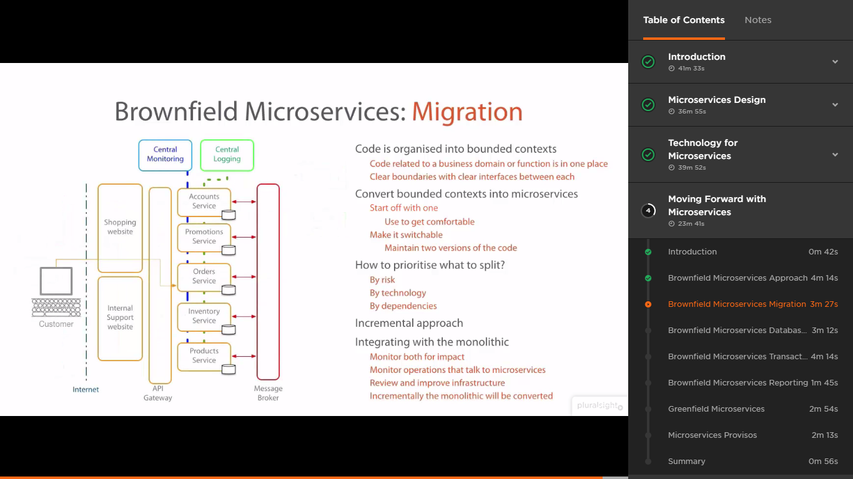

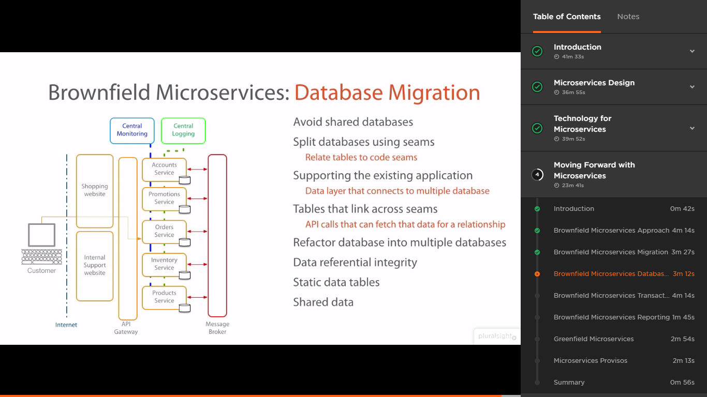

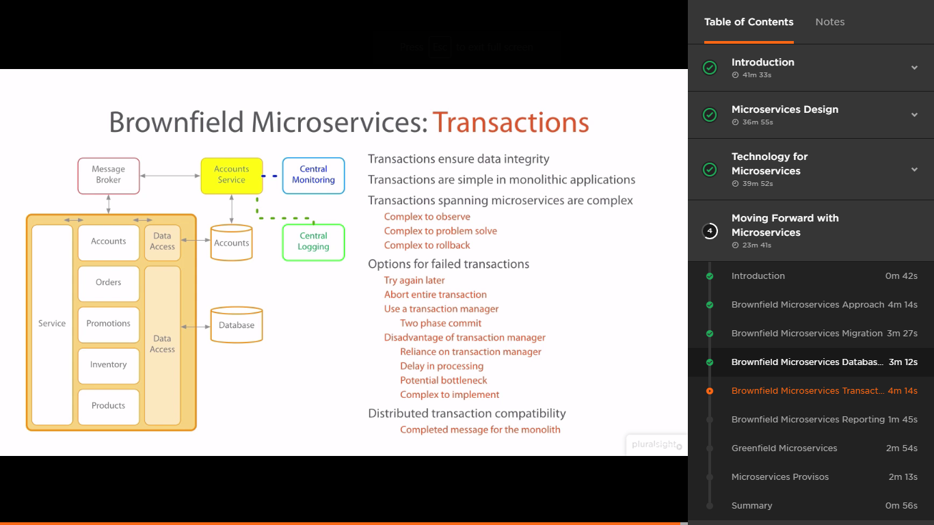

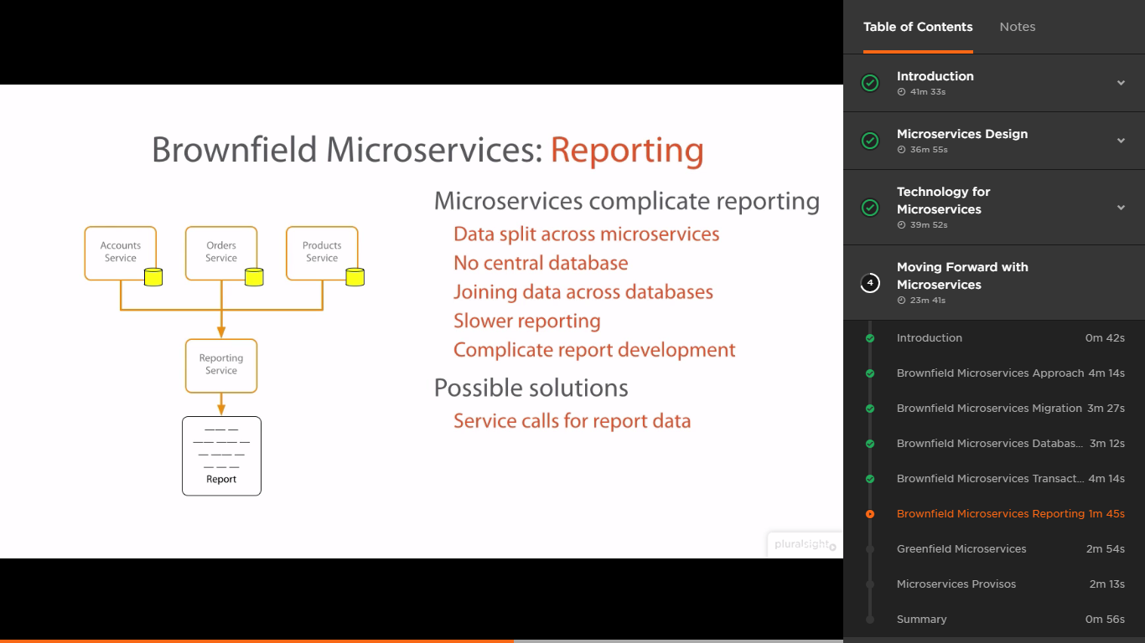

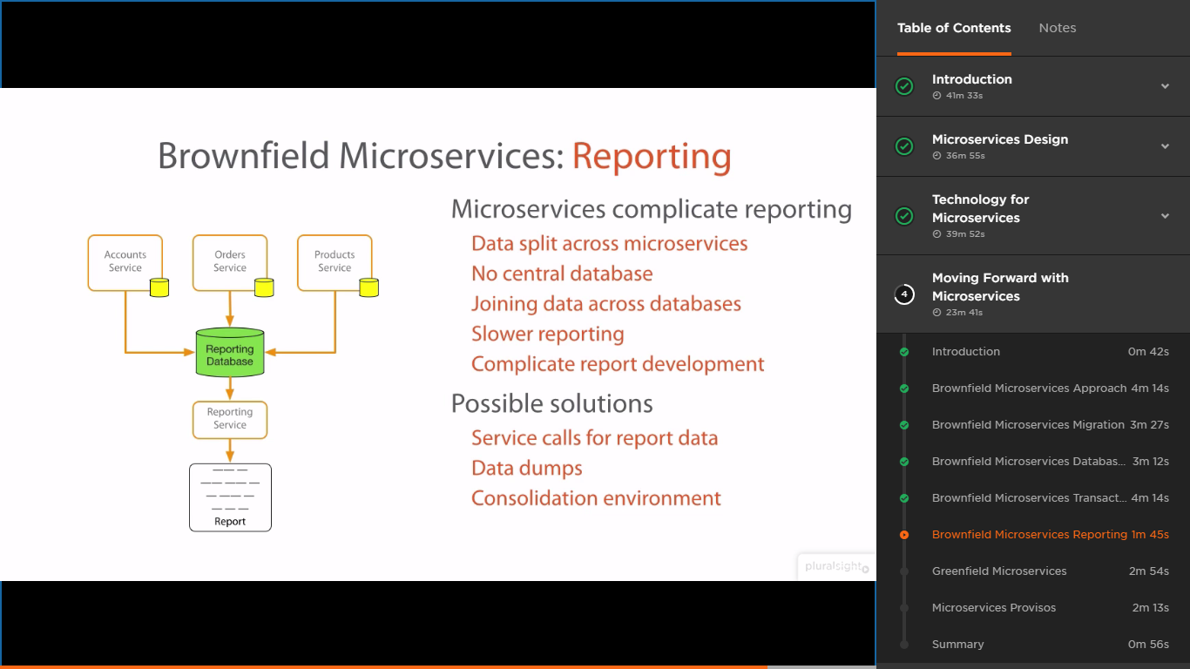

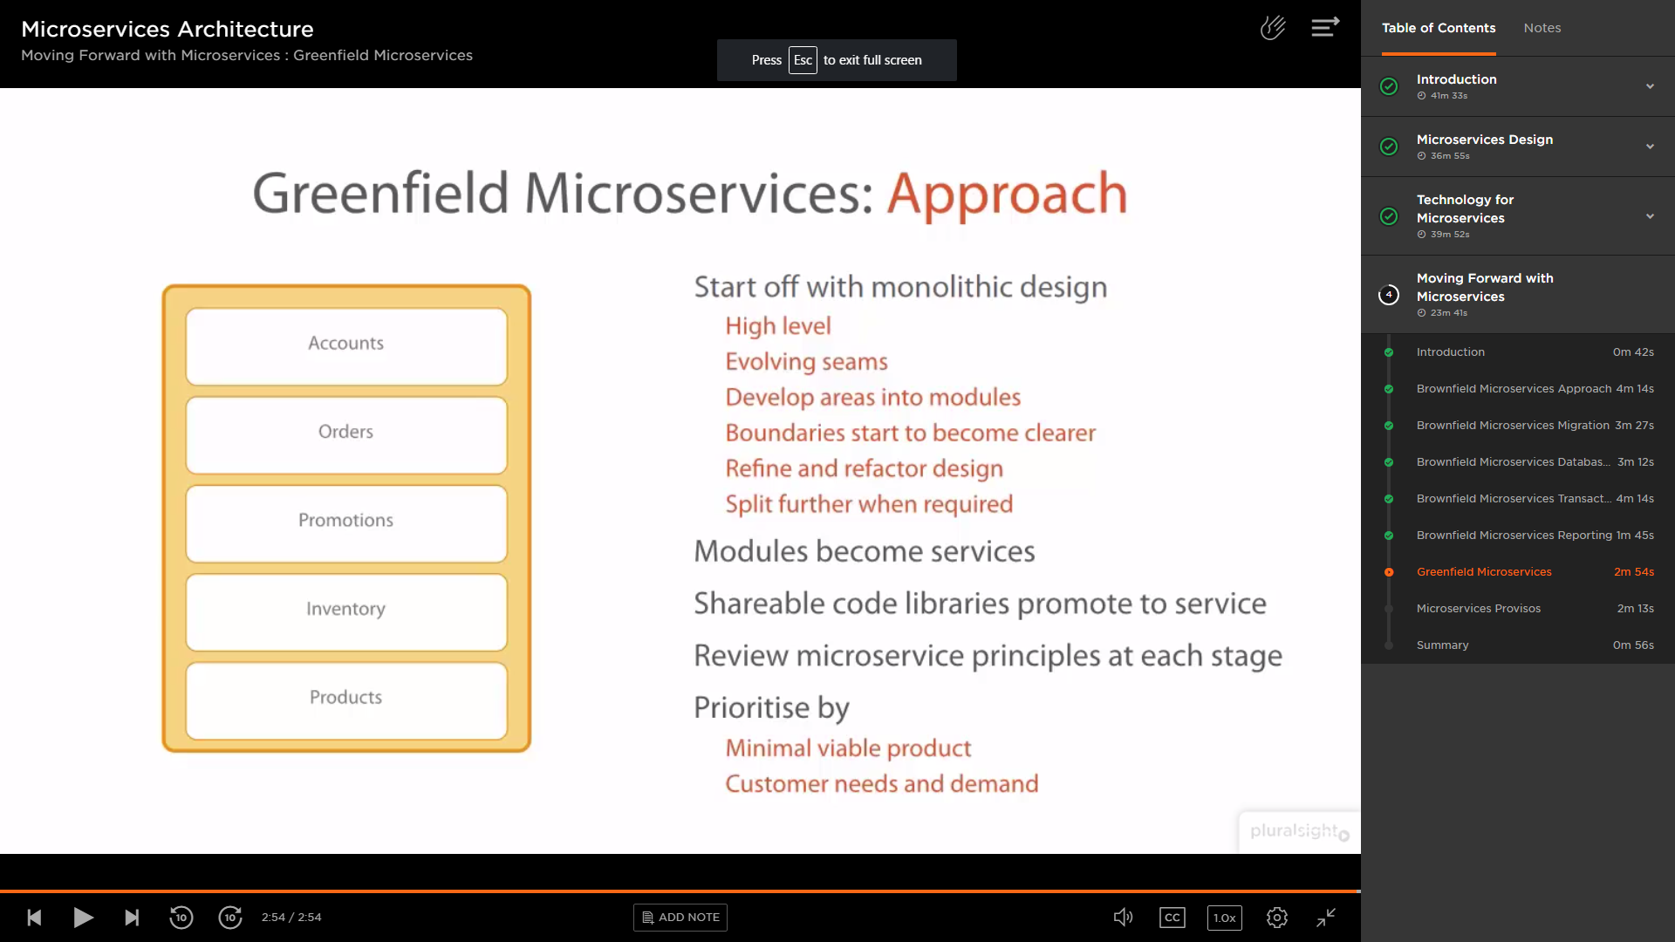

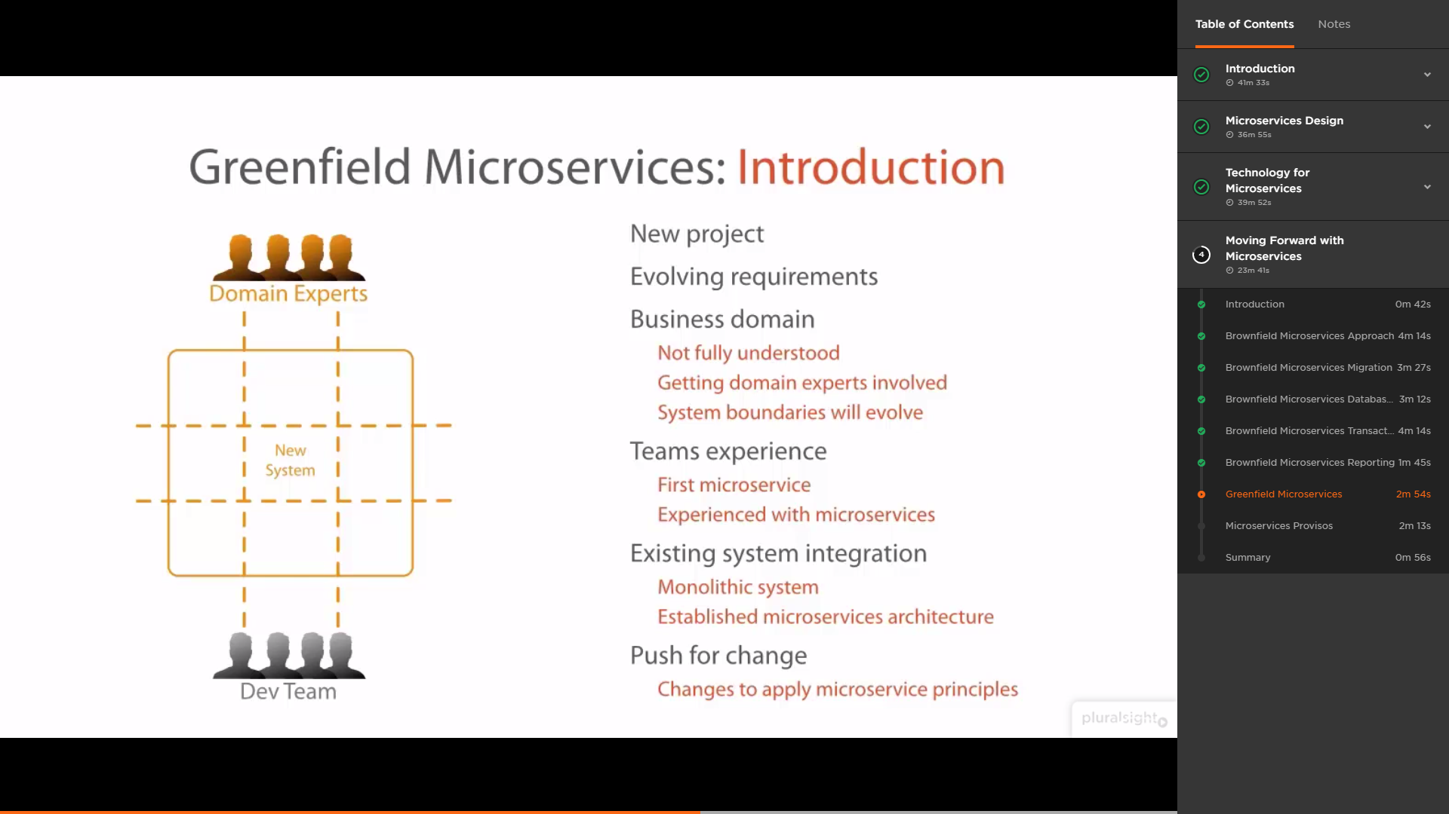

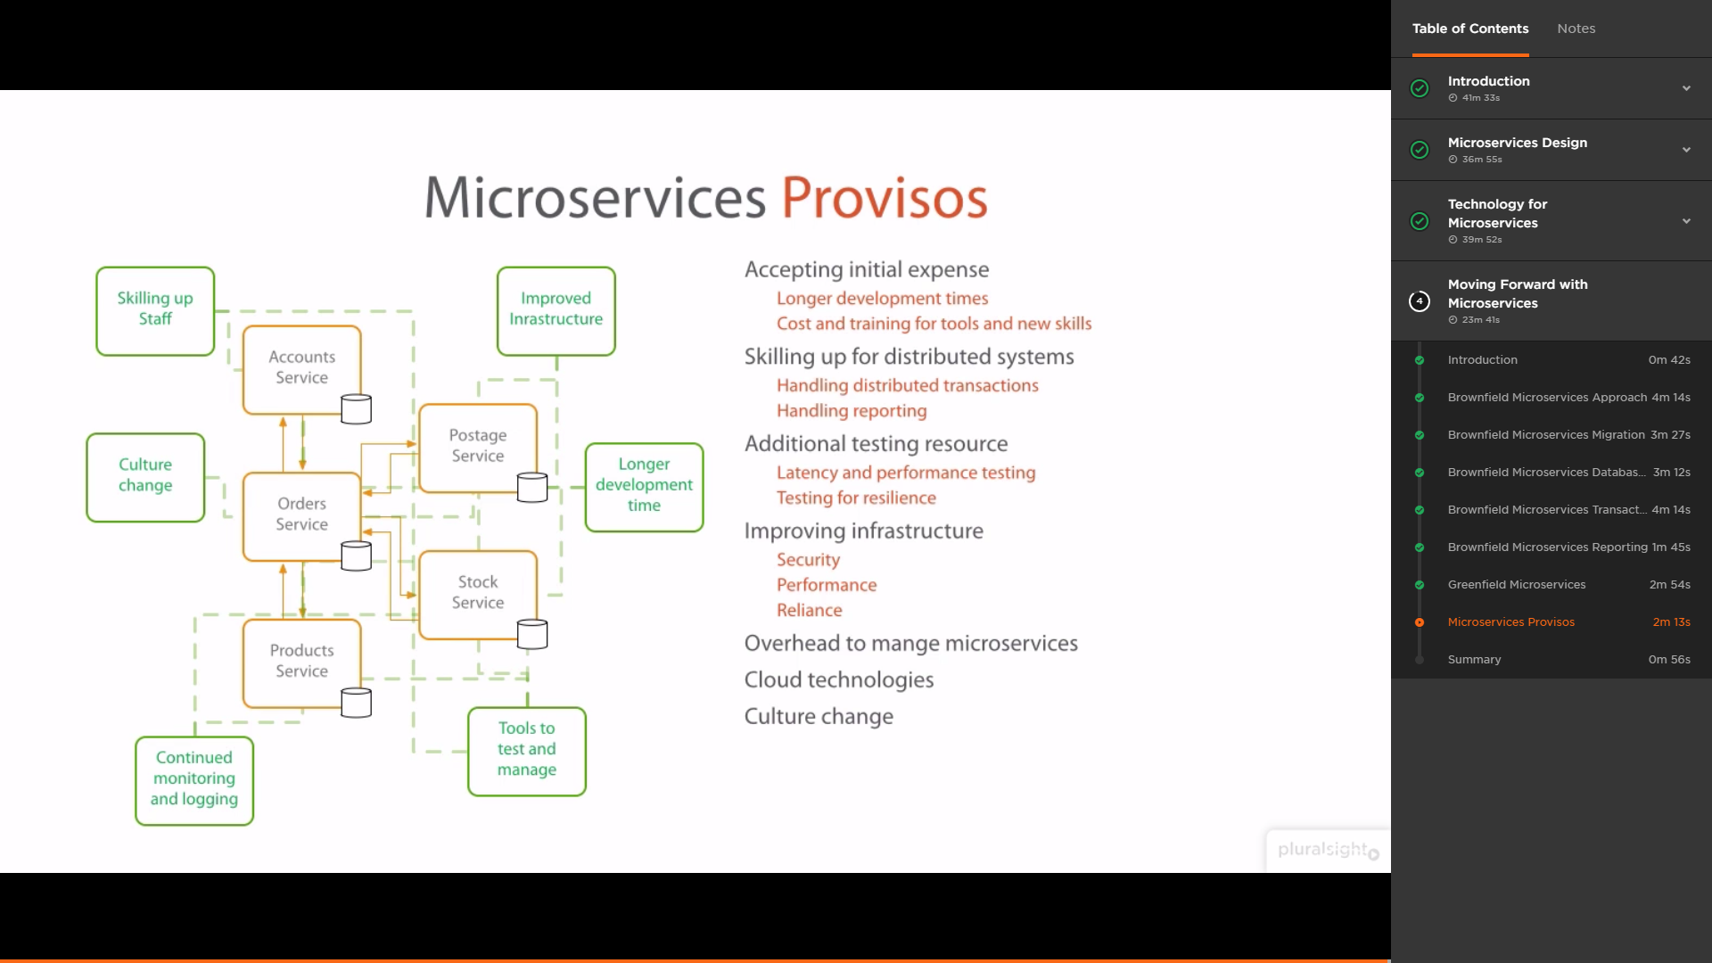

[Java Microservices with Spring Cloud: Developing Services](https://www.pluralsight.com/courses/java-microservices-spring-cloud-developing-services)

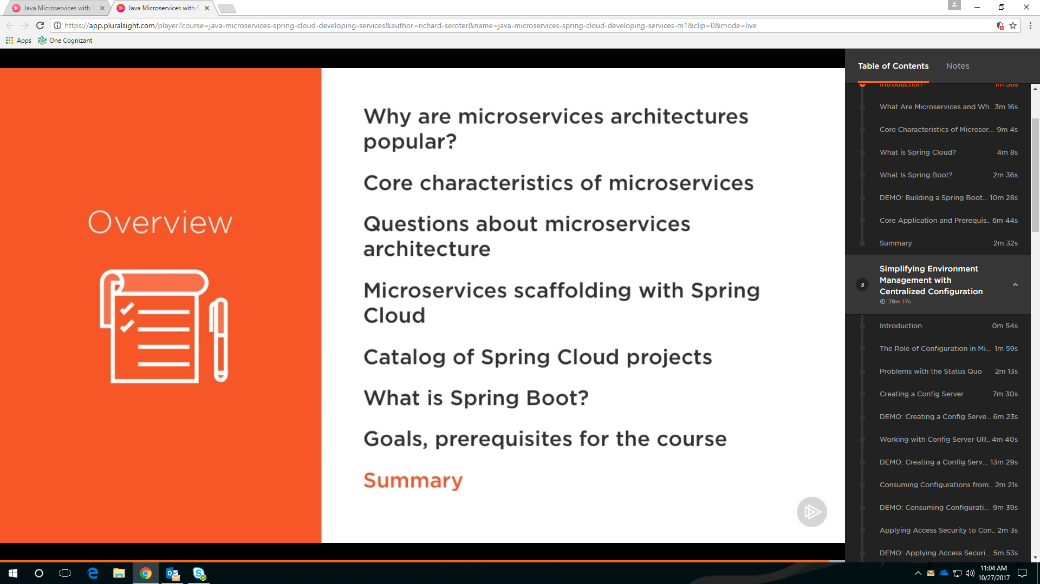

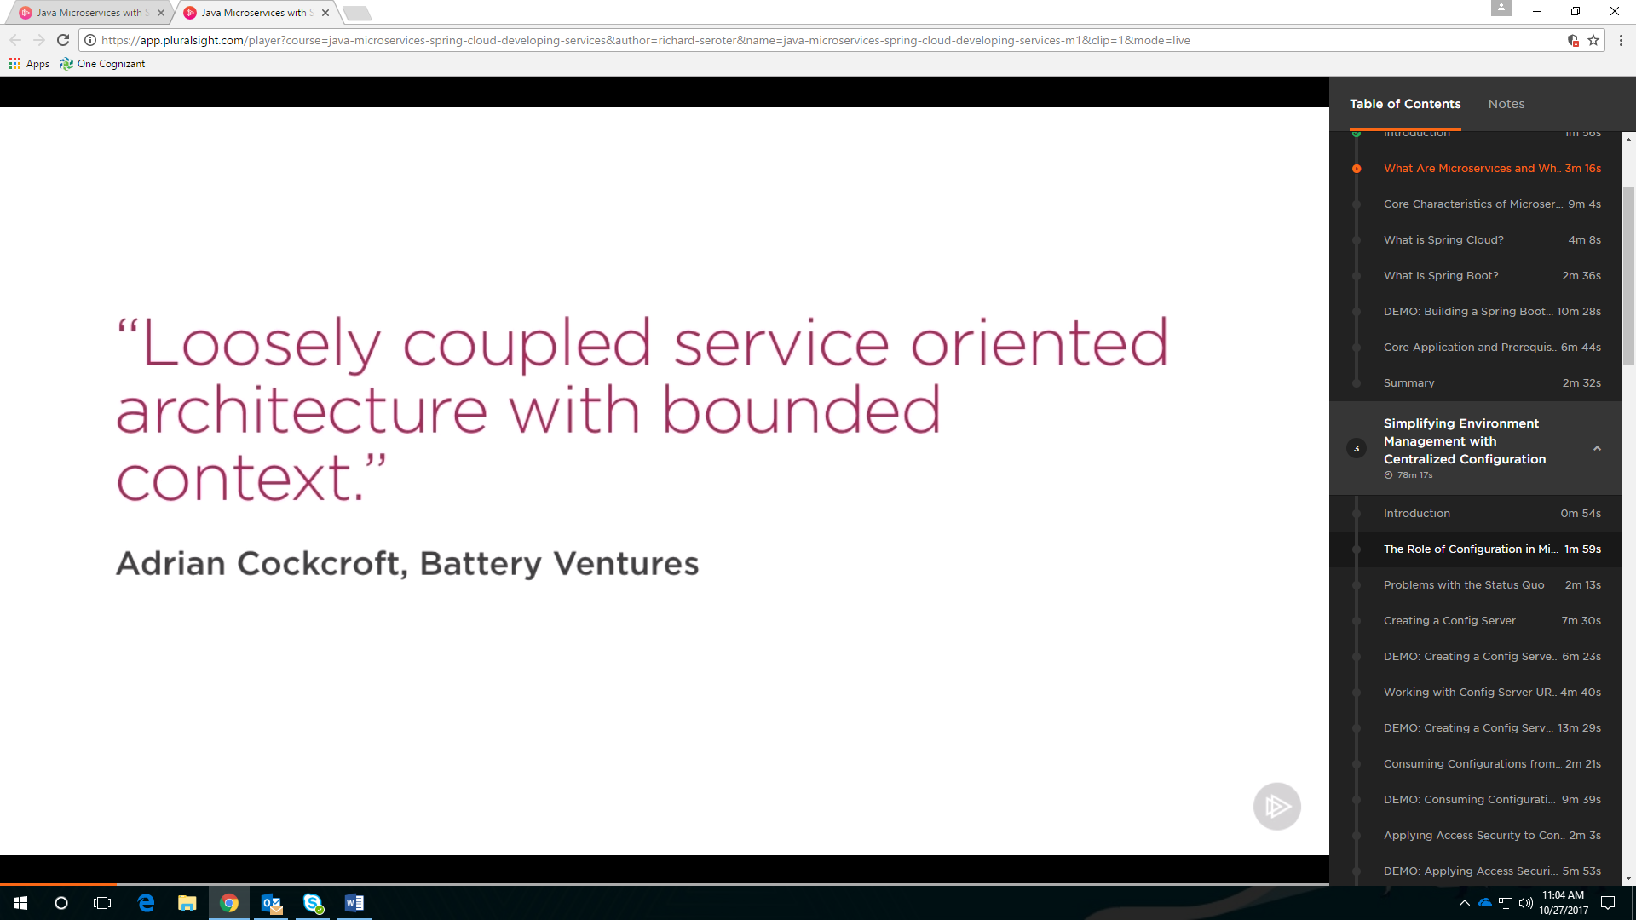

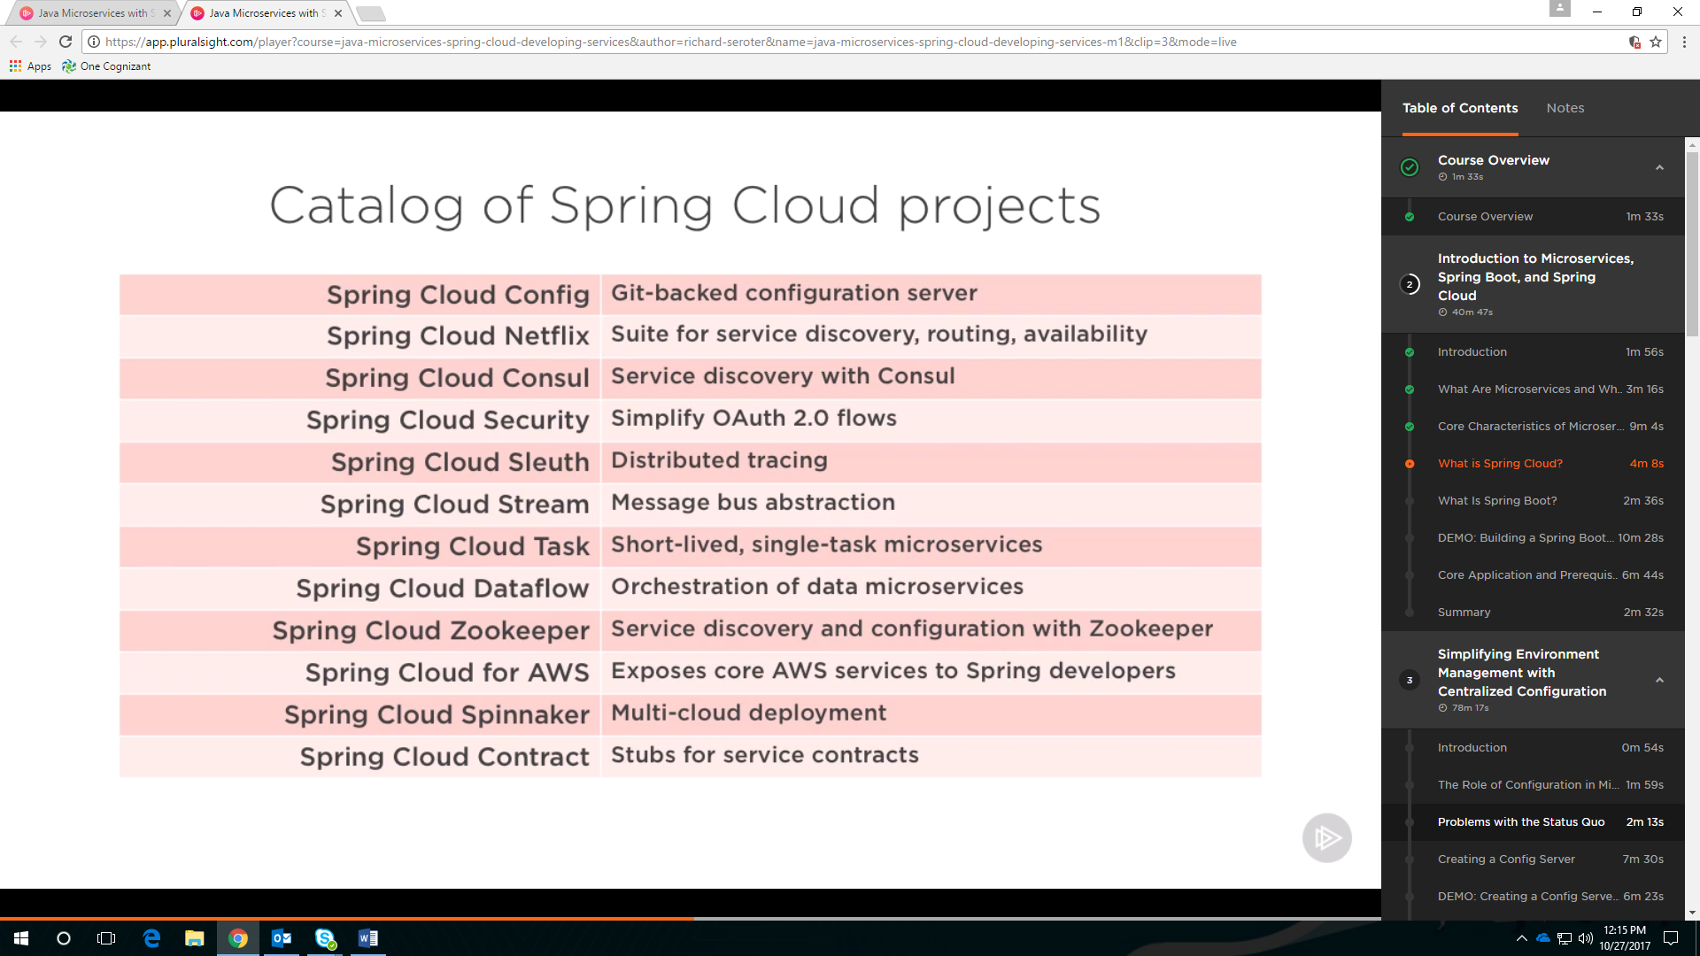

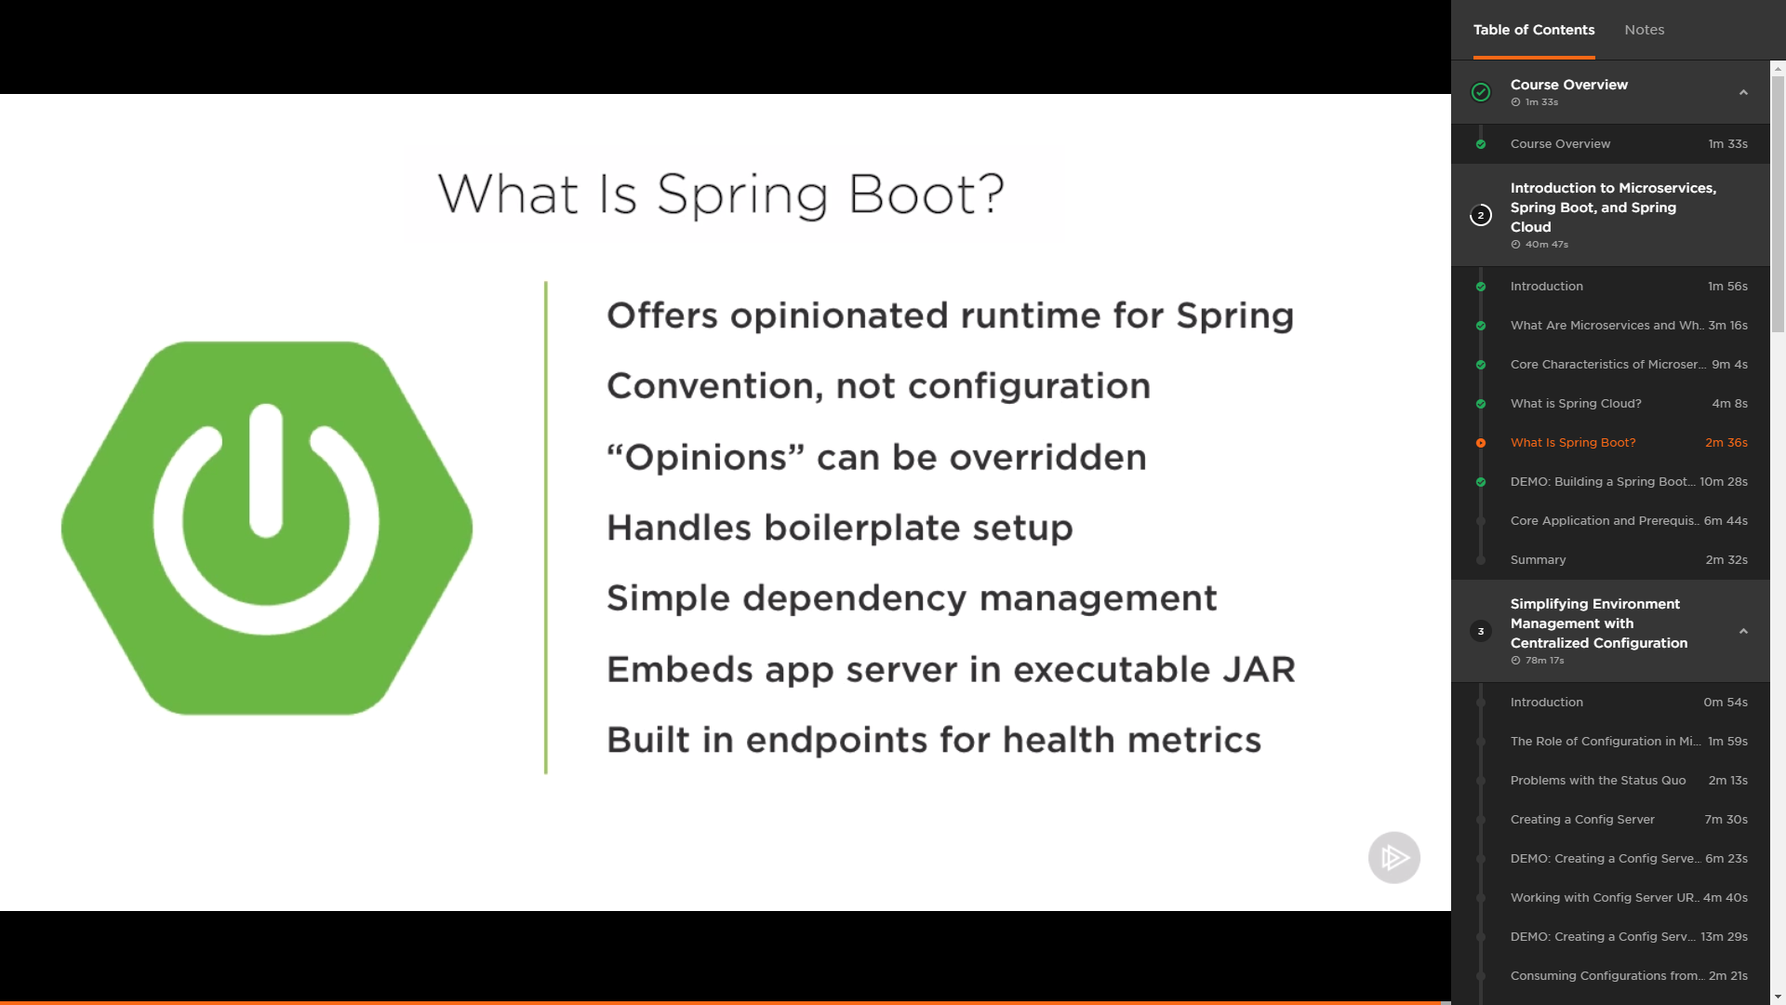

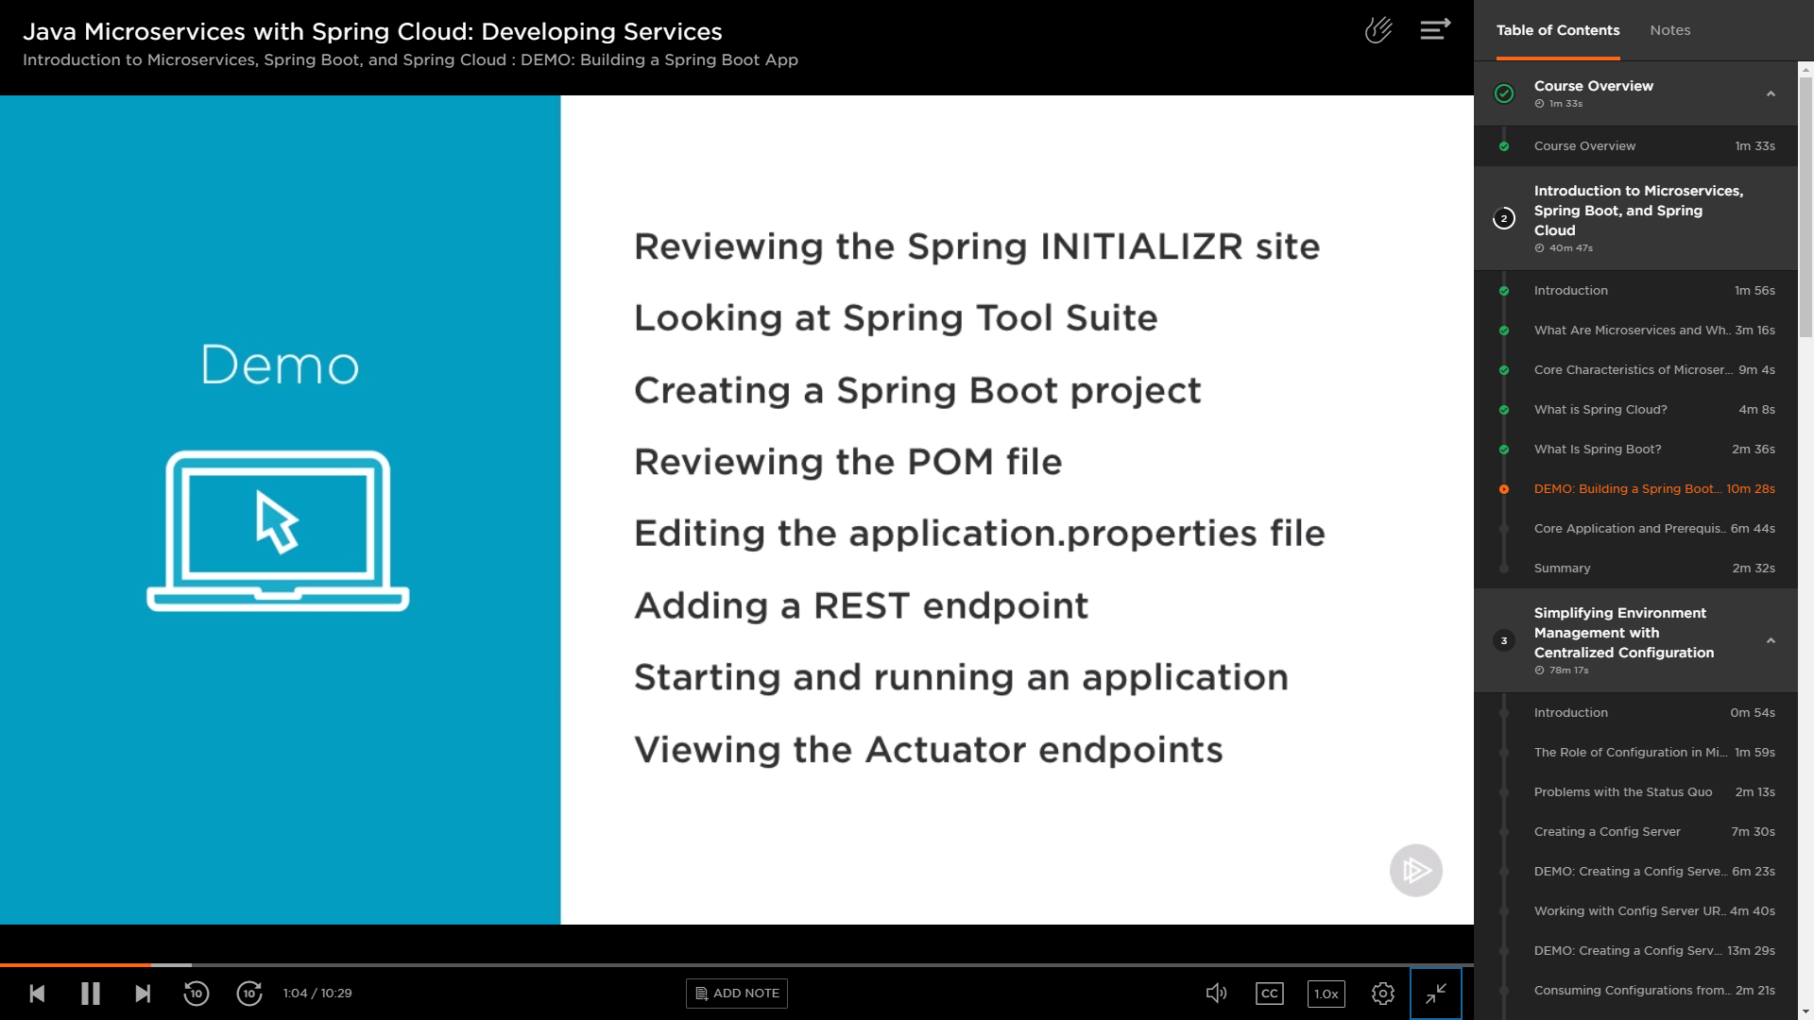

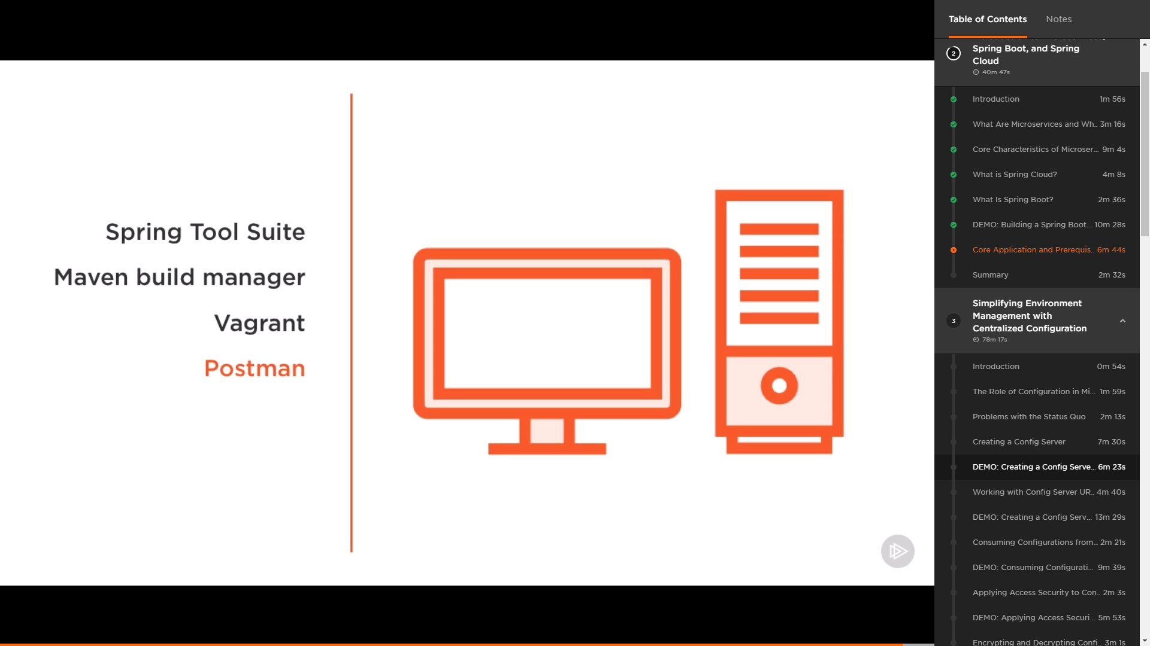

https://www.youtube.com/watch?v=rlS9eH5tEnY&pbjreload=10

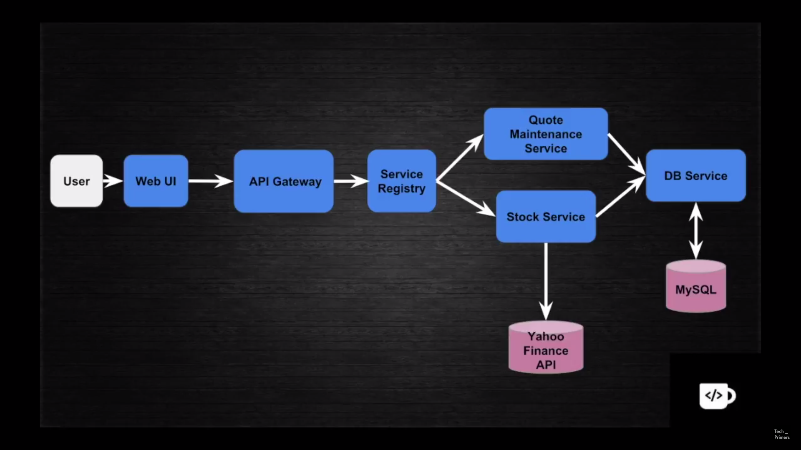

Spring cloud = Spring boot application + Zuul proxy

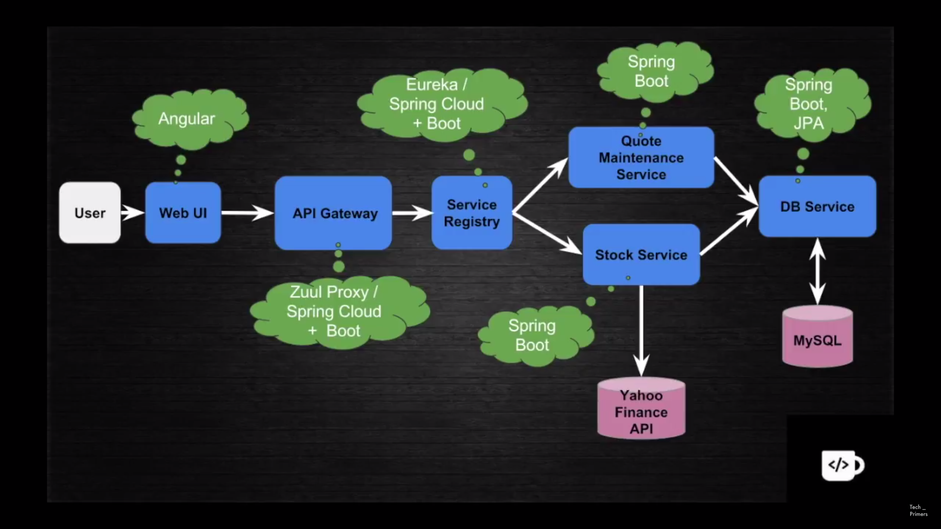

Eureka helps to do the service registry.

1. Register the name against the service URL.
2. Do the load balancing if we have multiple instances of the same service. Eureka works as a local load balancer.

<https://www.youtube.com/watch?v=rlS9eH5tEnY&pbjreload=10>

Eureka discovery dependency has to be added for Eureka Client (Stock service, Quote maintenance service).

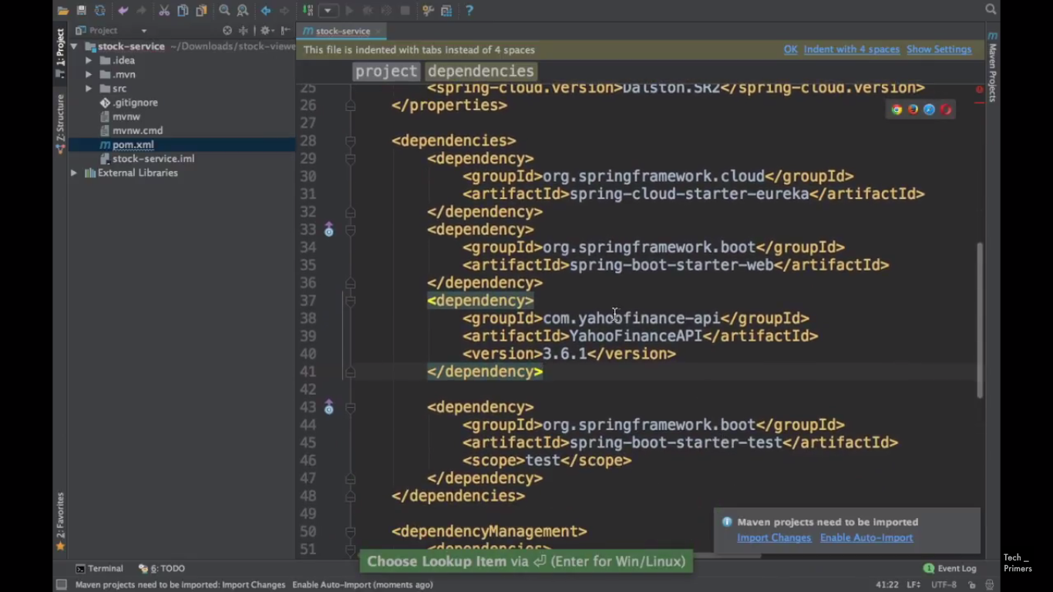

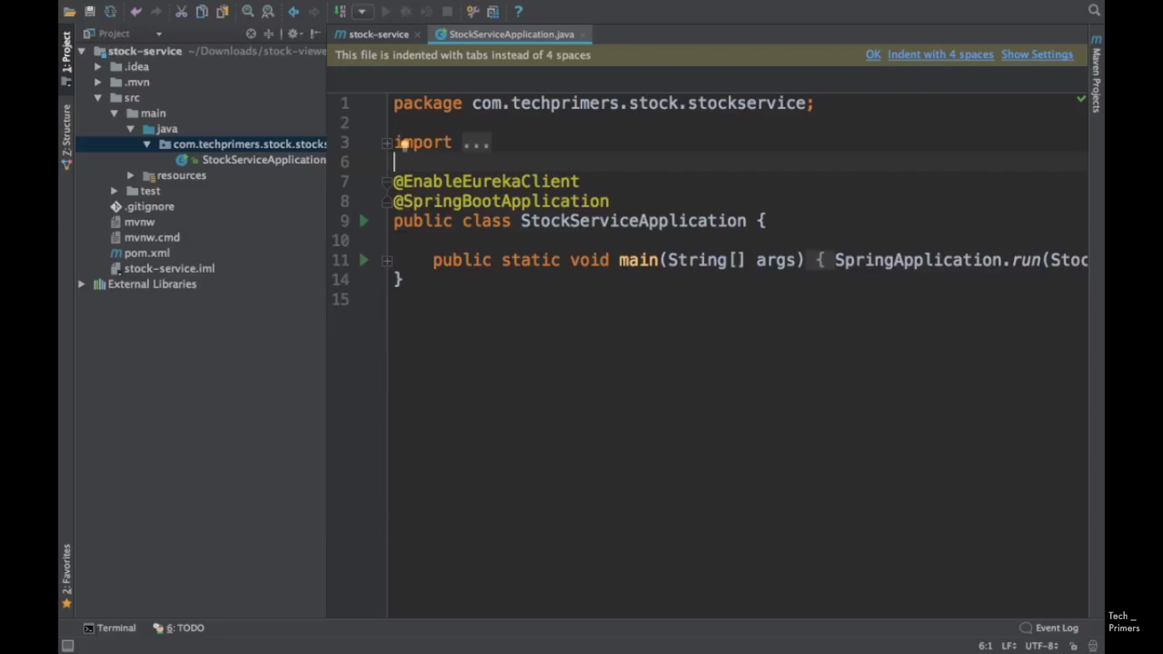

Eureka server is running in port 8070.

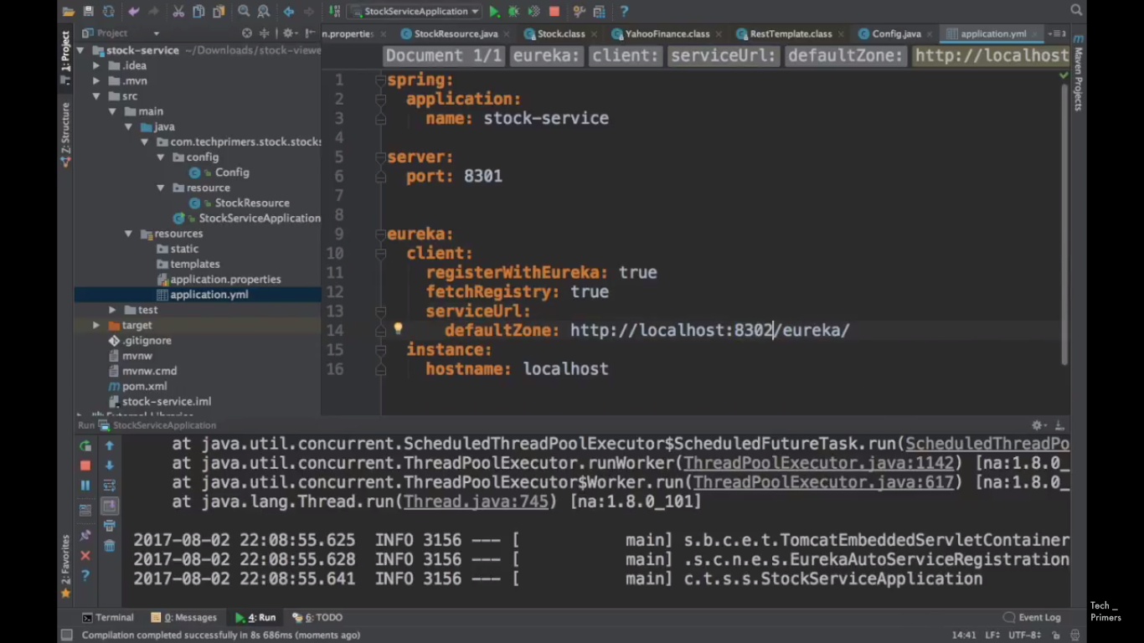

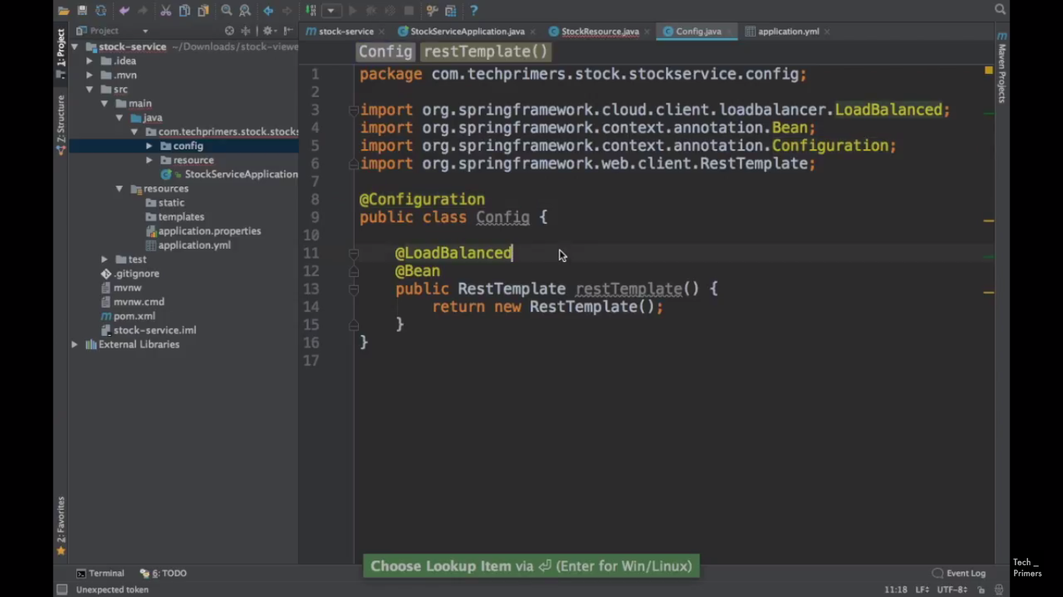



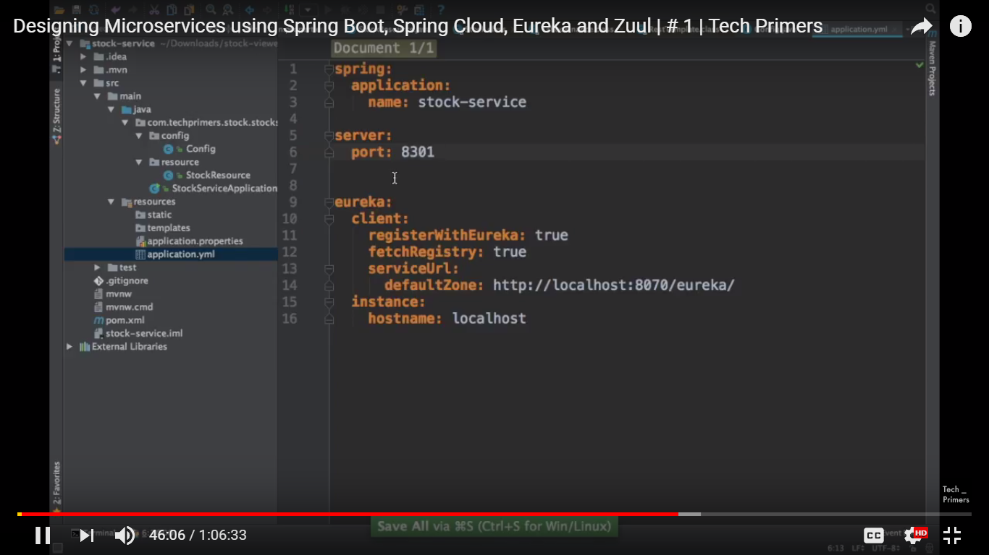

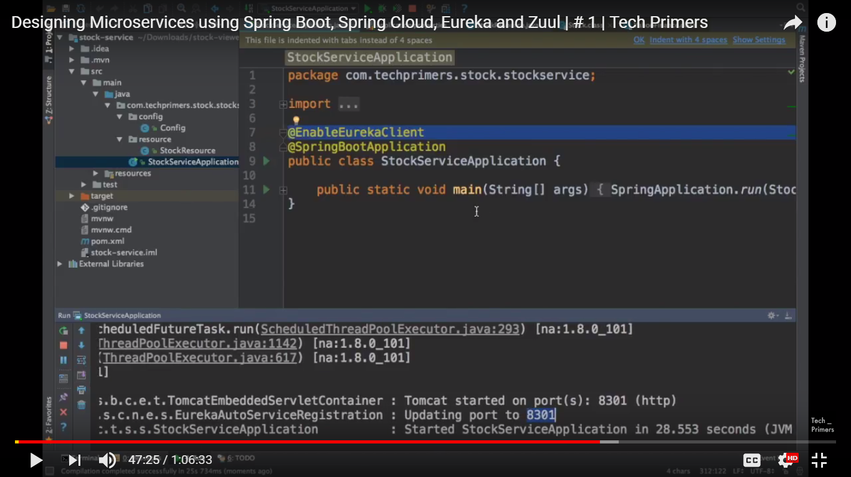

DB service is up in the 8300.

@LoadBalancer will be working fine if the project is created as a Euraka client-server application. Else, it will throw error.

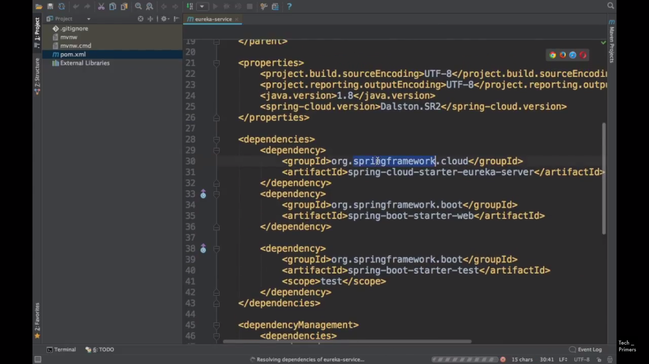

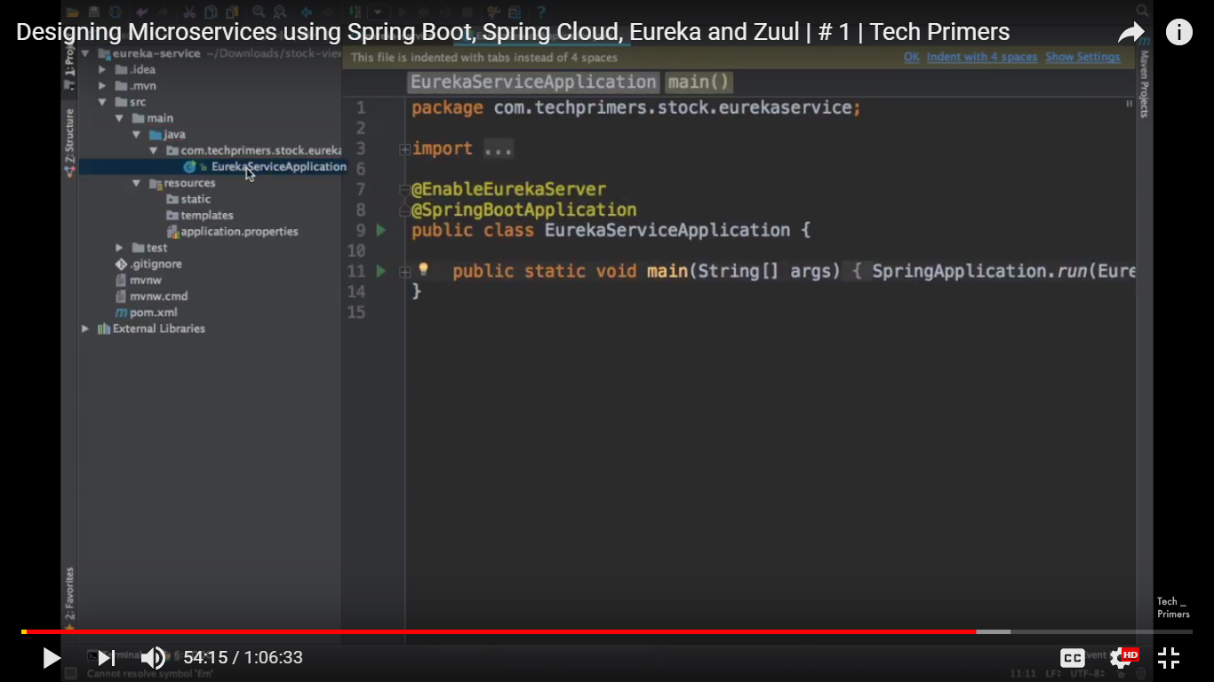

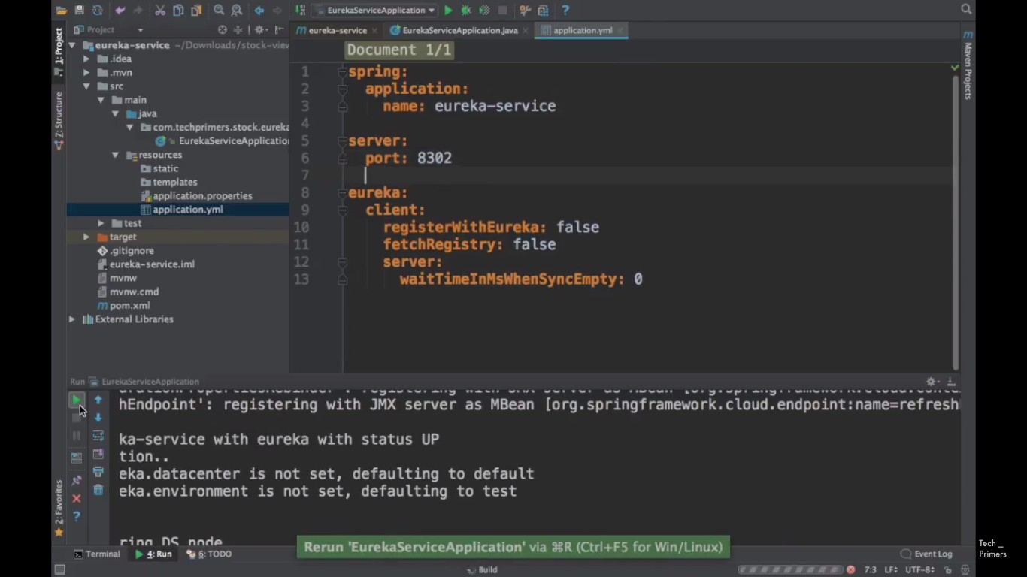

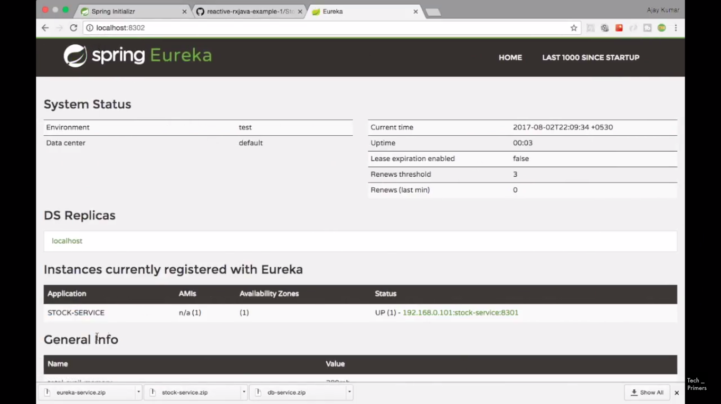

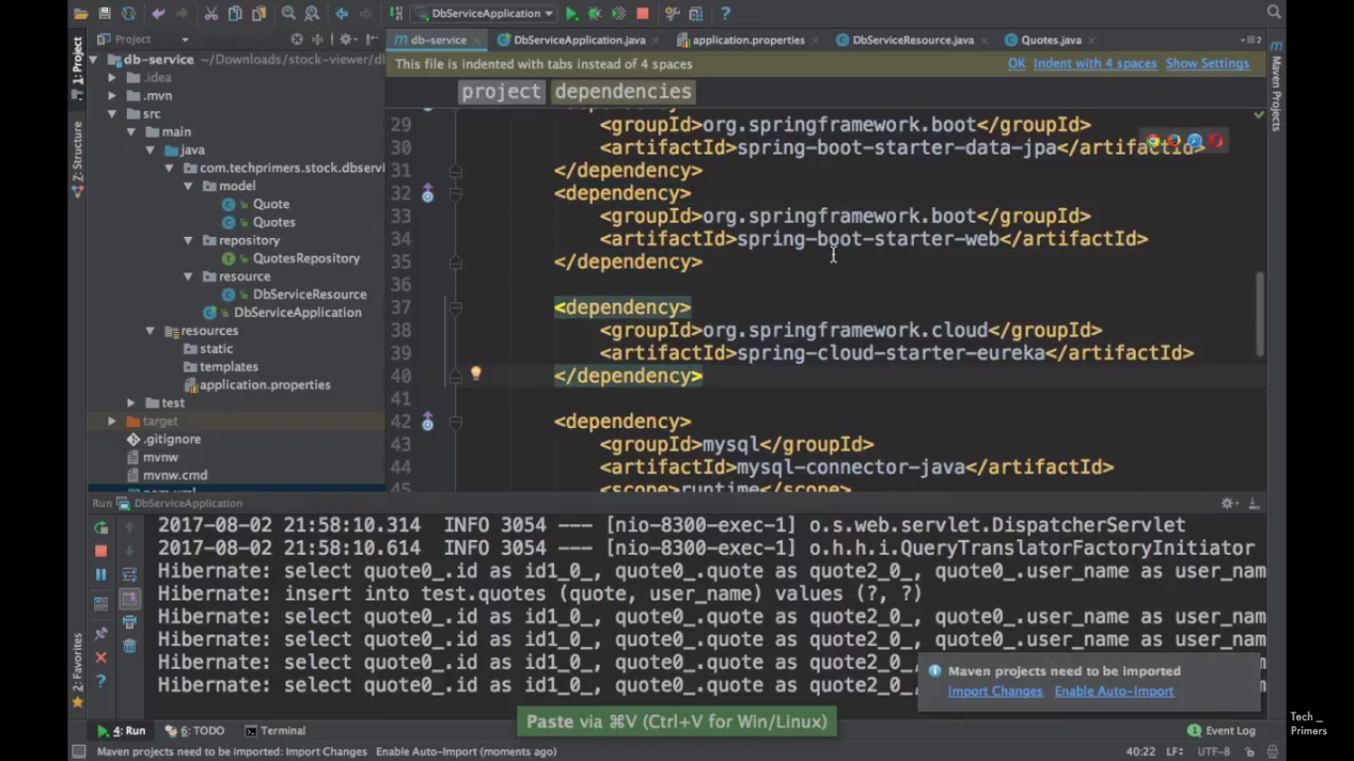

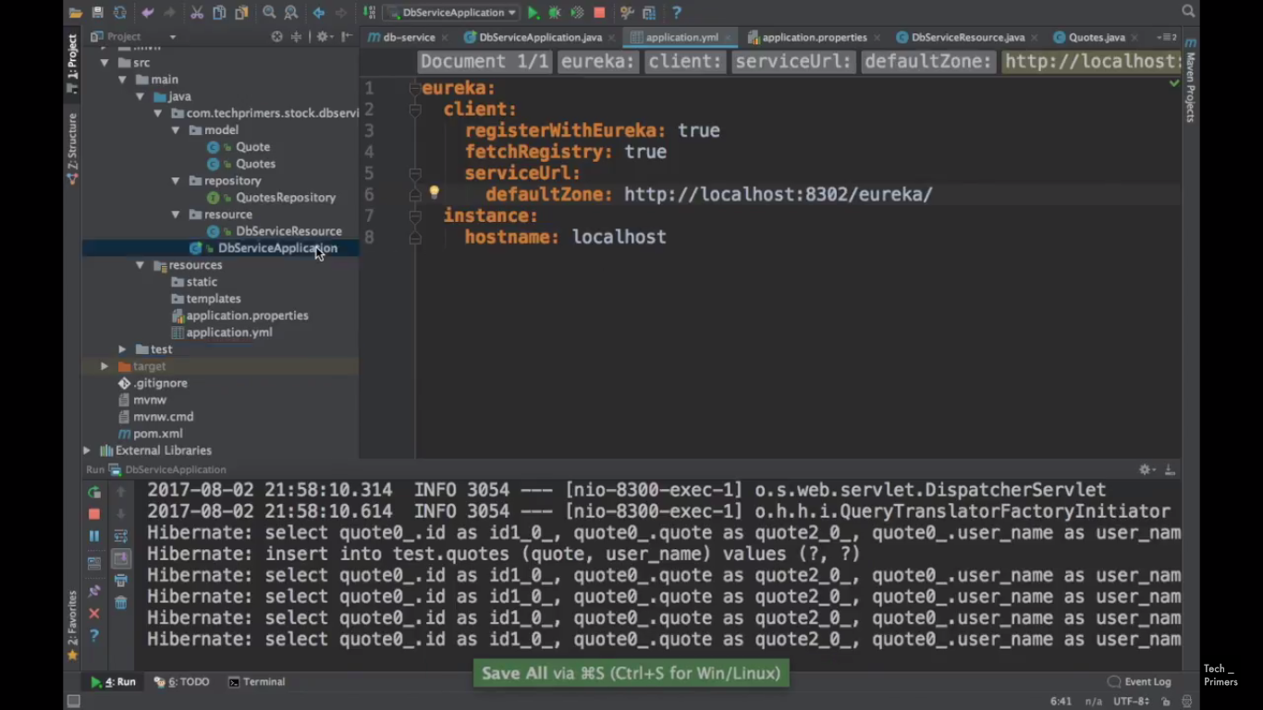

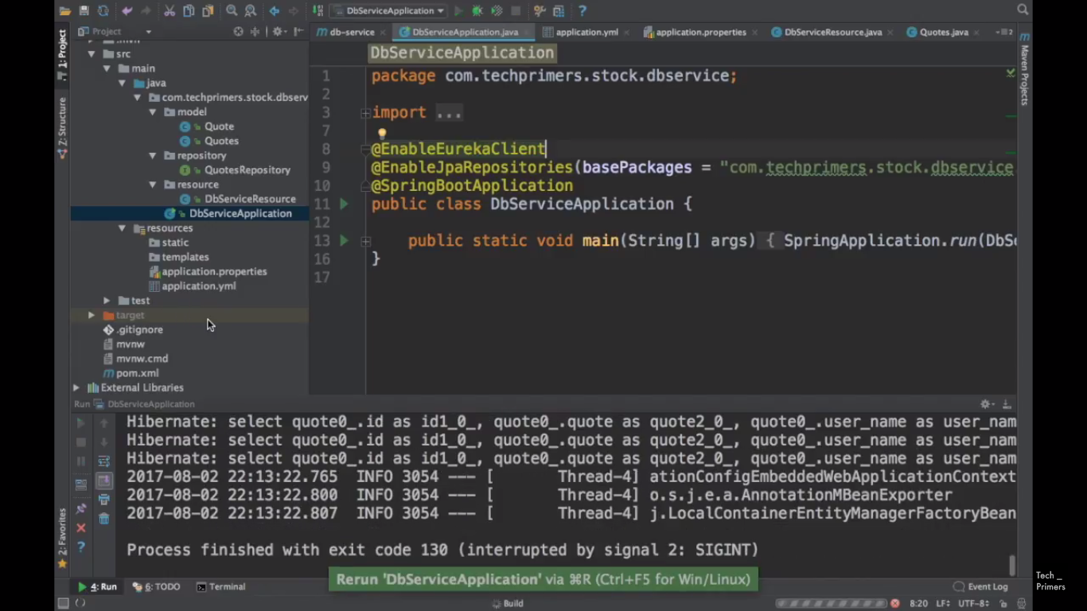

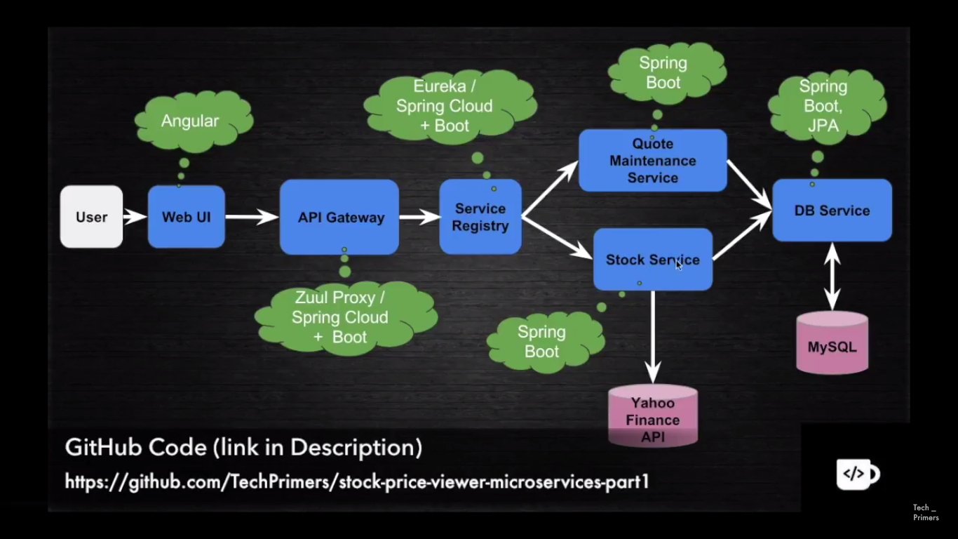

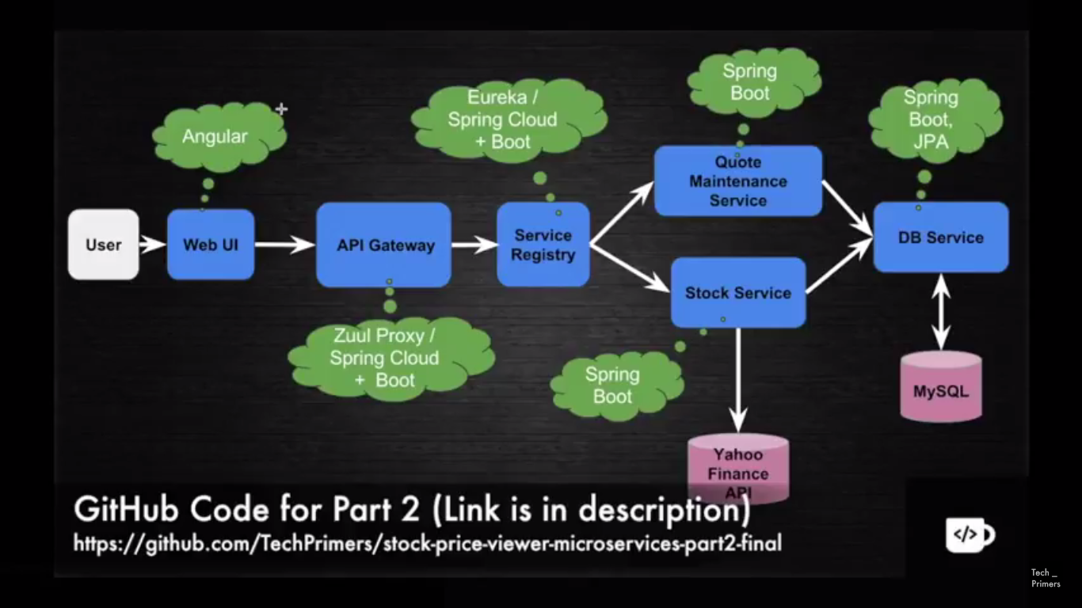

The final flow will be like, UI -> API Gateway -> Stock Service -> Service Registry -> DB Service and finally Stock service will return the data to the user.

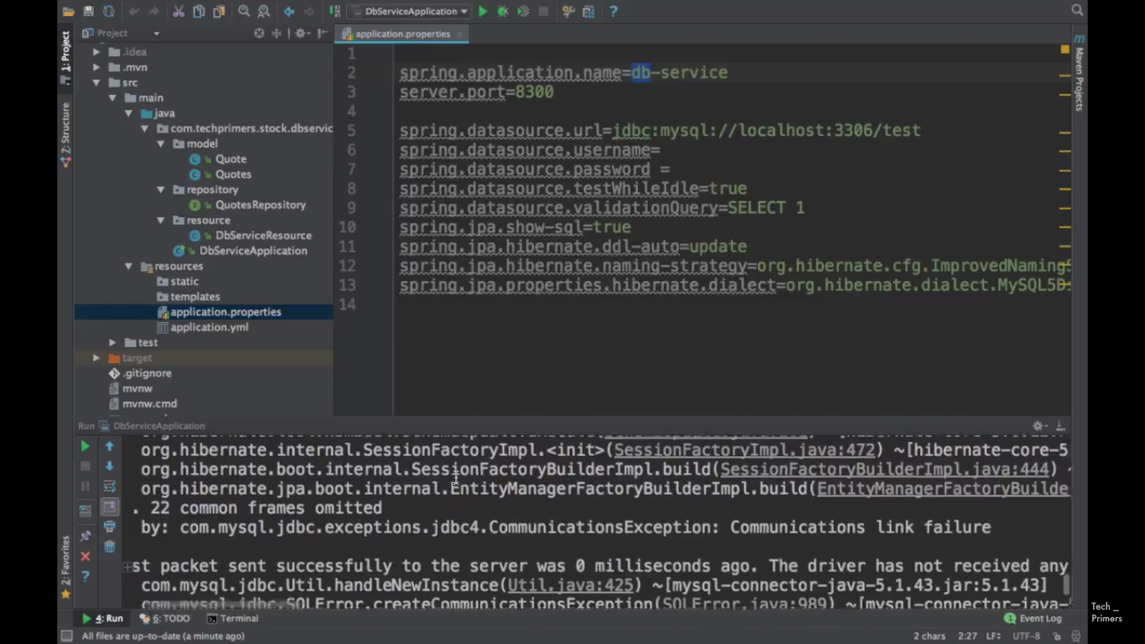

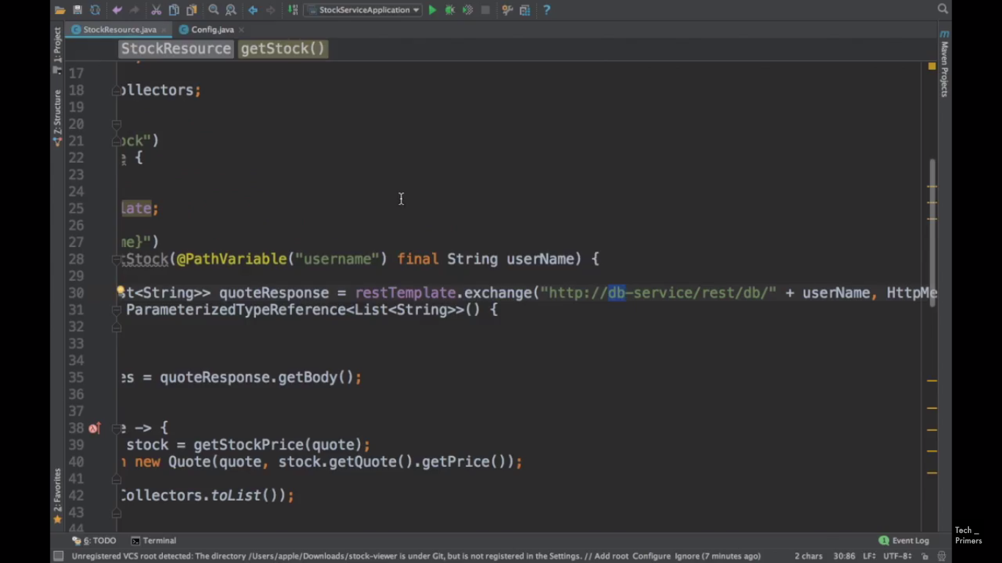

This db-service call is working fine since we made the entry(application name) in application.properties file and enabled @LoadBalanced.

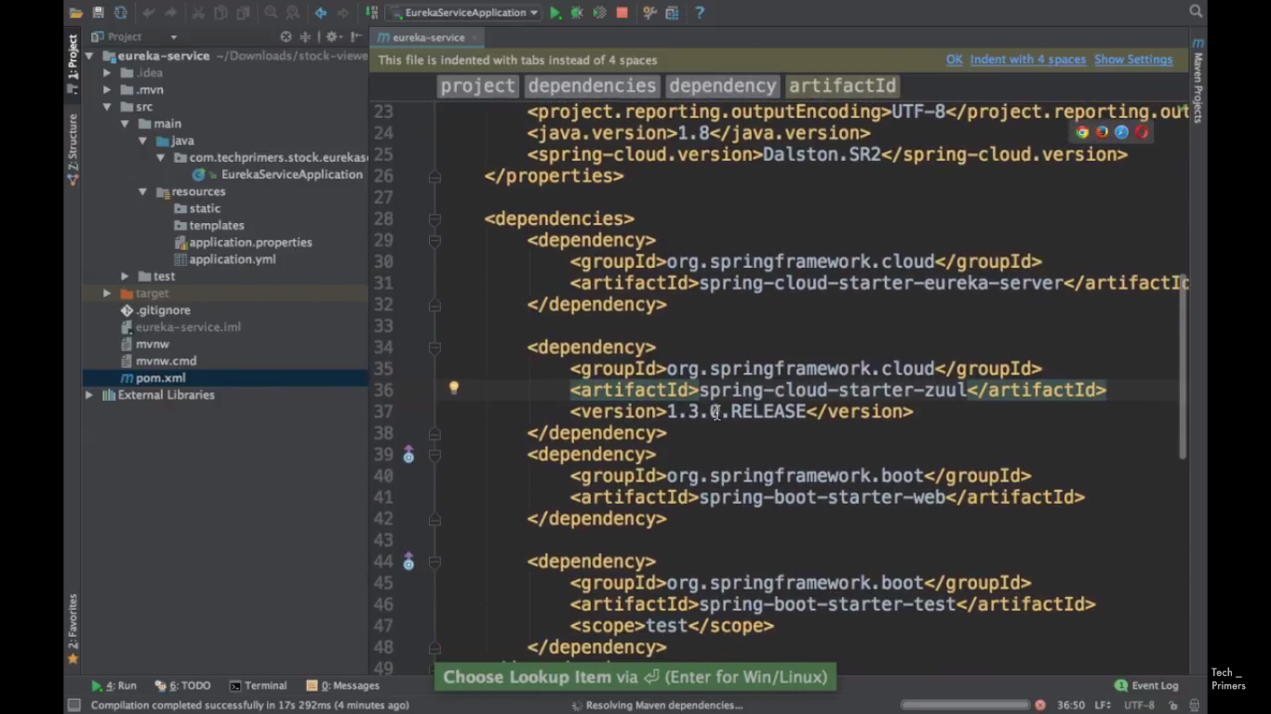

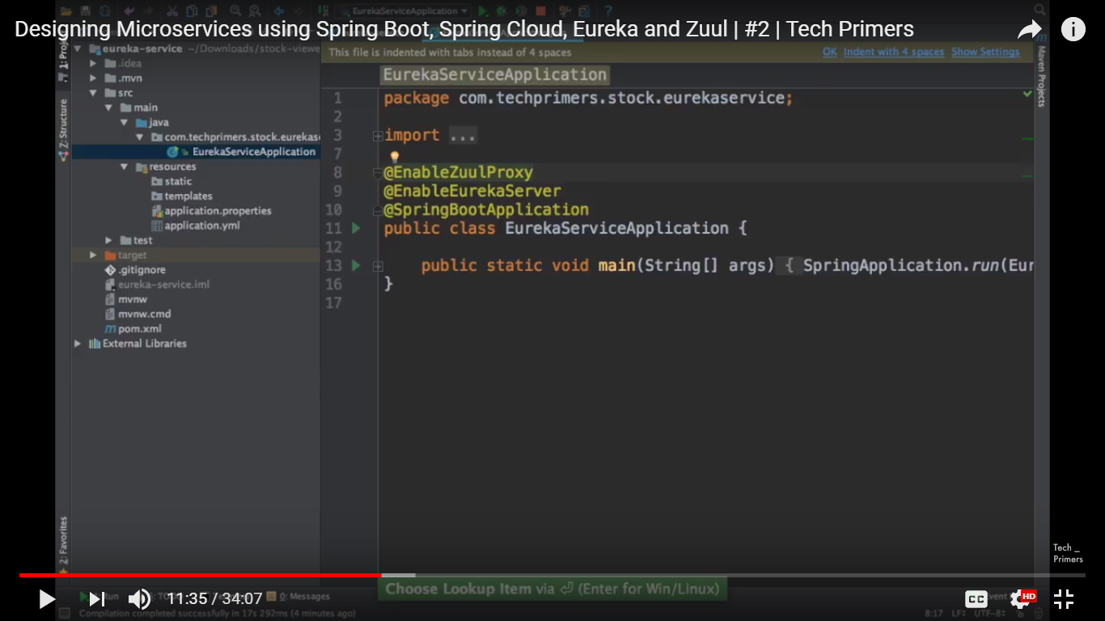

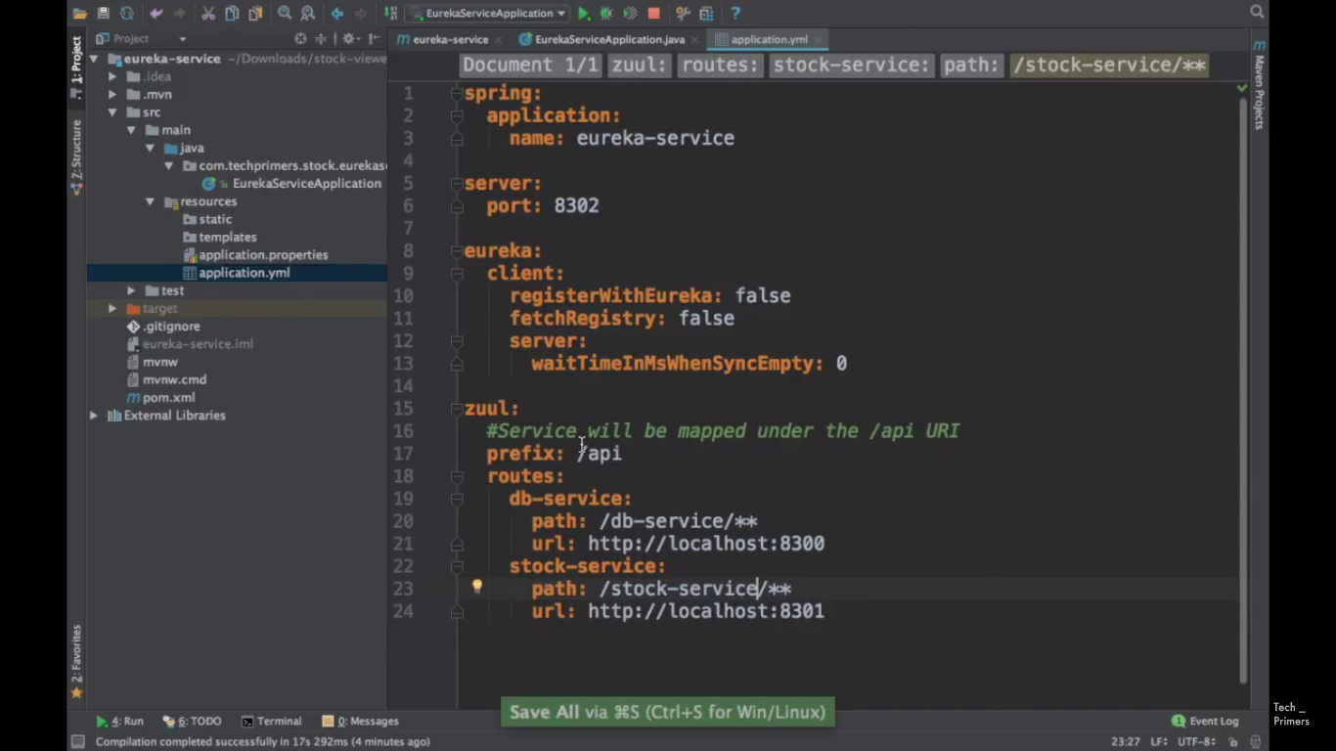

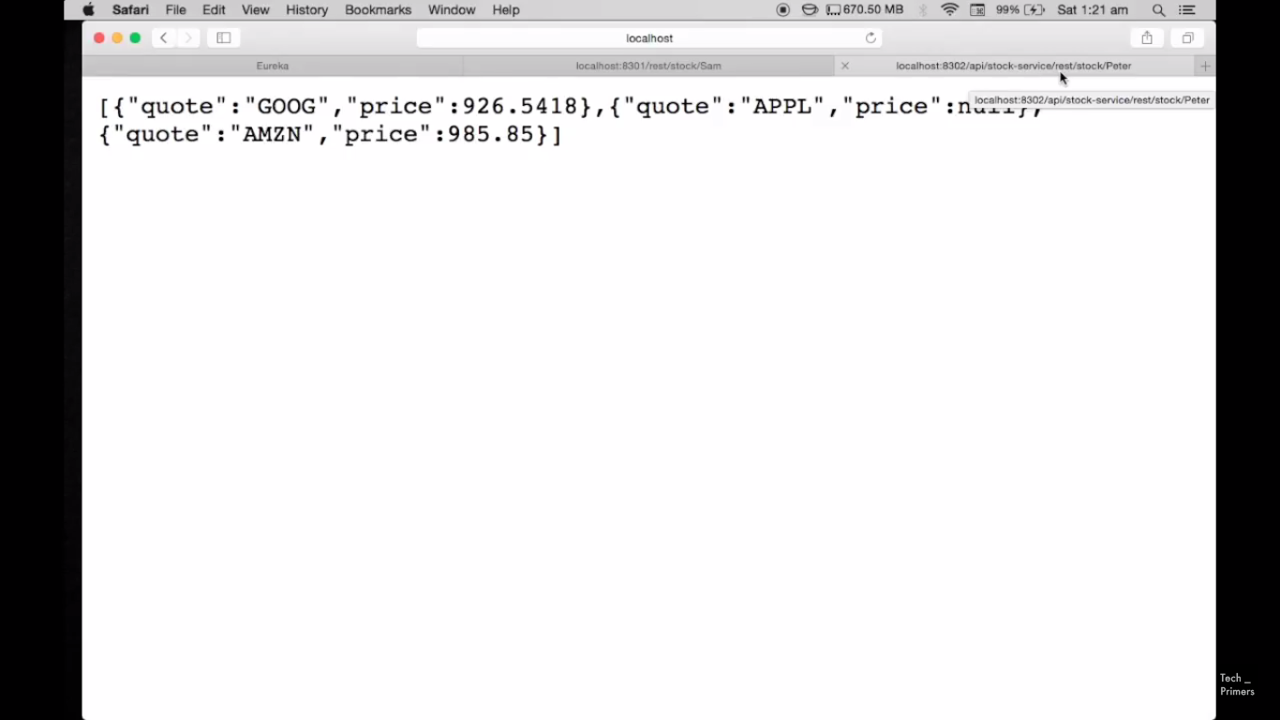

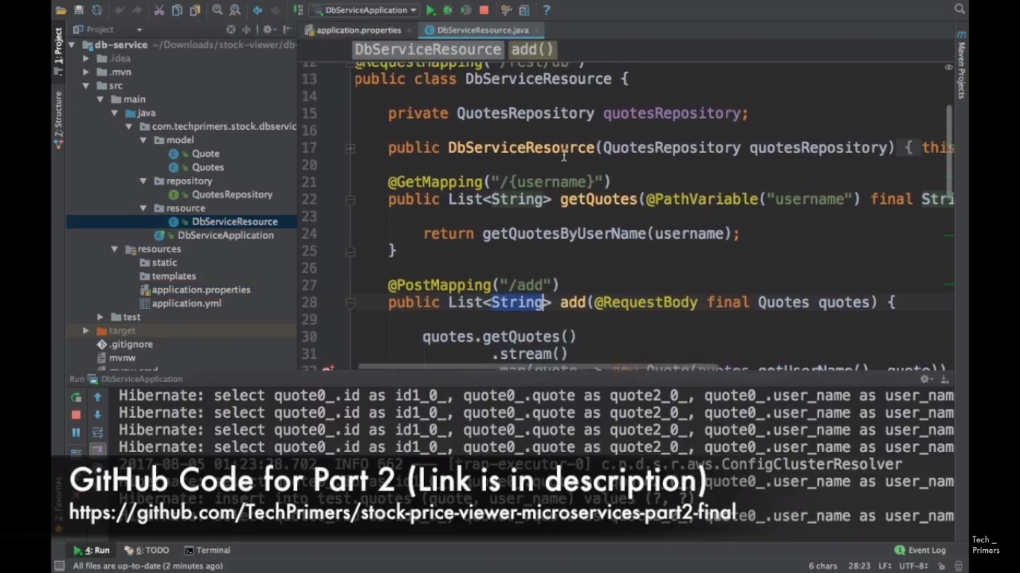

Resilience – Circuit breaker - Hystrix. Spring Retry is also other option for Circuit breaker.

Hystrix has Fallback method and Circuit breaker.

Logging for Micro services – spring-cloud-sleuth

If we would like to do Load balancing (having multiple instance of the same service), we have to via API Gateway -> Service registry -> different instance of services.

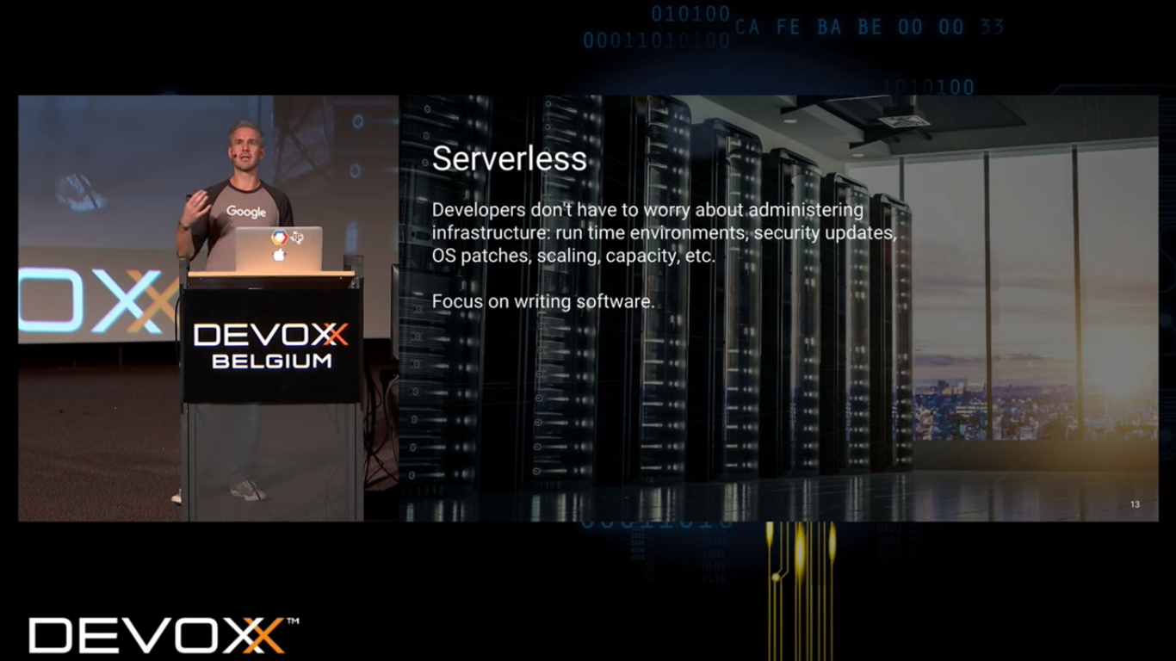

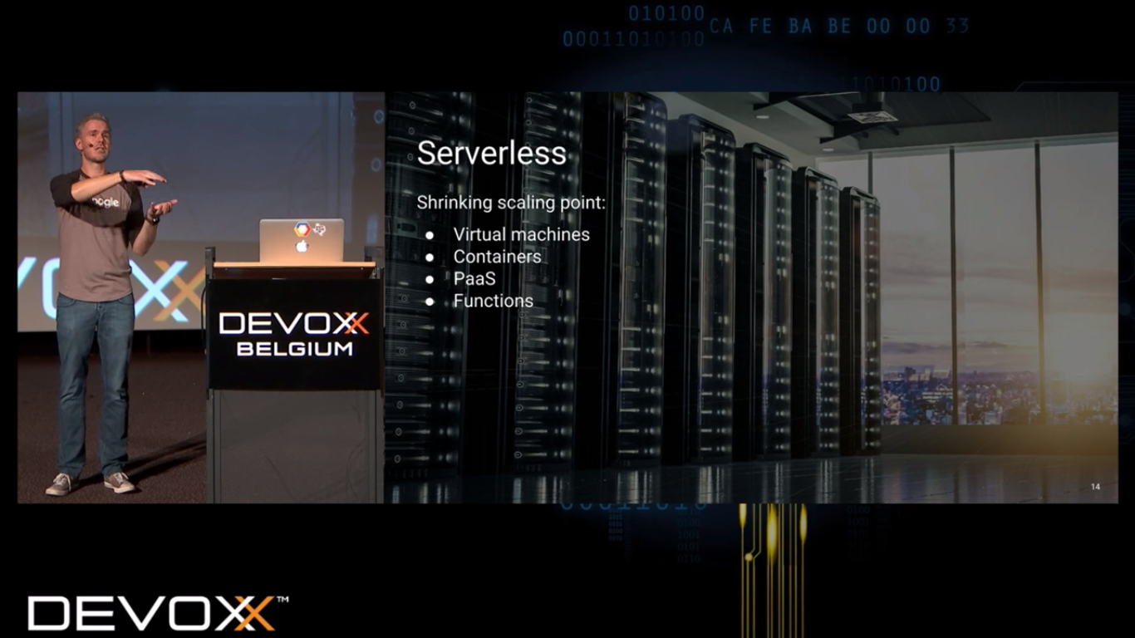

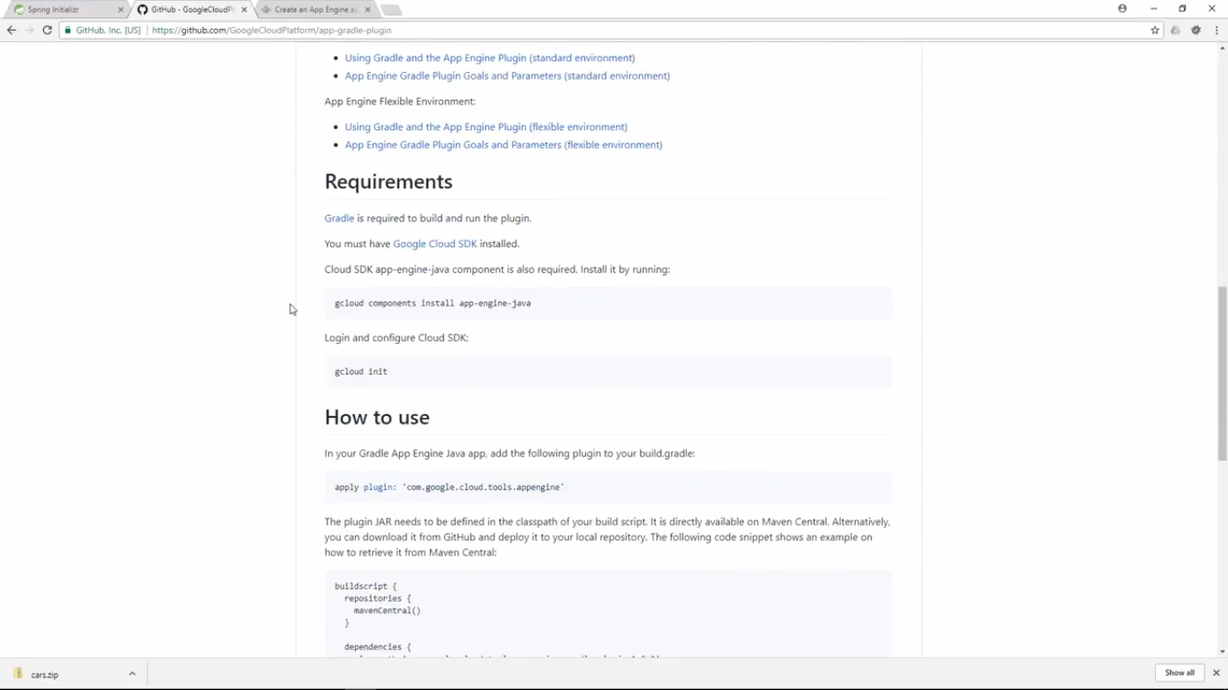

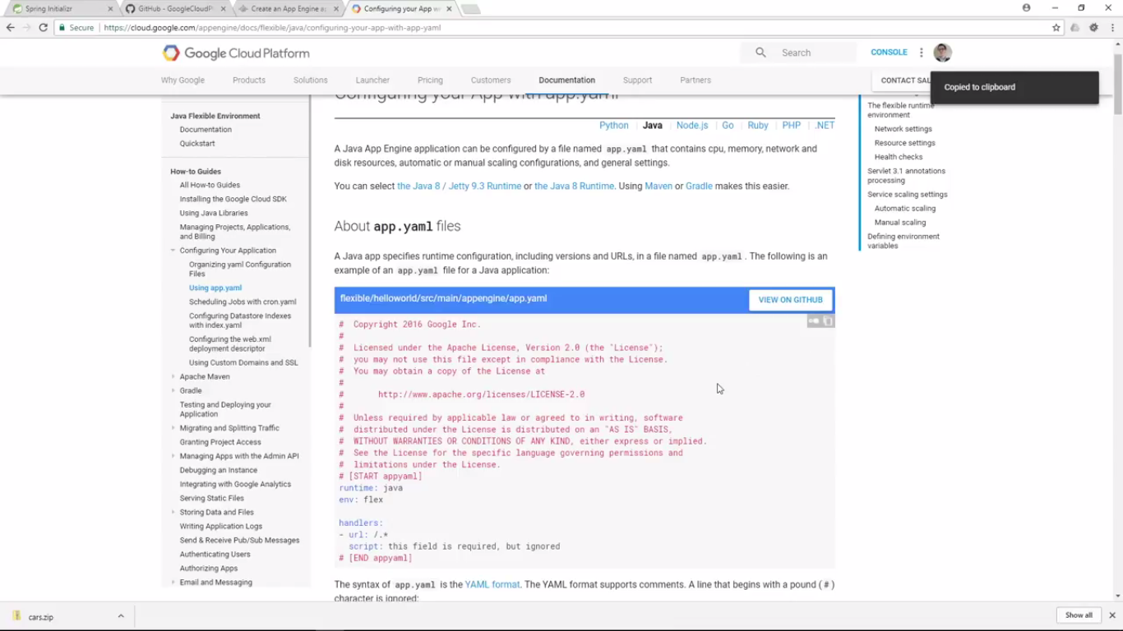

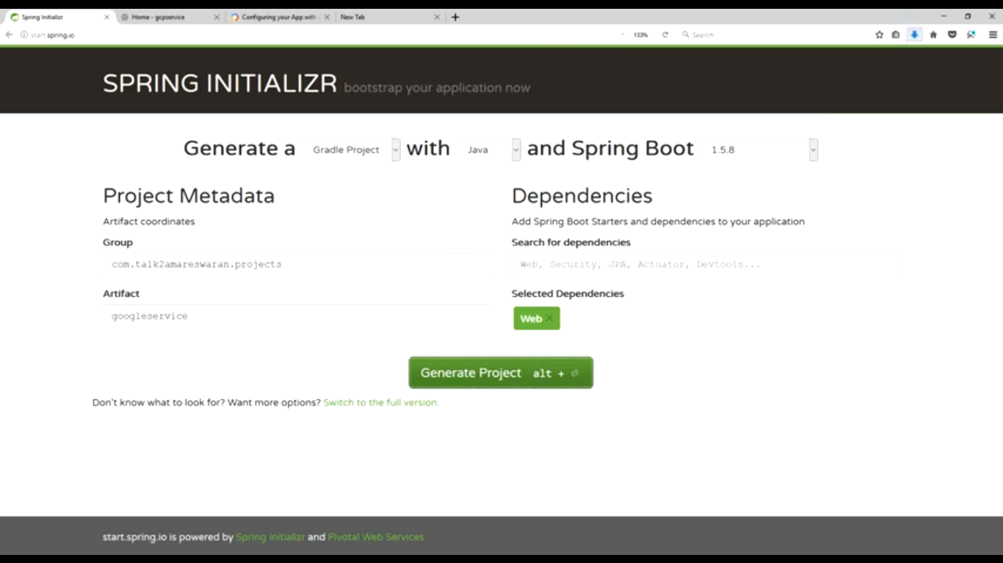

Once created sample project create a build and run jar file.

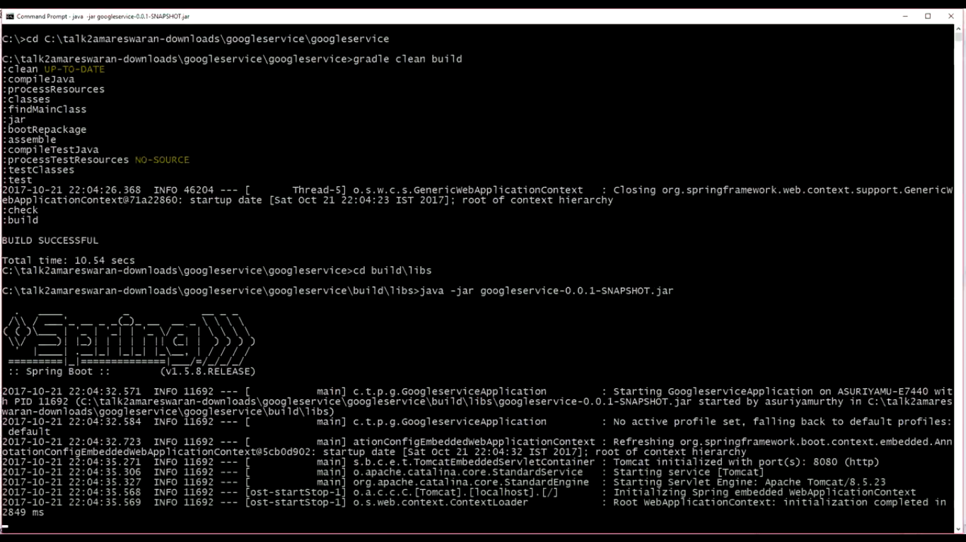

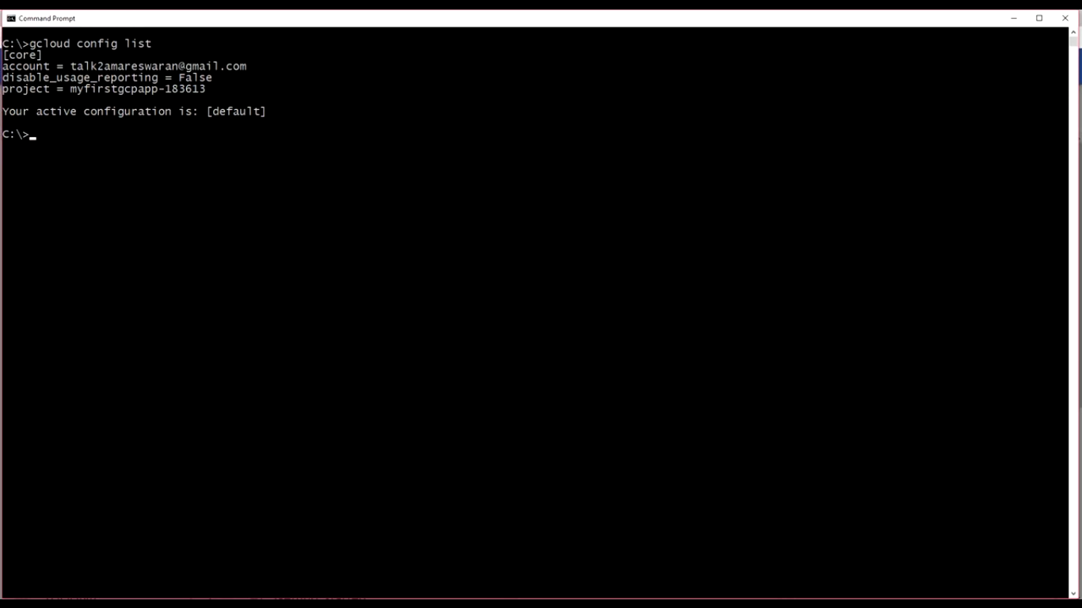

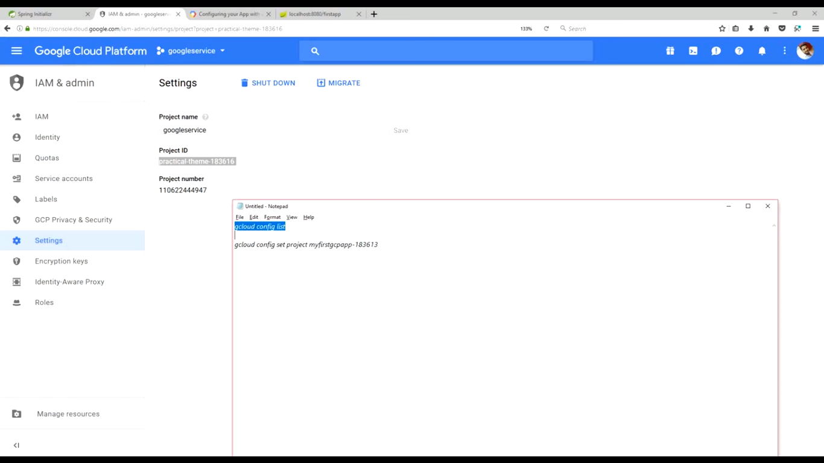

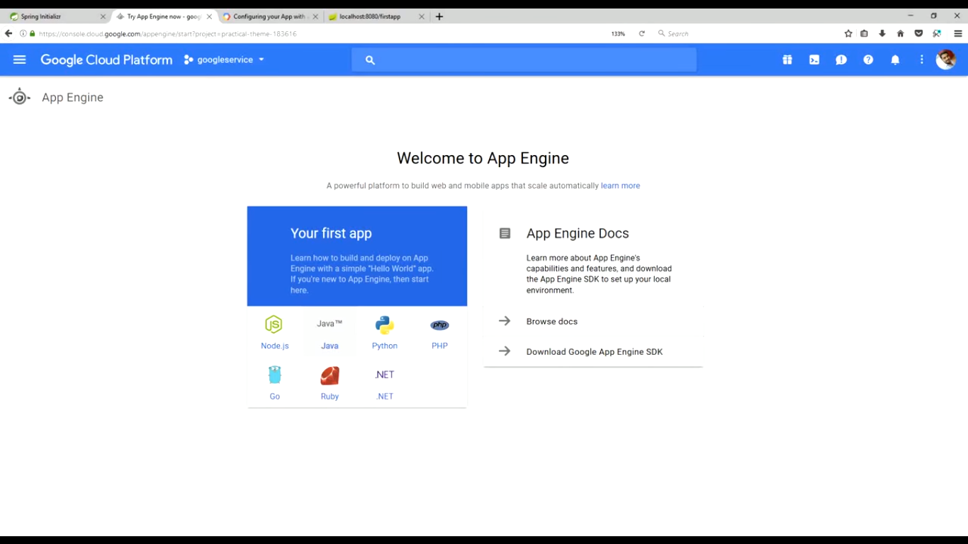

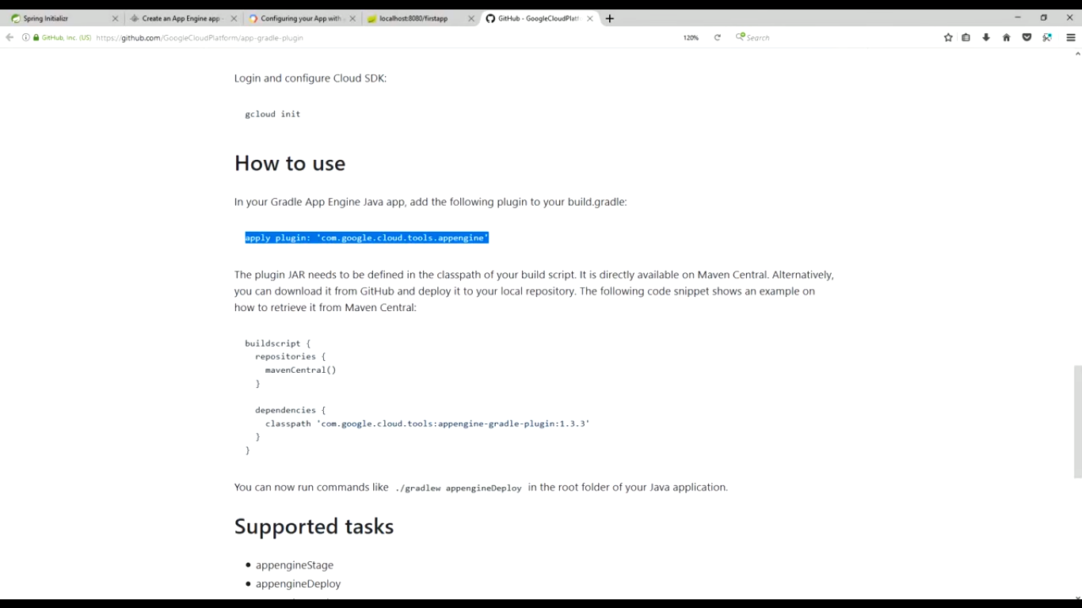

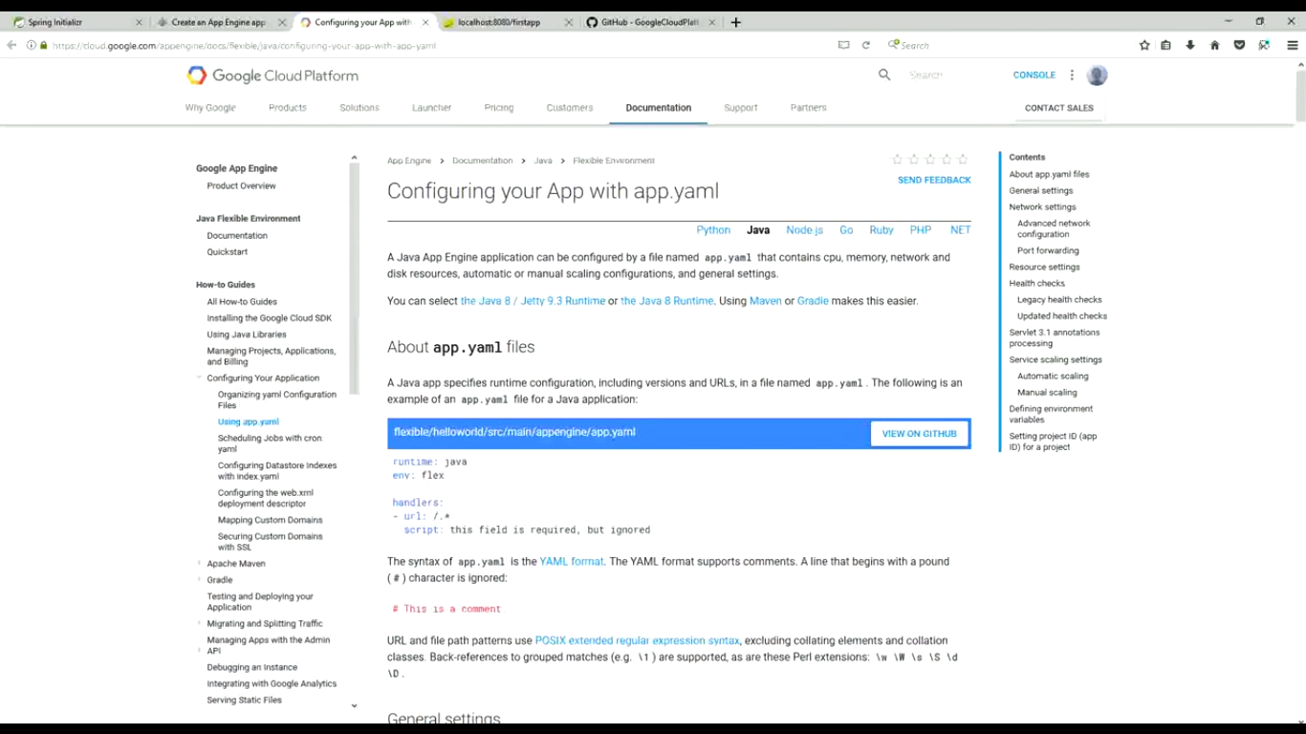

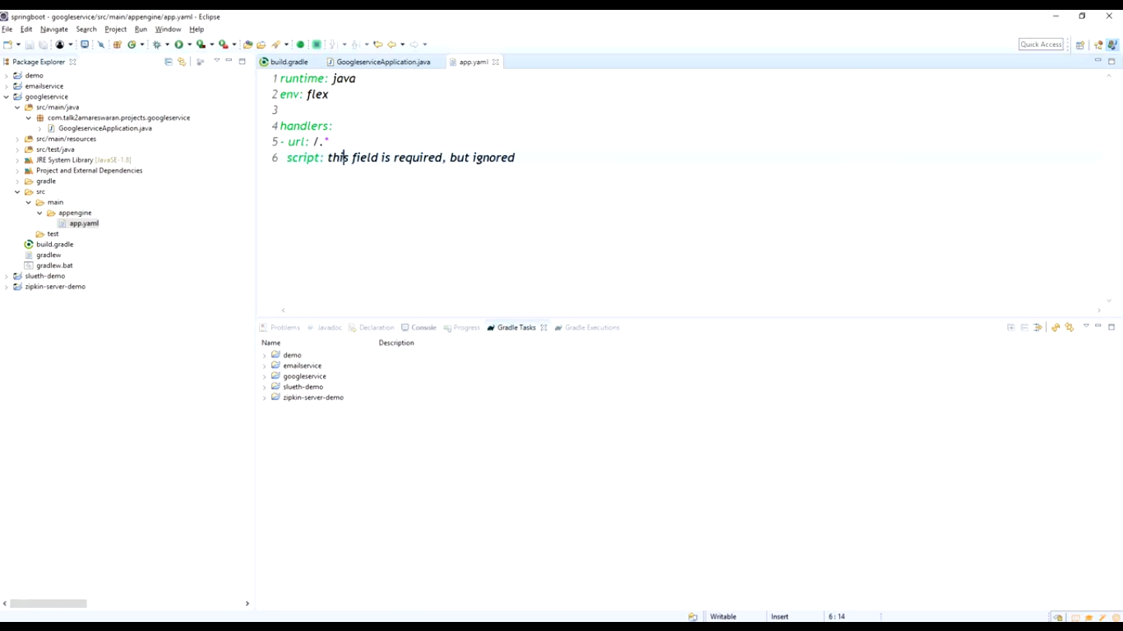

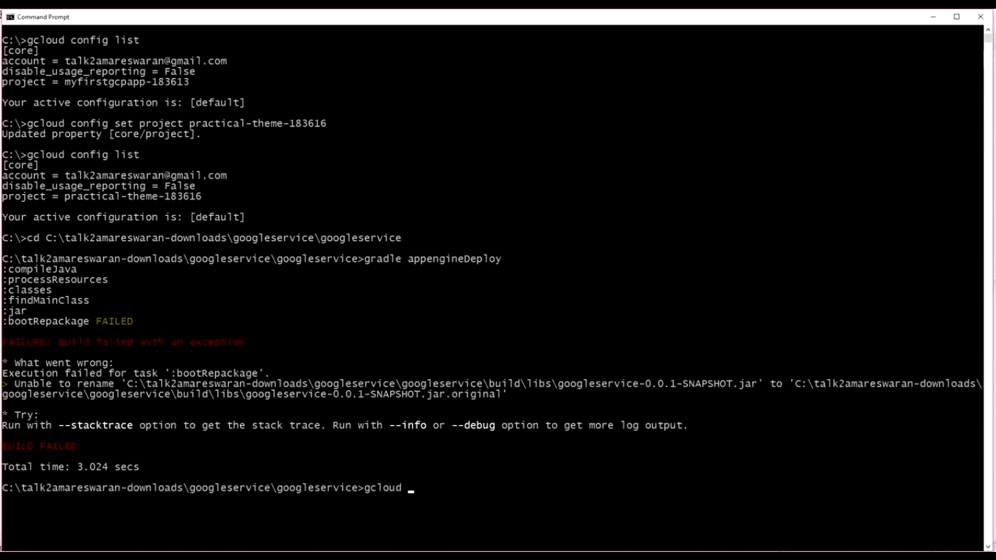

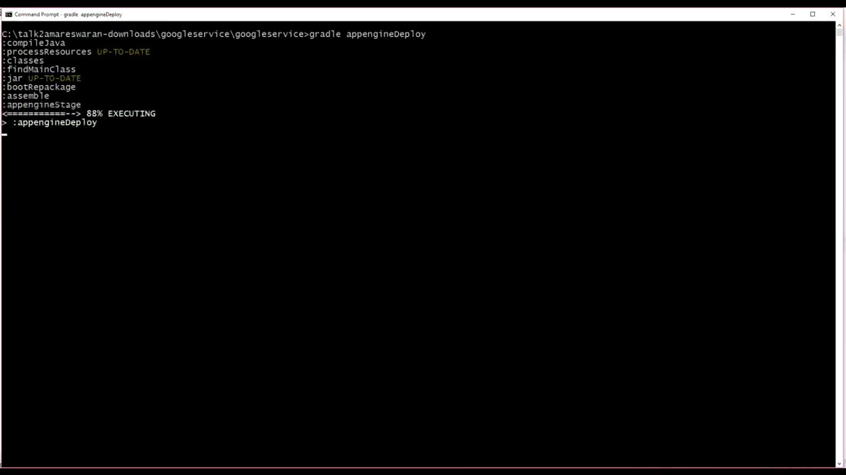

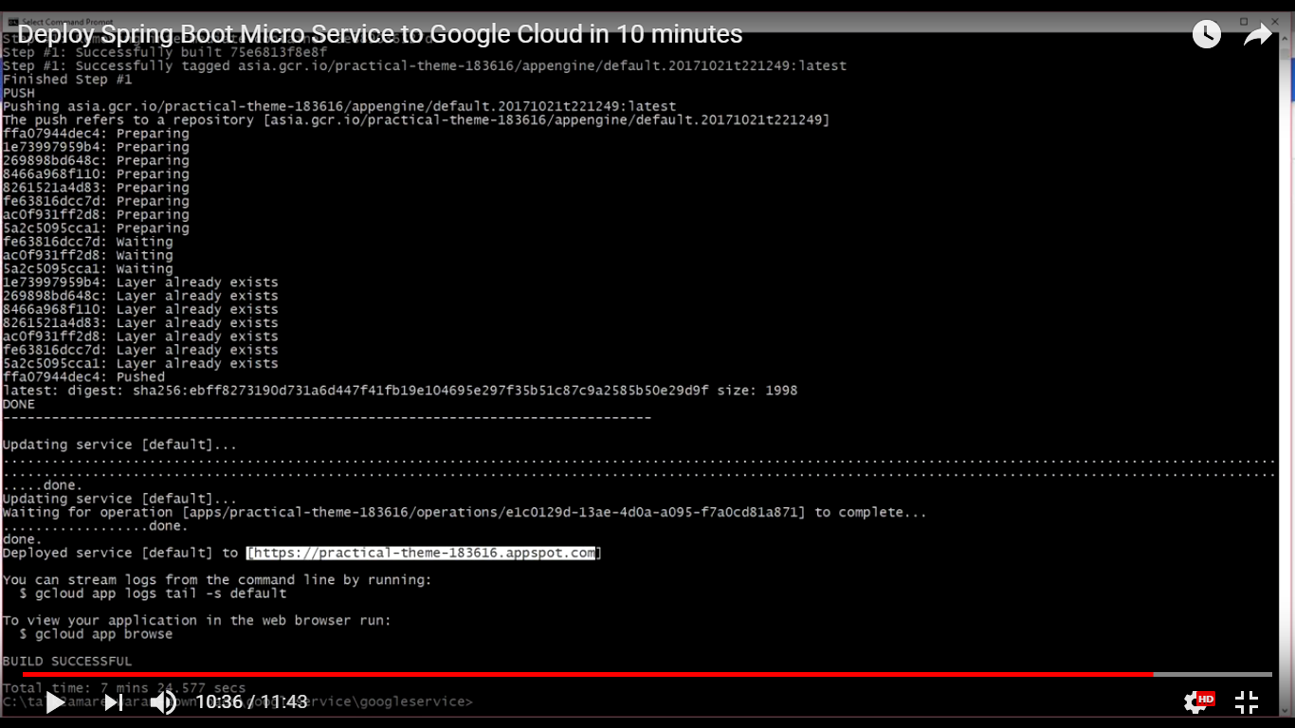

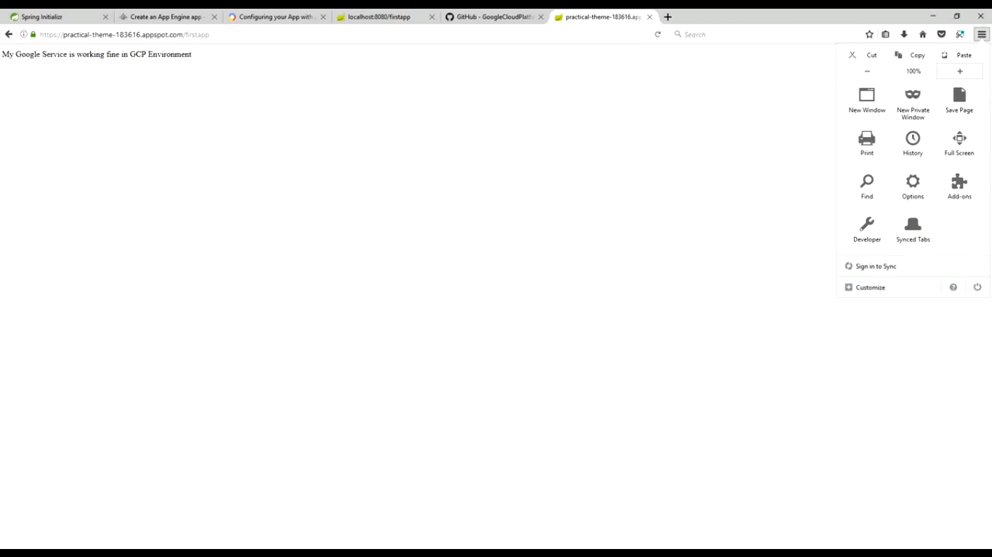

<https://www.youtube.com/watch?v=PN4NLSpAJWc>

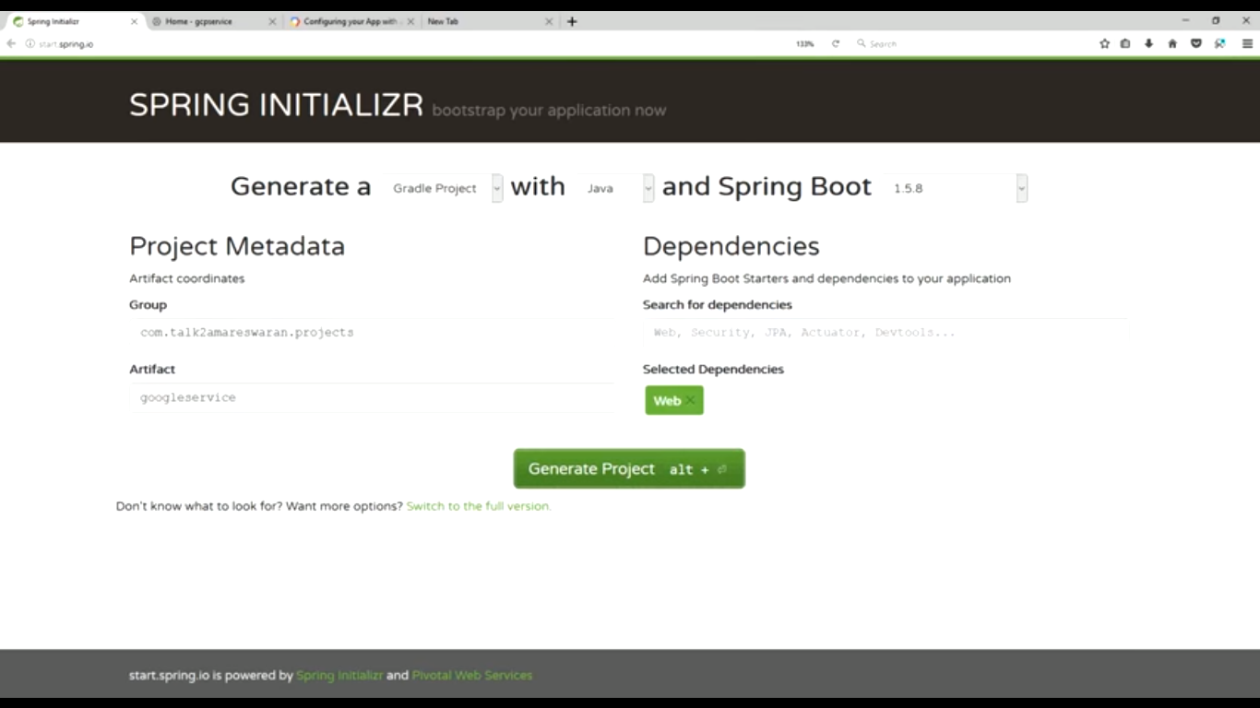

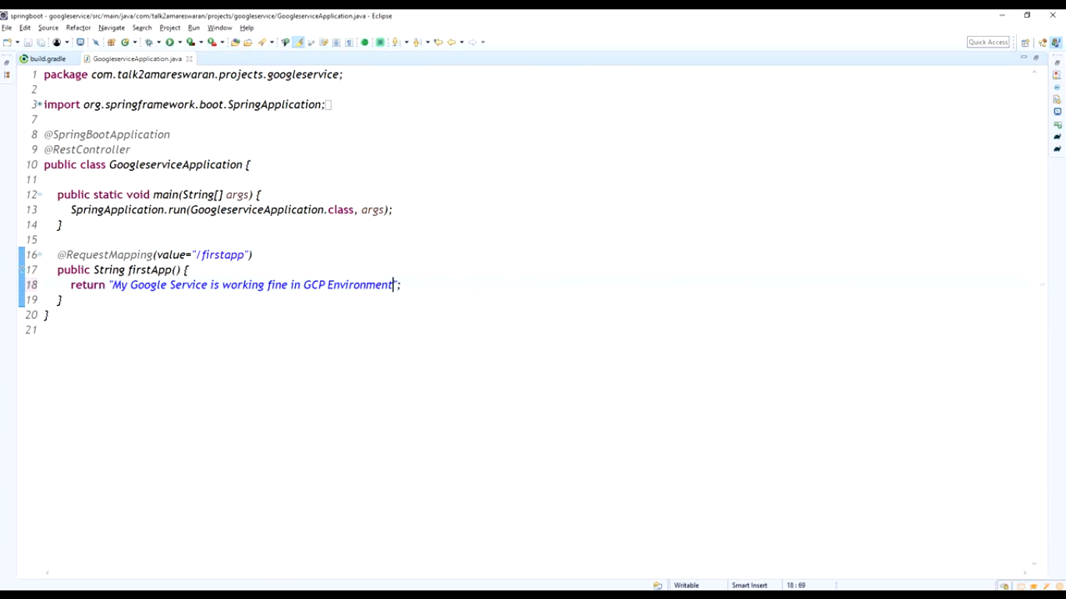

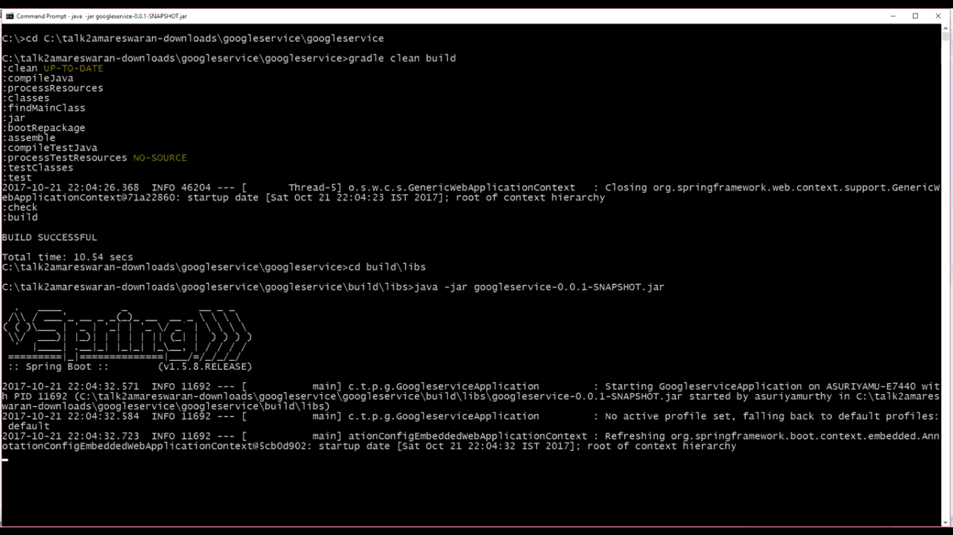

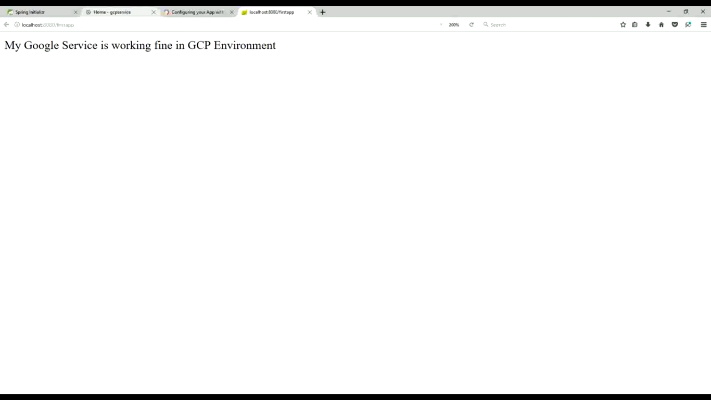

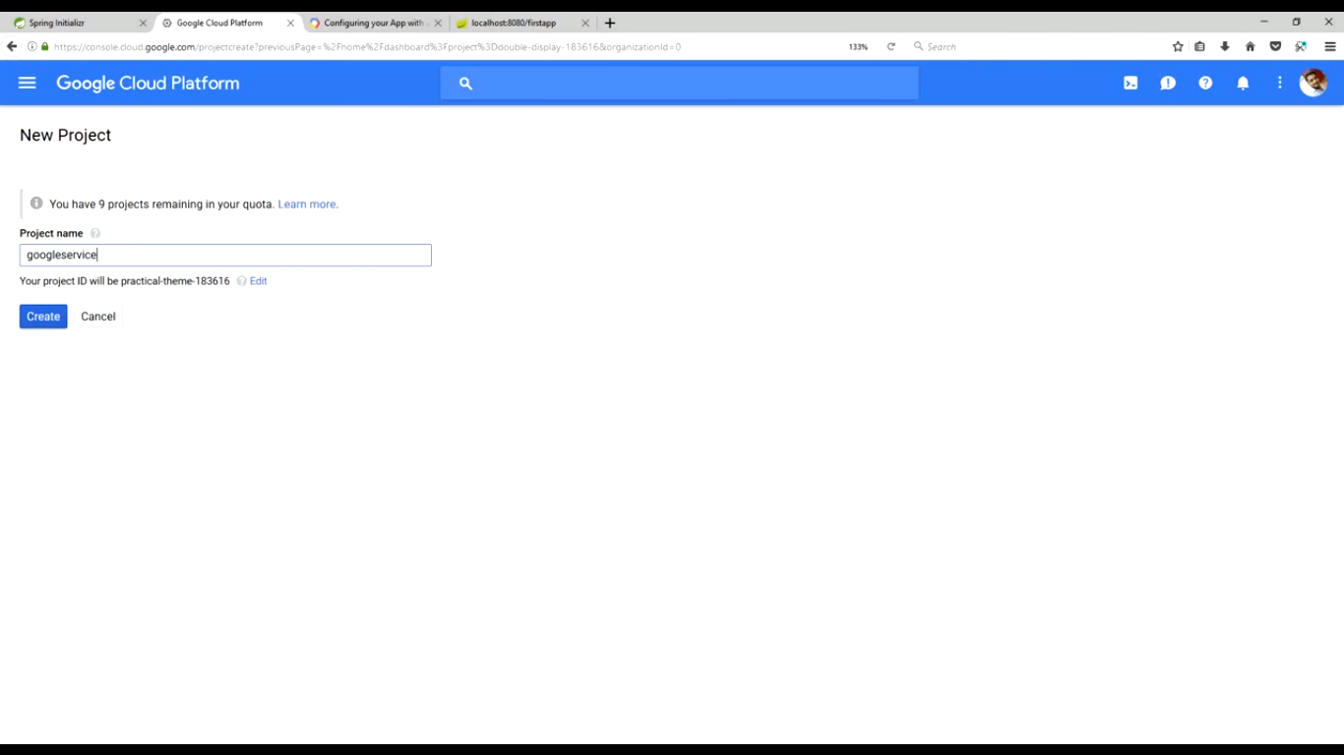

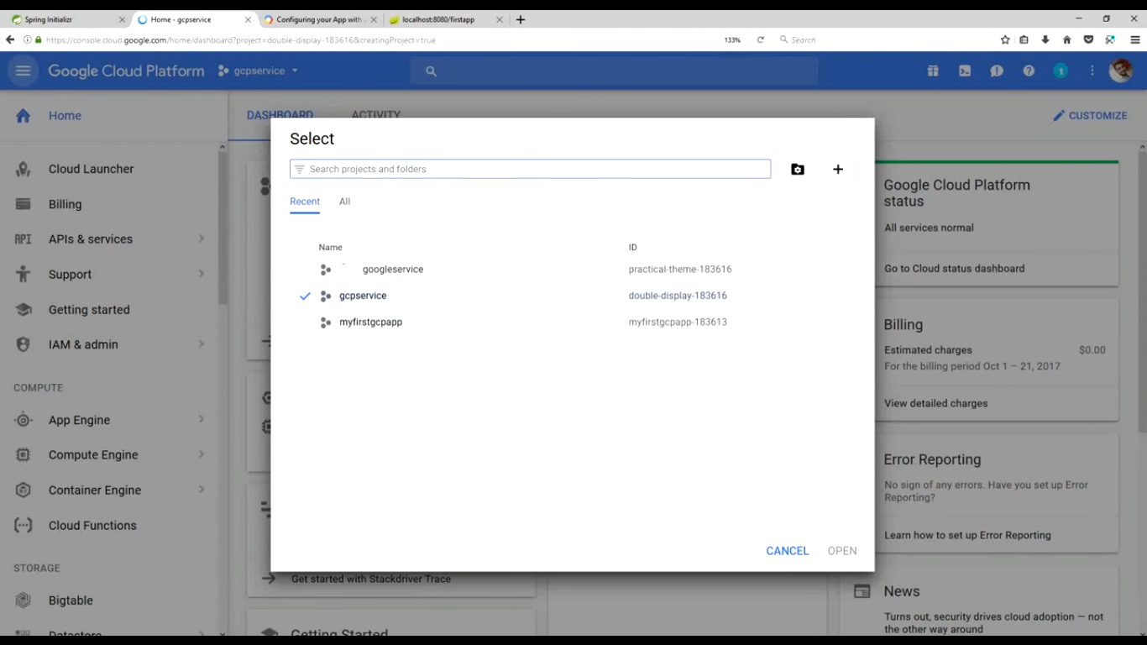

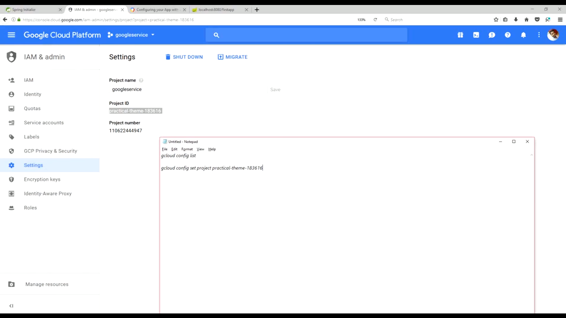

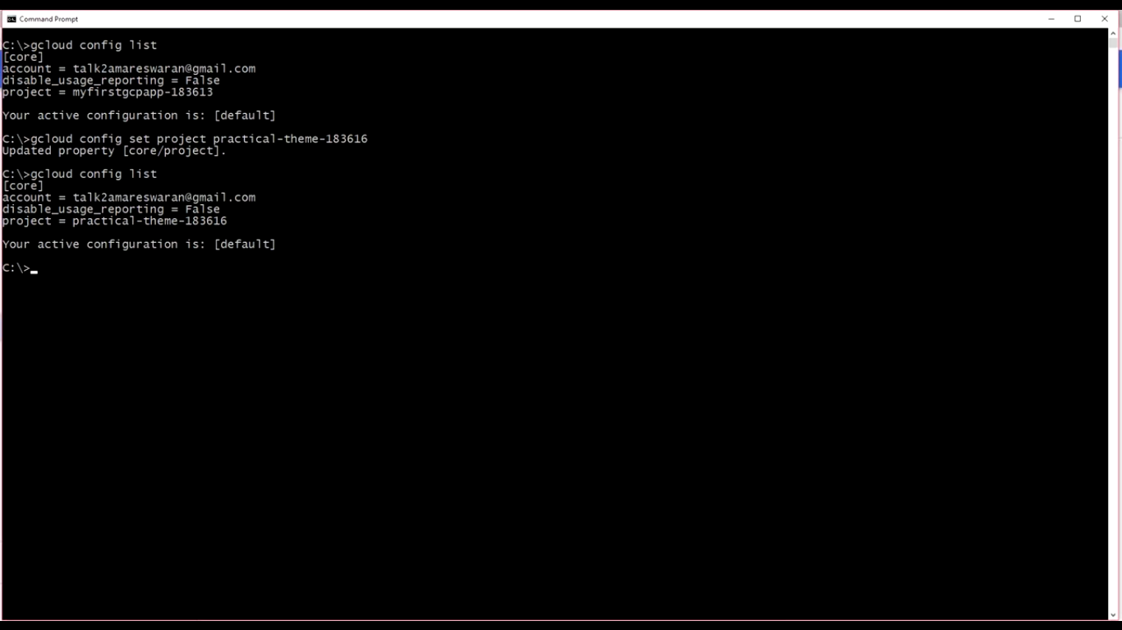

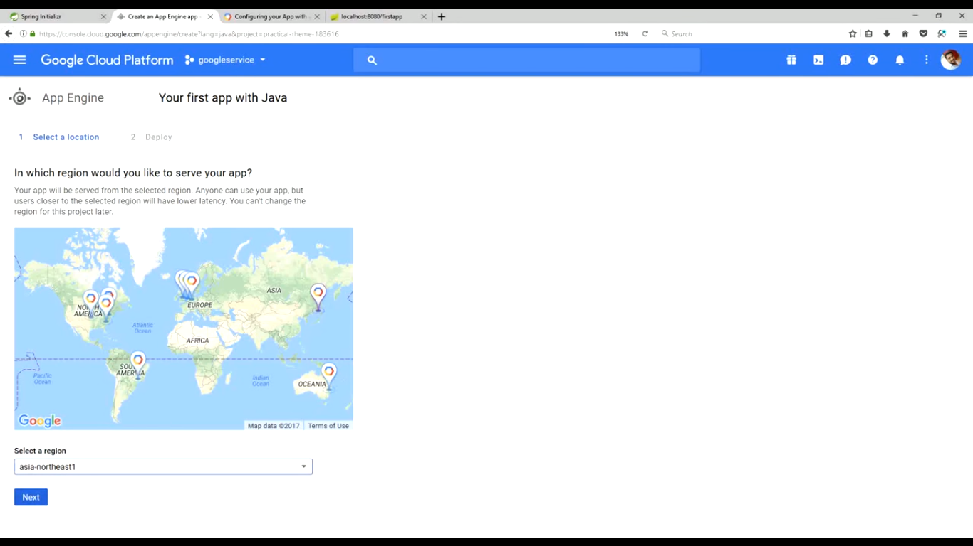

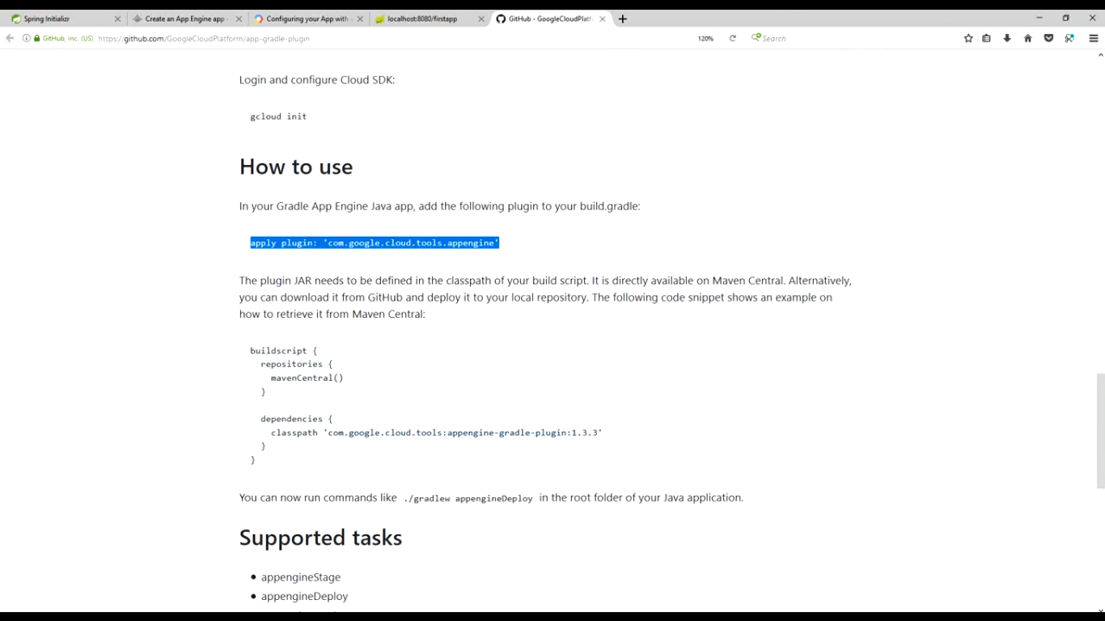

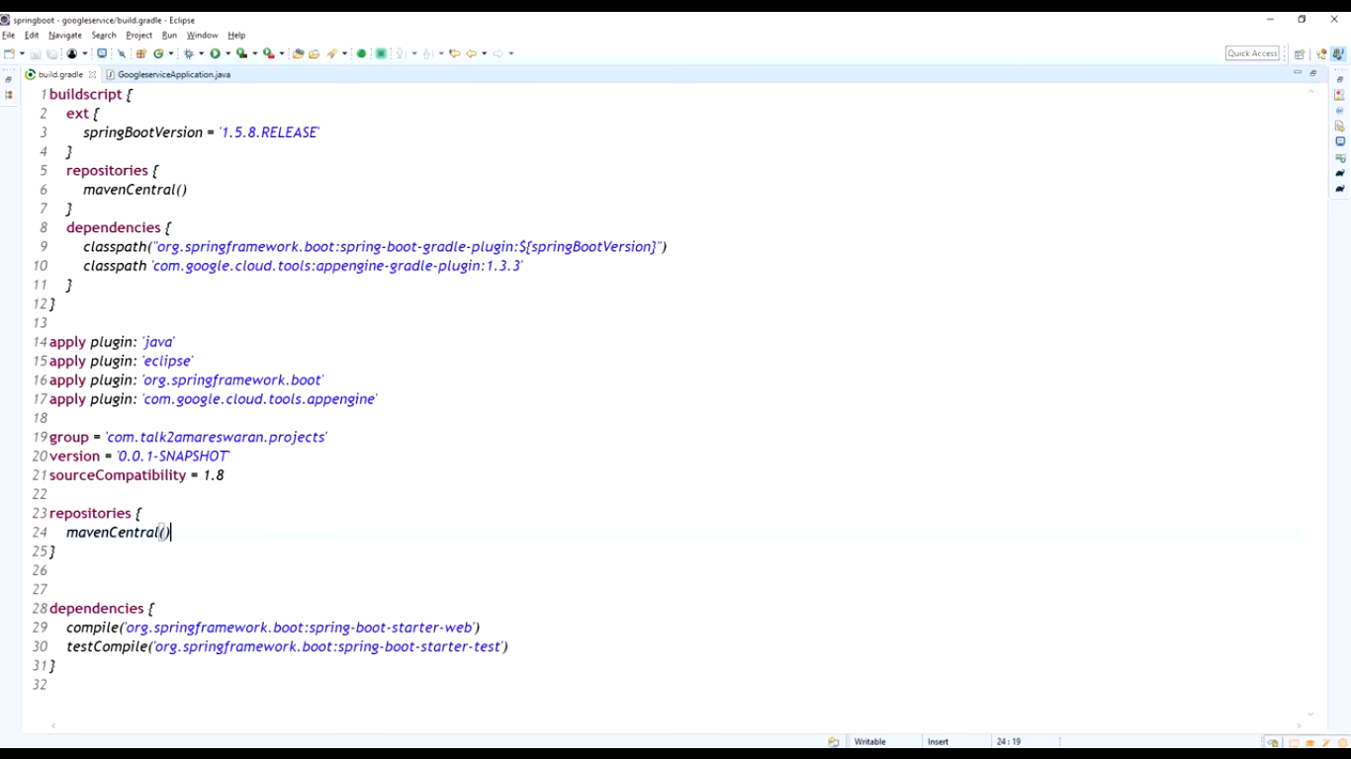

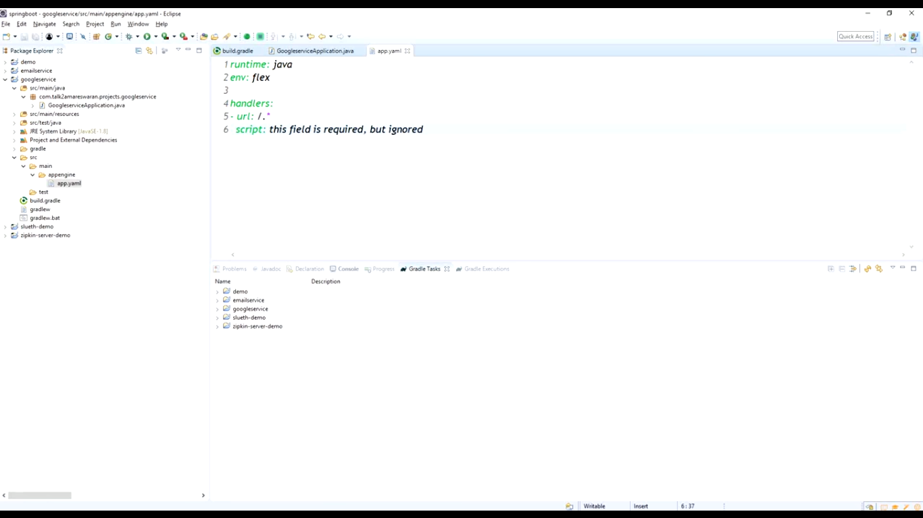

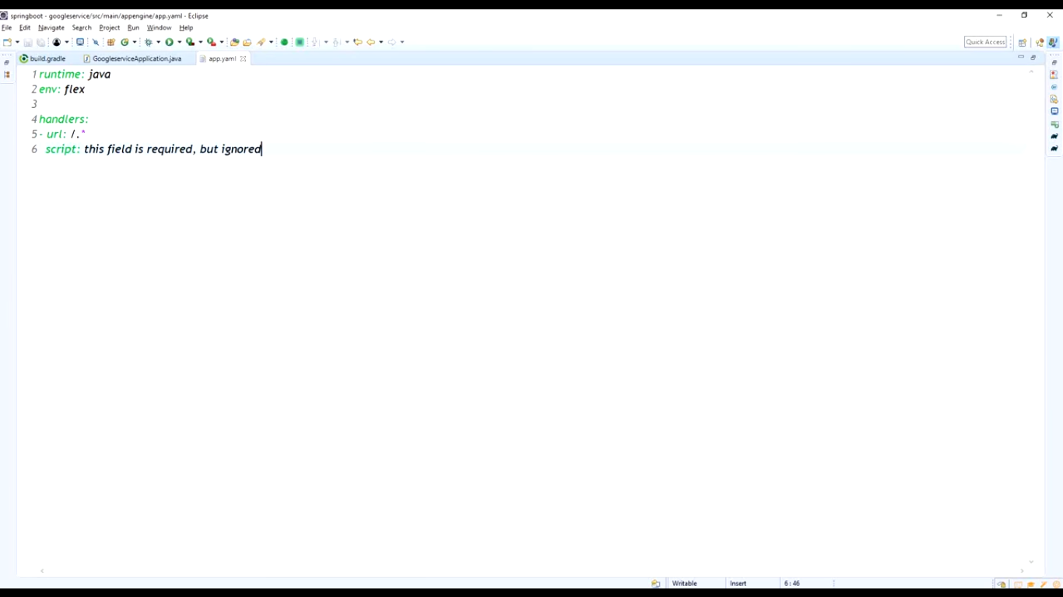

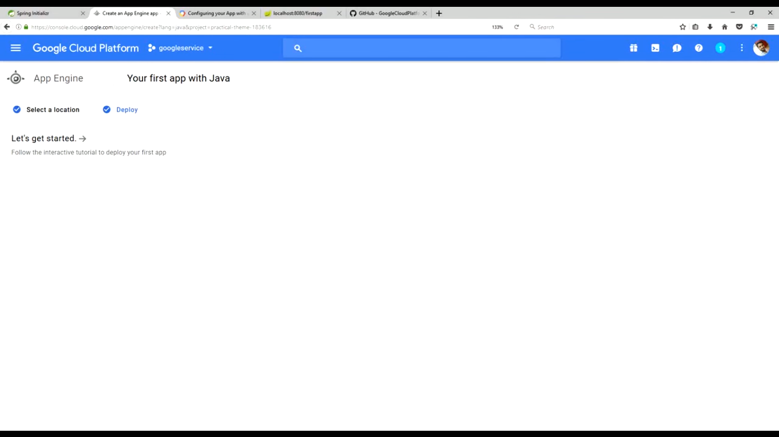

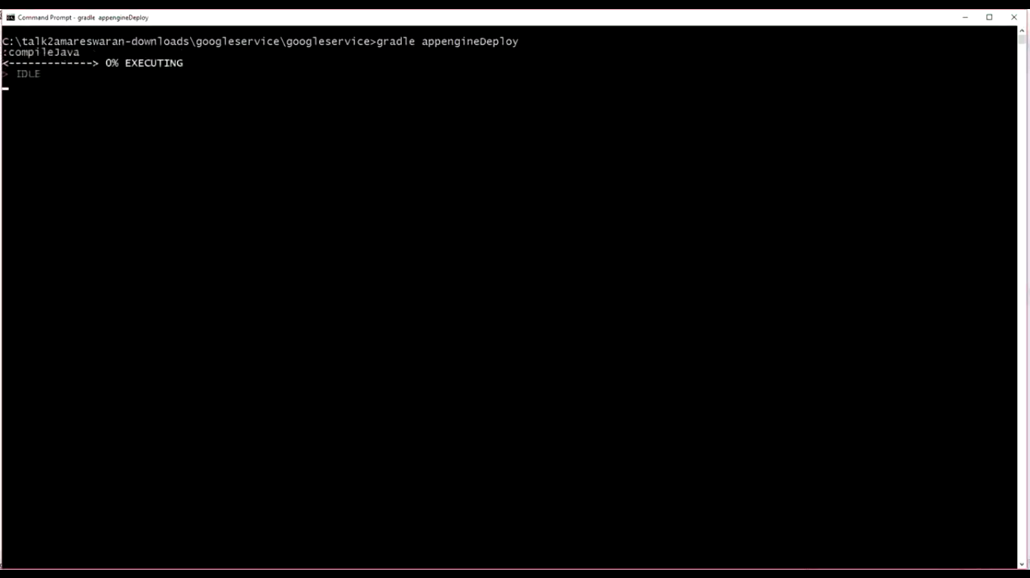

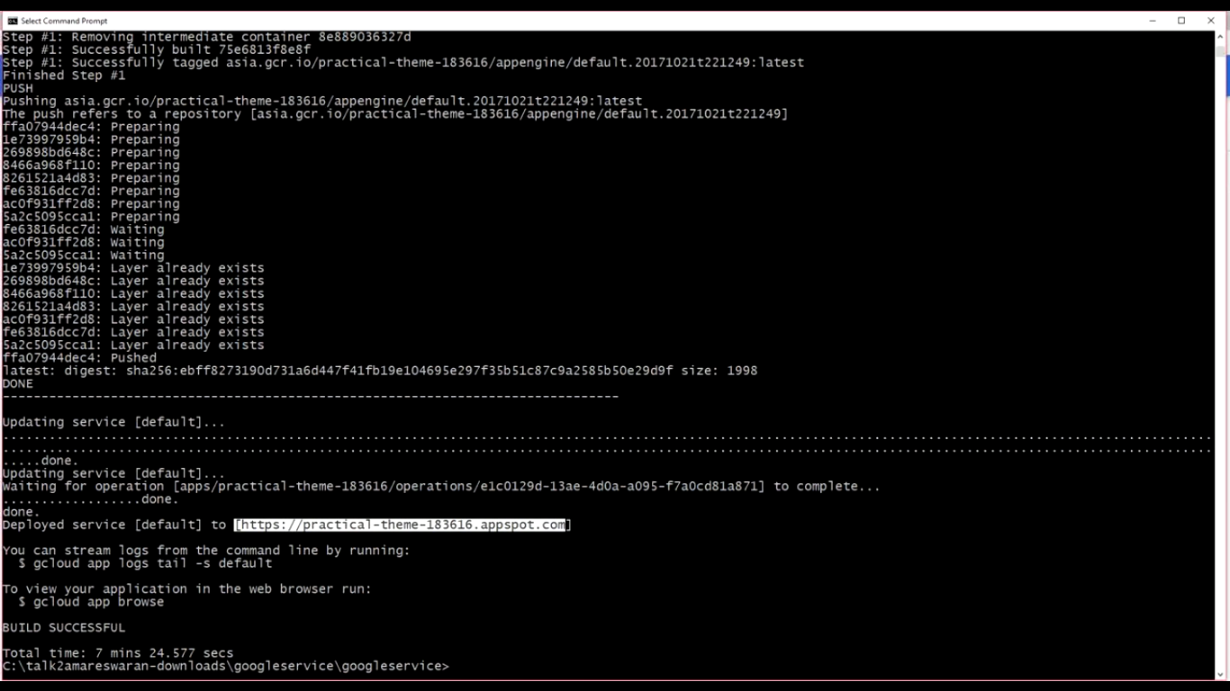

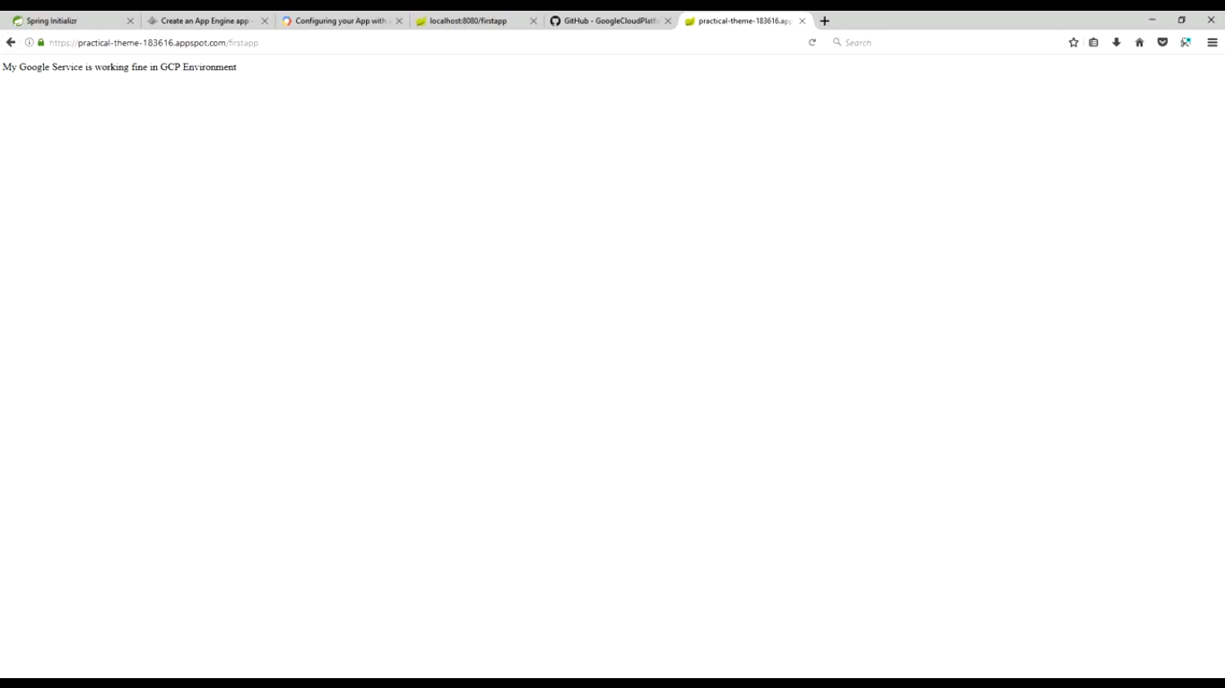

App engine integration with Cloud SQL

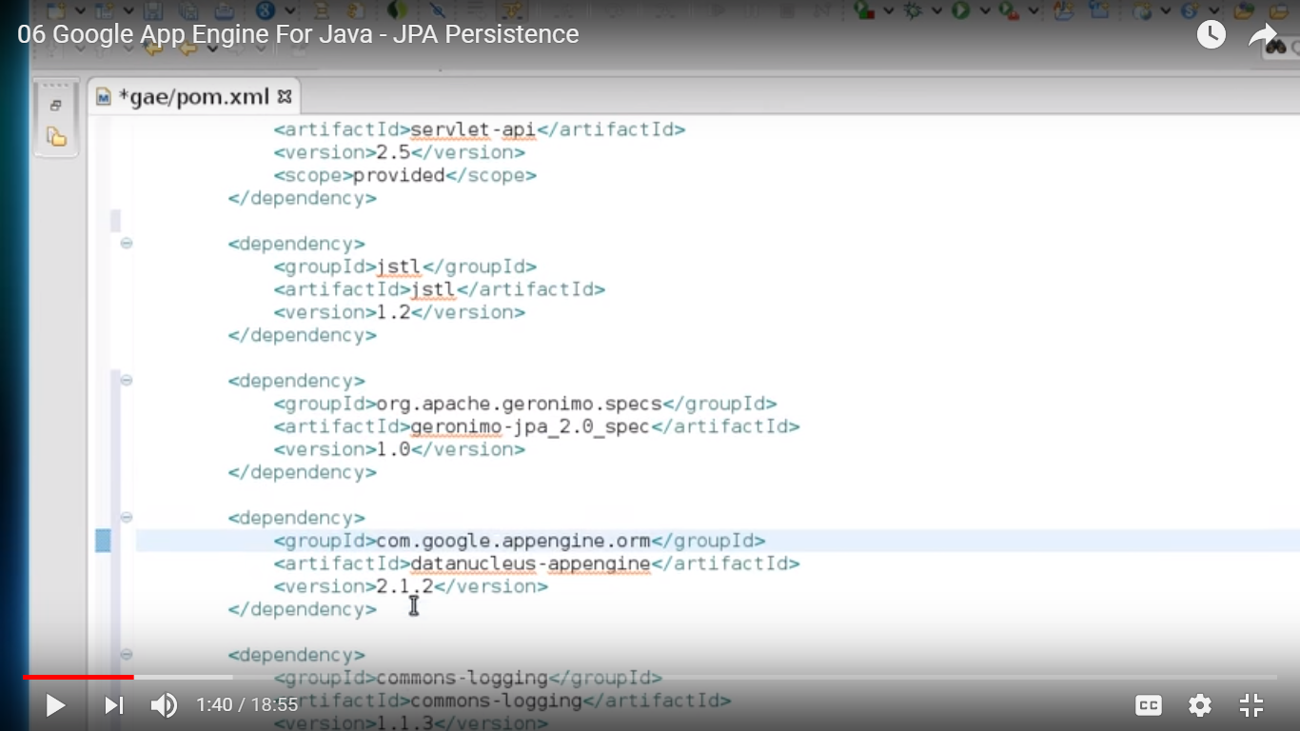

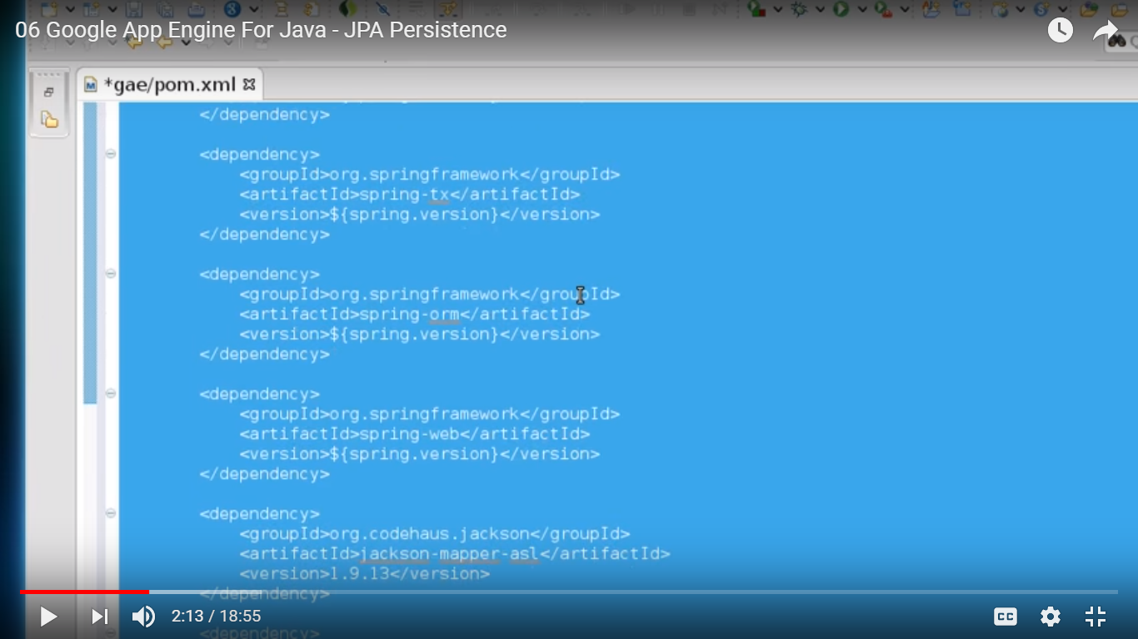

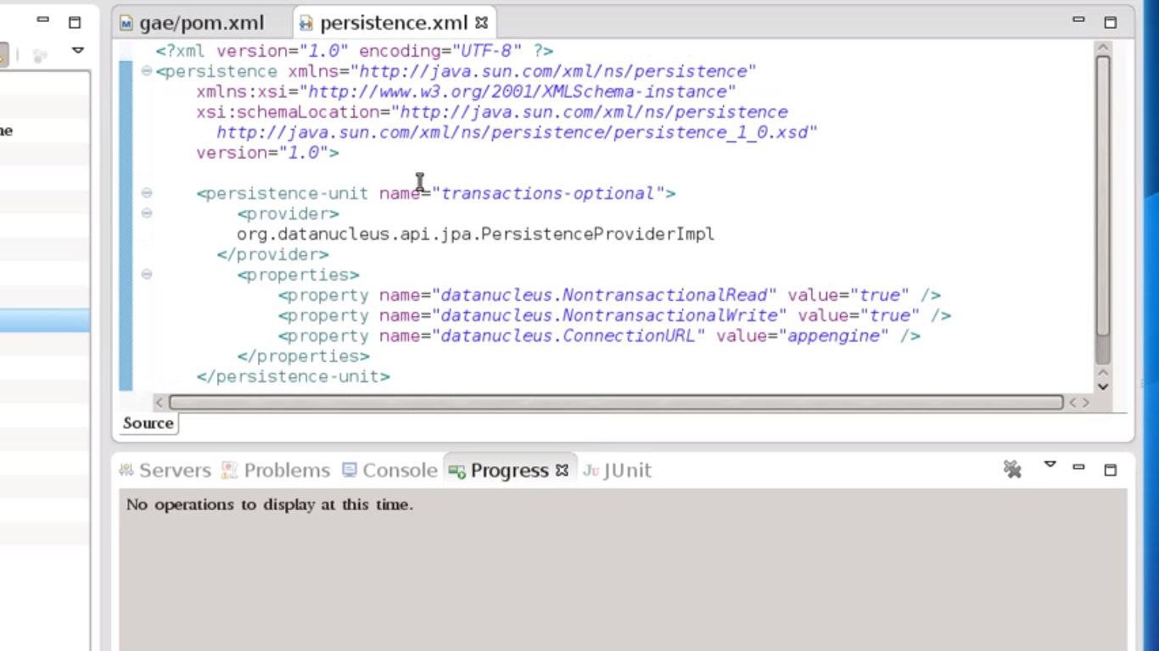

Get it from git hub

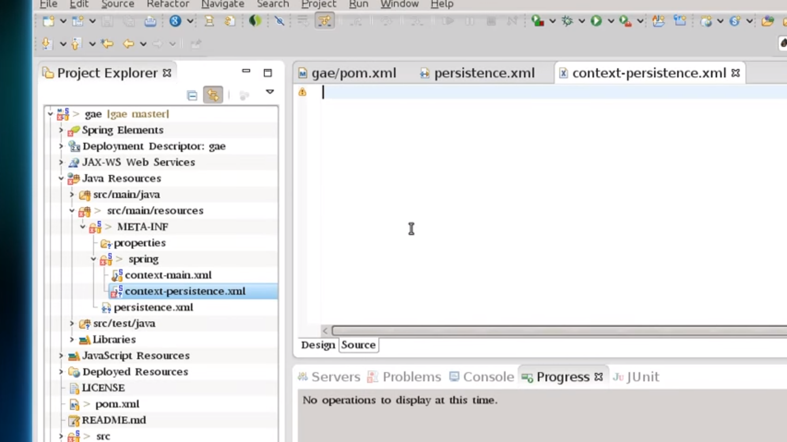

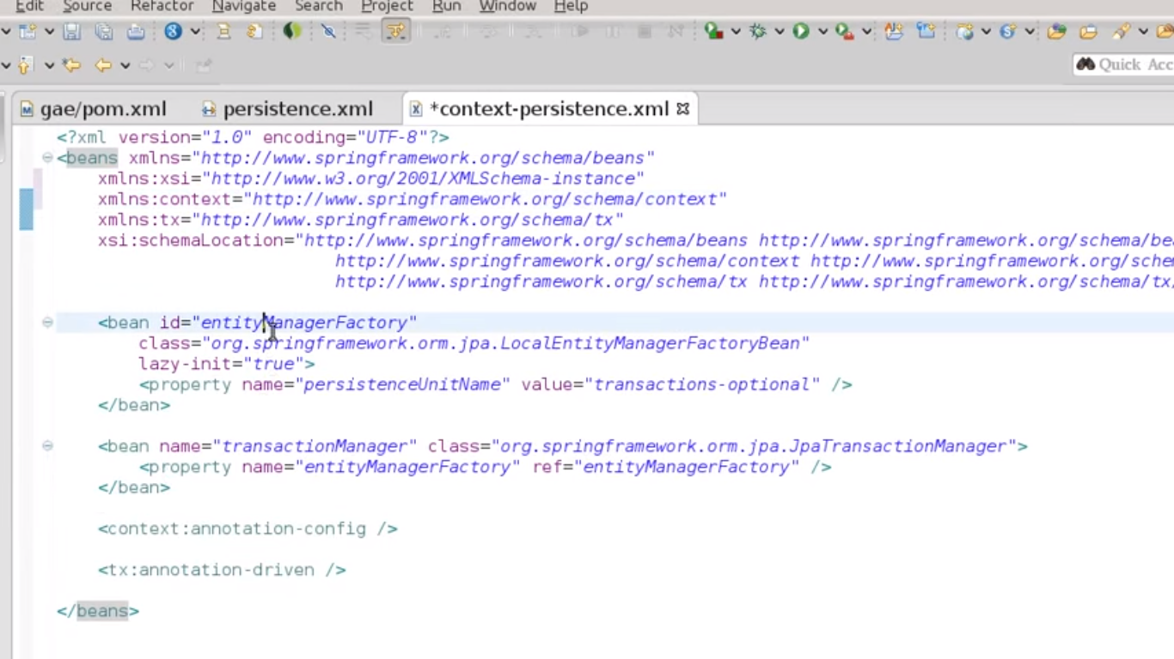

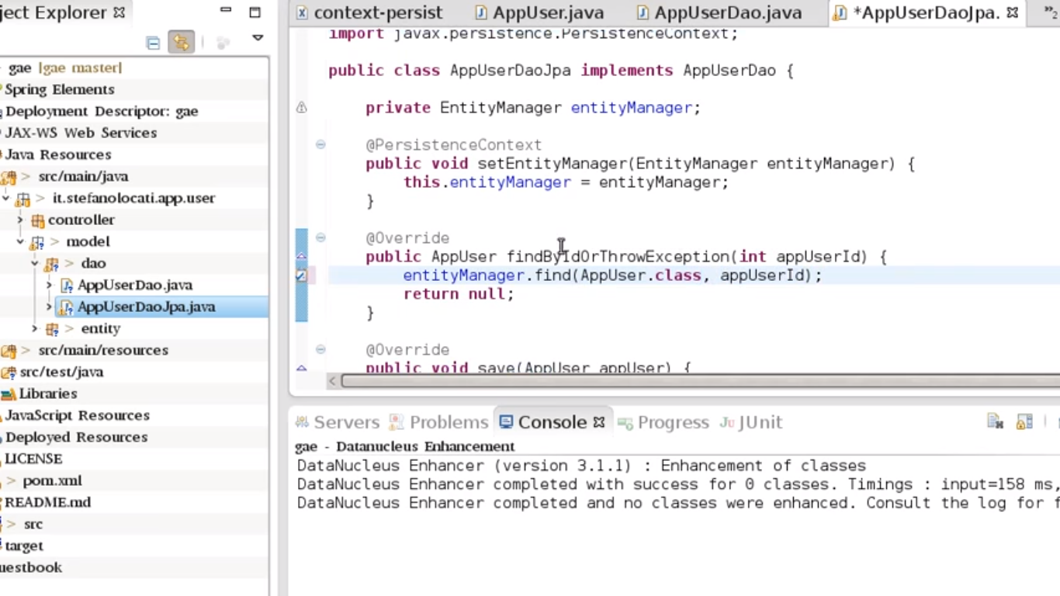

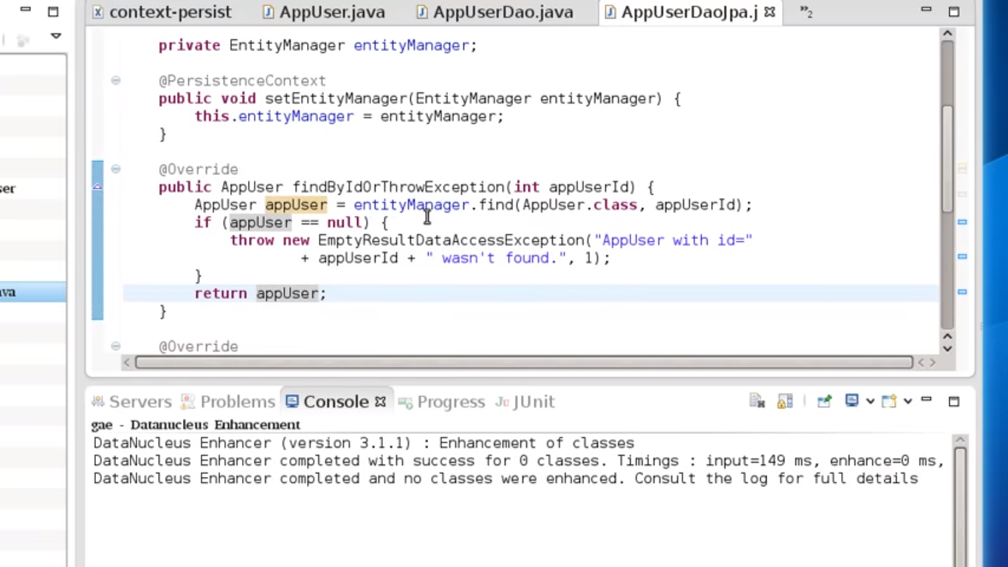

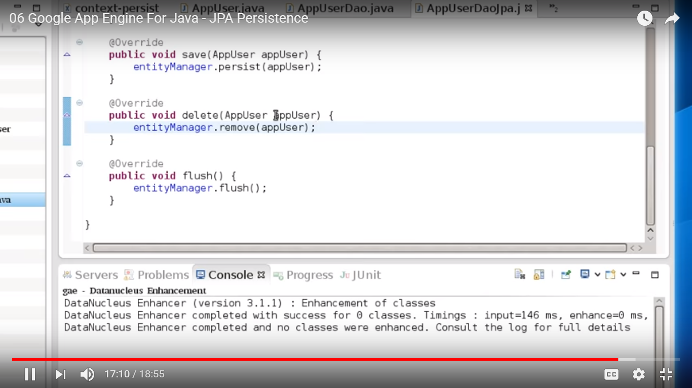

<https://www.youtube.com/watch?v=DnPo7kxgnr4>

## Hystrix

The @EnableCircuitBreaker annotation will scan the classpath for any compatible Circuit Breaker implementation.

To use Hystrix explicitly, you have to annotate this class with @EnableHystrix:

@SpringBootApplication

@EnableCircuitBreaker

public class RestConsumerApplication {

    public static void main(String[] args) {

        SpringApplication.run(RestConsumerApplication.class, args);

    }

}

Monitoring a ‘hystrix.stream’ is something fine, but if you have to watch multiple Hystrix-enabled applications, it will become inconvenient. For this purpose, Spring Cloud provides a tool called Turbine, which can aggregate streams to present in one Hystrix Dashboard.

Todo: Turbine

### URL to check the Hystrix dashboard:

Hystrix Stream: http://localhost:8301/hystrix.stream

## Spring Sleuth:

Distributed tracing

<https://www.youtube.com/watch?v=gPKJkY2t7Pc&pbjreload=10>

[Spring Cloud Sleuth](https://cloud.spring.io/spring-cloud-sleuth/) (org.springframework.cloud:spring-cloud-starter-sleuth), once added to the CLASSPATH, automatically instruments common communication channels:

* requests over messaging technologies like [Apache Kafka](https://spring.io/blog/2015/04/15/using-apache-kafka-for-integration-and-data-processing-pipelines-with-spring) or RabbitMQ (or any other [Spring Cloud Stream](https://cloud.spring.io/spring-cloud-stream/) binder
* HTTP headers received at Spring MVC controllers
* requests that pass through a Netflix Zuul microproxy
* requests made with the RestTemplate, etc.

By default, the threshold is 10%, or .1

spring.sleuth.sampler.percentage = 0.2

Trace ID, Span ID

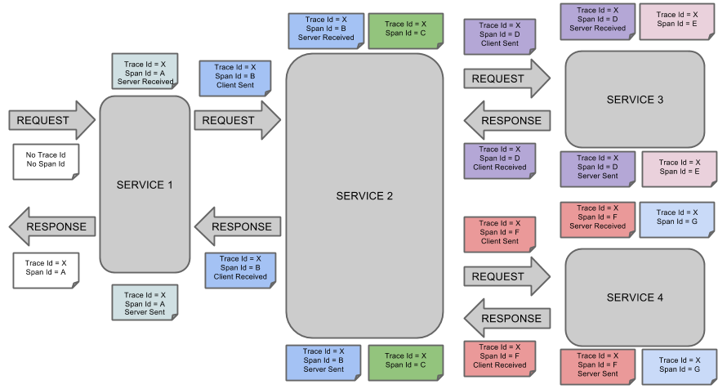

If you’re using a log aggregating tool like [Kibana](https://www.elastic.co/products/kibana), [Splunk](http://www.splunk.com/) etc. you can order the events that took place. An example of Kibana would look like this:

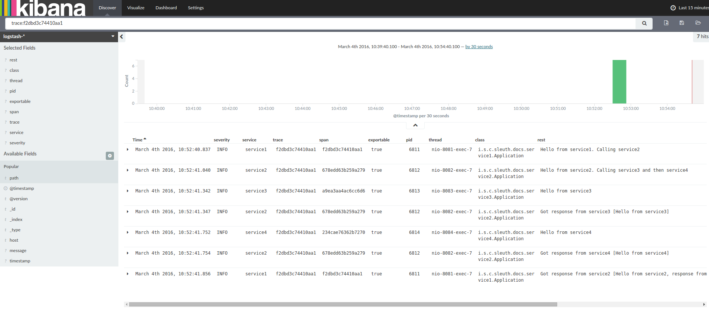

### Zipkin

Zipkin is an open source project that provides mechanisms for sending, receiving, storing, and visualizing traces. This allows us to correlate activity between servers and get a much clearer picture of exactly what is happening in our services.

Zipkin service will serve as the store for all our spans. Each span is sent to this service and collected into traces for future identification.

Note:

When all of an application’s functionality lives in a monolith - what we call applications written as one, large, unbroken deployable like a .war or .ear - it’s much easier to reason about where things have gone wrong. Is there a memory leak? It’s in the monolith. Is a component not handling requests correctly? It’s in the monolith. Messages getting dropped? Also, probably in the monolith. Distribution changes everything.

#### Setup

Downloaded zipkin-server-2.4.9-exec.jar and using cmd executed it.

Cmd > java -jar zipkin-server-2.4.9-exec.jar

Test it is working fine in the below URL once jar is successfully executed.

URL: <http://localhost:9411/zipkin>

Add the below in application.properties of all the micro services project

**spring.zipkin.baseUrl**=**http://localhost:9411  
spring.sleuth.sampler.percentage**=**1.0**

Add the dependency in all the micro services project

<**dependency**>  
 <**groupId**>org.springframework.cloud</**groupId**>  
 <**artifactId**>spring-cloud-starter-zipkin</**artifactId**>  
</**dependency**>

Hit the micro services and refresh the zipkin URL. It shows the statistics for the URL’s hit.

### Ribbon

Client side load balancing.

<https://www.youtube.com/watch?v=rsrYZ5cEySE&pbjreload=10>

application.yml

say-hello:

ribbon:

eureka:

enabled: false

listOfServers: localhost:8090, localhost:9092,localhost:9999

ServerListRefreshInterval: 15000

This configures properties on a Ribbon client. Spring Cloud Netflix creates an ApplicationContext for each Ribbon client name in our application. This is used to give the client a set of beans for instances of Ribbon components, including:

* an IClientConfig, which stores client configuration for a client or load balancer,
* an ILoadBalancer, which represents a software load balancer,
* a ServerList, which defines how to get a list of servers to choose from,
* an IRule, which describes a load balancing strategy, and
* an IPing, which says how periodic pings of a server are performed.

In our case above, the client is named say-hello. The properties we set are eureka.enabled(which we set to false), listOfServers, and ServerListRefreshInterval. Load balancers in Ribbon normally get their server lists from a Netflix Eureka service registry. (See the [Service Registration and Discovery](https://spring.io/guides/gs/service-registration-and-discovery/) guide for information on using a Eureka service registry with Spring Cloud.) For our simple purposes here, we’re skipping Eureka, so we set the ribbon.eureka.enabled property to false and instead give Ribbon a static listOfServers. ServerListRefreshInterval is the interval, in milliseconds, between refreshes of Ribbon’s service list.